Acids and bases: knowledge check
- Label this diagram of the pH scale using the words below to show the pH of:
  - an acidic solution
  - an alkaline solution
  - a neutral solution.

acidic alkaline neutral

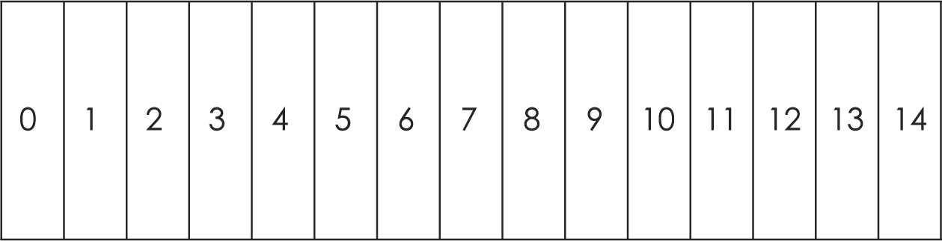
- Use the words to complete the sentences.

acidic acidity alkaline

alkalinity neutral
  - The pH scale measures the ___________________________ or ___________________________ of a solution.
  - ___________________________ solutions have a pH less than 7.
  - ___________________________ solutions have a pH of 7.
  - ___________________________ solutions have a pH greater than 7.

- Use the words to complete the sentences.

hydrochloric acid hydrogen nitric acid

sodium hydroxide solution sulfuric acid
  - Three acids commonly found in school laboratories are ___________________________, nitric acid and ___________________________.
  - An alkali commonly found in school laboratories is ___________________________.
  - ___________________________ ions are present in all acid solutions.

- Use the words to complete the sentences. You can use the words more than once.

carbon dioxide salt water

These general equations represent some methods used to make salts:
  - acid + metal $→$ ___________________________ + hydrogen
  - acid + metal oxide $→$ salt + ___________________________
  - acid + metal hydroxide $→$ salt + ___________________________
  - acid + metal carbonate $→$ salt + ___________________________ + ___________________________

- Use the words to complete the sentences.

laundry detergent lemon juice
  - Two everyday acids you might find in your home are vinegar and ______________________________________________________.
  - Two everyday bases you might find in your home are ___________________________ and baking soda.

Acids and bases: test myself
- What is an indicator? Use the words to complete the sentence.

colour concentration pH strength

An indicator is a substance that changes ___________________________ depending on the ___________________________ of the solution.

- What colour is universal indicator in an acidic solution, an alkaline solution and a neutral solution? Use the words to complete the sentences.

blue green red
  - Universal indicator is ___________________________ in an acidic solution.
  - Universal indicator is ___________________________ in an alkaline solution.
  - Universal indicator is ___________________________ in a neutral solution.

- What colour is universal indicator in a solution with a pH of 1? Use the words to complete the sentence.

blue green red

Universal indicator is ___________________________ in a solution with a pH of 1.

- What colour is the indicator litmus in acidic and alkaline solutions? Use the words to complete the sentence.

blue green red yellow

Litmus indicator solution turns ___________________________ in acidic solutions and ___________________________ in alkaline solutions.

- What is a base? Use the words to complete the sentences.

copper oxide disappears reacts

salt sugar water

A base is any substance that ___________________________ with an acid to form a ___________________________ and ____________________________.
For example, ___________________________ is a base.

- What is an alkali? Use the words to complete the sentences.

acids bases pH sodium hydroxide

Alkalis are soluble ___________________________ and have a ___________________________ greater than 7. For example, ___________________________ is an alkali.

- What type of reaction occurs when an acid reacts with an alkali? Use the words to complete the sentence.

combustion conduction neutralisation

A ___________________________ reaction occurs when an acid reacts with an alkali.

- What names are given to the types of salts formed in reactions with these acids? Use the words to complete the sentences.

carbonates chlorides hydrates

nitrates sulfates
  - Hydrochloric acid produces ___________________________.
  - Sulfuric acid produces ___________________________.
  - Nitric acid produces ___________________________.

- Name the salt made when copper oxide reacts with sulfuric acid. Use the words to complete the sentence.

copper copper hydroxide copper sulfate

The salt made when copper oxide reacts with sulfuric acid is ___________________________.

- Draw lines to link the name of the acid with its formula.
  - hydrochloric acid H₂SO₄
  - sulfuric acid HNO₃
  - nitric acid HCl

Acids and bases: feeling confident?
- Complete the word equations.

acid hydroxide nitrate sodium

sulfate sulfuric water
  - Hydrochloric acid reacting with sodium hydroxide:
hydrochloric ___________________________ + ___________________________ hydroxide $→$ sodium chloride + water
  - Sulfuric acid reacting with sodium hydroxide:
___________________________ acid + sodium hydroxide $→$ sodium ___________________________ + ___________________________
  - Nitric acid reacting with sodium hydroxide:
nitric acid + ___________________________ $→$ sodium ___________________________ + water
- Complete and balance the equations for the reactions in question 3.1.

H₂O H₂SO₄ NaCl NaNO₃

NaOH Na₂SO₄
  - HCl + ___________________________ $→$ NaCl + H₂O
  - ___________________________ + ___NaOH $→$ Na₂SO₄ + ___H₂O
  - HNO₃ + NaOH $→$ ___________________________ + H₂O

Acids and bases: what do I understand?

Think about your answers and confidence level for each mini-topic. Decide whether you understand it well, are unsure or need more help. Tick the appropriate column.
Mini-topic | I understand  this well | I think I understand this | I need more  help
I can describe the pH scale.
I know the pH of acidic and alkaline solutions.
I can name common acids and alkalis.
I can write general word equations for reactions of an acid with a:
- metal
- metal oxide
- metal hydroxide
- metal carbonate.
I can write chemical formulas for common laboratory acids.
I can name types of salt produced by reactions with:
- hydrochloric acid
- sulfuric acid
- nitric acid.
I can use universal and litmus indicators to identity acidic, alkaline and neutral solutions.
Feeling confident? topics | I understand  this well | I think I understand this | I need more  help
I can write word equations for reactions between an acid and a:
- metal
- metal oxide
- metal hydroxide
- metal carbonate.
I can write symbol equations for reactions between an acid and a:
- metal
- metal oxide
- metal hydroxide
- metal carbonate.

