Superbugs and their chemical reactions

This resource accompanies the article Wonder weapons in Education in Chemistry which can be viewed at: rsc.li/3yi6pOc

Learning objectives
- Draw an energy level diagram for both a catalysed and uncatalysed reaction.
- Explain the effect of catalysts on the profile of a reaction.

Introduction

There are lots of examples of animals across nature that rely on chemicals or a mixture of chemicals to help them avoid being eaten. Some spray acid whereas some spray oils. However, the bombardier beetle is slightly different. In this activity, your learners will read an extract from an article published in Education in Chemistry then use their knowledge to answer some questions.

Using the worksheets

There are two differentiated versions of the student worksheet. In the unscaffolded version, learners are expected to be able to draw a sketch graph including their own axes. In the scaffolded version, the axes are already drawn, as are the start and end points. Learners should add labels to the axes and complete the reaction profiles. Further scaffolding includes fill-in-the-gap answers, while the unscaffolded worksheet requires learners to write their own sentences.

The scaffolded worksheet is denoted by the symbol in the header of the document. The unscaffolded version has no symbol in the header. The content and knowledge assessed in both the scaffolded and unscaffolded worksheets are the same and therefore, only one set of answers is given below.

Answers
- Answers shown in red on diagram.
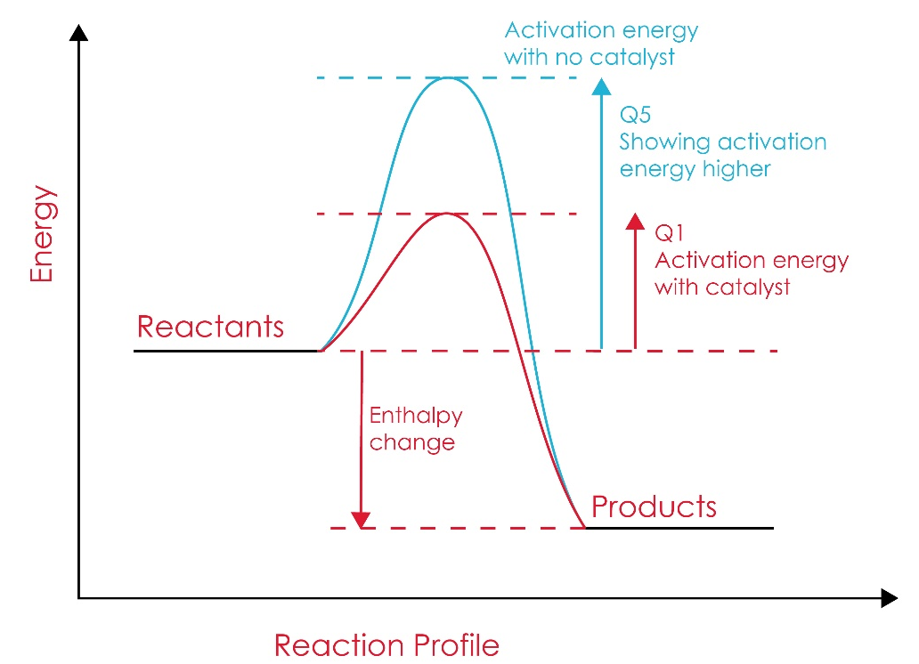

- Answers to the scaffolded (fill-in-the-gap) student worksheet are shown in bold:
The catalyst increases the rate of the chemical reaction between the hydroquinone and the hydrogen peroxide. This is because it provides an alternative pathway which requires a lower activation energy.
- As the reaction is exothermic the chemicals that are released are hot. This deters predators of the beetle from trying to eat it.
- The exothermic reaction may burn the beetle so the beetle must spray the chemicals away from its body.
- Answers shown in light blue on diagram.

Extension questions
- $C_{6}H_{4}{(OH)}_{2}\left(aq\right)+ H_{2}O_{2}\left(aq\right)→ C_{6}H_{4}O_{2}\left(aq\right)+ 2H_{2}O(l)$
- The catalysts are not mentioned in the equation. Catalysts are not shown in chemical equations because they remain unchanged at the end of the reaction.
- This is a negative enthalpy change which proves that the reaction is exothermic and releases energy.
- Unscaffolded student sheet only:
The water that is produced has a boiling point of 100°C. The heat produced from the exothermic reaction causes almost a fifth of the quinone (other product) to be vapourised. This pressure build up is what allows the beetle to force the products so far and keep itself safe from any harm.

