Writing methods for required practicals with CIDER hexagons
Education in Chemistry
January 2021
rsc.li/2XKwB1g
Help students better understand and remember methods for required practicals with this worksheet
For each required practical, provide this grid of hexagons for students to complete using the pneumonic CIDER (control, independent, dependent, equipment, risk assessment) – some of the essential parts to include in a scientific method. Use the last section to draw a diagram of the equipment. You could also ask them to draw the diagrams including each step, similar to the format of David Paterson’s integrated instructions.
Have students then use the grid to write up a summary of the method for each required practical, including detail on what equipment is chosen and why. Apart from the planning tool aspect, using hexagons enables students to organise their thoughts and can they can refer to their grids before attempting practice questions.
Use this in class, as a homework task, or as a remote-teaching activity done either in breakout rooms or individually before returning for feedback.
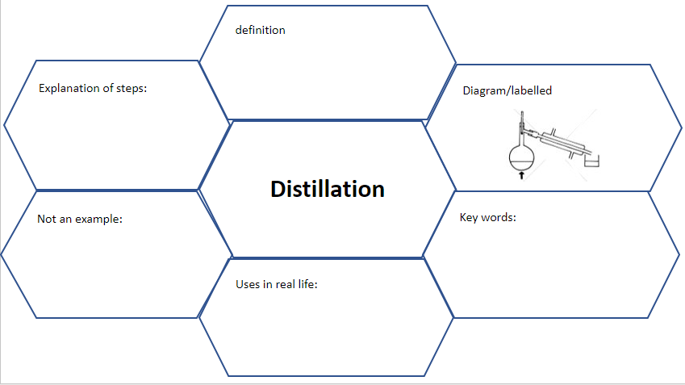
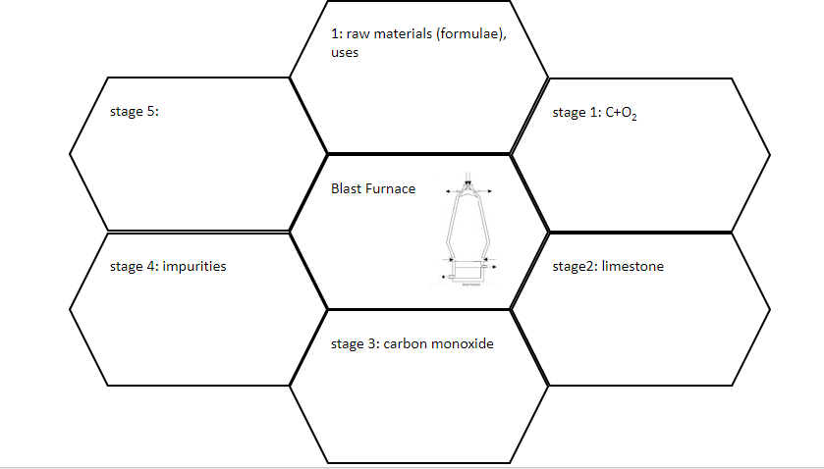
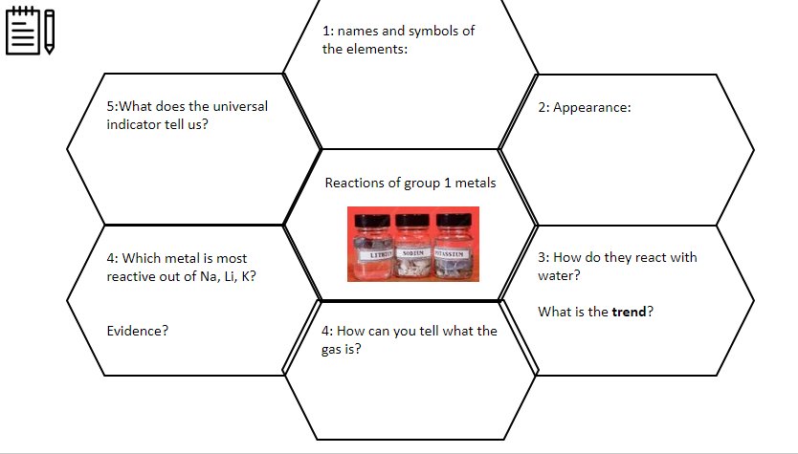
The third page includes a blank hexagon grid to use for your own purposes, such as for exam questions (write the question in the middle and points linking to the question in the outside hexagons) or as revision maps (write the topic/keyword in the middle and the key points around the outside), as in these three examples below:

Independent variable
Diagram

Writing a method with CIDER
Title of practical:
Control variables

Dependent variable
Risk assessment

Equipment

