Swimming pool chemistry

This resource accompanies the article What am I swimming in? in Education in Chemistry which can be viewed at: https://rsc.li/39eZpYL

The worksheet originally appeared in the book Chemistry for the gifted and talented.

Learning objectives
- Describe how the water in swimming pools is disinfected.
- Calculate the concentration of various ions present in the water.
- Interpret data obtained from a mass spectrometer.
- Determine the structure of organic molecules.

Introduction

This activity is synoptic in nature, with questions on many different aspects of chemistry. It is context driven, looking at a collection of interesting chemistry that can be derived from swimming pools.

The main subject content areas are:
- Structure and bonding
- Equilibrium
- Spectrometry
- Spectroscopy

There are two versions of the student sheet. One is aimed at stretching the most able and the other comes with hints on how to answer the questions, making it accessible to a wider range of students.

The version is indicated in the top right header of the student document:

= challenge

= support

The activity comes in two parts and these can be given separately to the students.
- Part 1 can be used at the end of teaching equilibrium or at the end of a course.
- Part 2 should be attempted at the end of a course.

The accompanying presentation should be used to set the scene and stimulate discussion.
- Slide 2 provides the stimulus as it asks the question ‘How do we keep a swimming pool well maintained, clean and safe for the general public to use?’
- The health and safety information on slide 3 can be used to discuss why chlorine is no longer used in pools in the UK and has been replaced by sodium chlorate(I).
- Slide 4 can be used to develop the discussion further and introduce ideas surrounding pool maintenance and maintaining water quality. It supports question 7 on the student sheet.
- Slide 5 introduces the solubility product $K_{sp}$ and should be used with students who have not covered this as part of their chemistry studies. It supports questions 5–7.
- Slide 6 can be used to stimulate discussion around question 11. Students may wish to discuss this in small groups and use molecular models to make up the different resonance structures of isocyanuric acid.
- Slide 7 can be used to stimulate discussion around question 13, either as a whole class or in small group discussions.

Curriculum links
- Equilibria ($K_{c}, K_{sp}, Ka$ buffers, Le Chatelier’s principle) and entropy (solvent effects).
- Mass spectra, oxidation numbers, curly arrow mechanisms, nuclear magnetic resonance (NMR) spectroscopy, delocalisation, tautomerism and relative molecular mass calculations.

Please note that most A-level courses and the Scottish Advanced Highers do not require students to carry out $K_{sp}$ calculations. However, information included within the accompanying presentation should allow students to access the questions.

Tautomerism is beyond the scope of most post-16 specifications, however enough information is included in the questions to allow students to answer them.

Prior knowledge

$K_{c}, pH$, Le Chatelier’s principle, buffers, spectra, NMR and curly arrows.

Answers

Part 1
- $1 {dm}^{3}$ contains $55.6 moles$ of water

Therefore:

$$1 ppm =55.6 ×{10}^{-6} mol {dm}^{-3}$$

$$=5.56 × {10}^{-5} mol {dm}^{-3}$$

$$0.5 ppm=5.56 × {10}^{-5} mol {dm}^{-3} ×0.5$$

$$=2.78 × {10}^{-5} mol {dm}^{-3}$$

$$=2.8 × {10}^{-5} mol {dm}^{-3} (two sig fig)$$

- $$pH =pKa+\log_{10 }\frac{[O{Cl}^{-}]}{[HOCl]}$$

$$7.3-7.54 =\log_{10 }\frac{(2.78 ×{10}^{-5}-\left[HOCl\right])}{[HOCl]}$$

$$-0.24 =\log_{10 }\frac{(2.78 ×{10}^{-5}-\left[HOCl\right])}{[HOCl]}$$

$$0.575 =\frac{(2.78 ×{10}^{-5}-\left[HOCl\right])}{[HOCl]}$$

$$0.575\left[HOCl\right]=2.78 ×{10}^{-5}-\left[HOCl\right]$$

$$\left[HOCl\right]=\frac{2.78 ×{10}^{-5}}{1.575}$$

$$=1.76 × {10}^{-5} mol {dm}^{-3}$$

$$=1.8 × {10}^{-5} mol {dm}^{-3} (two sig fig)$$

$$\left[O{Cl}^{-}\right]=2.78 ×{10}^{-5} mol {dm}^{-3}-1.76 ×{10}^{-5} mol {dm}^{-3}$$

$$=1.02 ×{10}^{-5} mol {dm}^{-3}$$

$$\left[HC{O_{3}}^{-}\right]=1.08 ×{10}^{-3} mol {dm}^{-3}- 1.02 ×{10}^{-5} mol {dm}^{-3}$$

$$=1.07 ×{10}^{-3} mol {dm}^{-3}$$

$$\left[H_{2}CO_{3}\right]=\frac{\left[{HCO_{3}}^{-}\right][H^{+}]}{Ka}$$

$$\left[H_{2}CO_{3}\right]=\frac{1.07 ×{10}^{-3} ×{10}^{-73}}{4.2 ×{10}^{-7}}$$

$$=1.28 ×{10}^{-4} mol {dm}^{-3}$$

$$=1.3 ×{10}^{-4} mol {dm}^{-3} (two sig fig)$$

- Adding extra $CO_{2}$ gas increases the concentration of $H_{2}CO_{3}$. This in turn causes a drop in $pH$. The drop in $pH$ shifts the position of the equilibrium for:

$$HOCl\left(aq\right)⇌O{Cl}^{-}(aq)+H^{+}(aq)$$

to the left, increasing the concentration of $HOCl(aq)$.

- $Units ={mol}^{a+b} {dm}^{-3(a+b)}$

- $${[Ca}^{2+}(aq)] = \frac{0.1}{2} mol {dm}^{-3}$$

$$= 0.05 mol {dm}^{-3}$$

$$[{SO_{4}}^{2-}\left(aq\right)]=\frac{K_{sp}}{{[Ca}^{2+}(aq)]}$$

$$=\frac{(2.4 × {10}^{-5})}{0.05} mol {dm}^{-3}$$

$$= 4.8 ×{10}^{-4} mol {dm}^{-3}$$

- The phenomenon at work here is known as the common ion effect. The calcium chloride added raises the concentration of calcium ions. This is turn limits the amount of calcium sulfate that can dissolve before the solution is saturated, because $K_{sp}$ is the product of the concentration of the two ions.
- The more charged calcium and sulfate ions must cause more ordering of the water molecules around them than the sodium and chloride ions. So $∆S_{system}$ is likely to be negative for the solution $CaSO_{4}$ and positive for $NaCl$. The chemguide website (accessed May 2022) has a good discussion of the problems relating solubility to enthalpies of solution and the effect of entropy.

Part 2
- (a)
Mass/charge ratio | Relative height of peak as a percentage of the most abundant peak (%) | Species giving rise to the peak
42 | 17.9 | $$NCO^{+}$$
70 | 100.0 | $C_{2}O_{2}N^{+}$and ${}_{}^{35}{{{Cl}_{2}}^{+}}$
71 | 2.7 | $C_{2}O_{2}N^{+}$ (C−13 satellite)
72 | 12.9 | $${}_{}^{35}{Cl}{}_{}^{37}{{Cl}^{+}}$$
74 | 2.3 | $${}_{}^{37}{{{Cl}_{2}}^{+}}$$
77 | 81.4 | $$CON{}_{}^{35}{{Cl}^{+}}$$
79 | 26.4 | $$CON{}_{}^{37}{{Cl}^{+}}$$
154 | 18.4 | $$C_{2}O_{2}N_{2}{}_{}^{35}{{{Cl}_{2}}^{+}}$$
156 | 11.7 | $$C_{2}O_{2}N_{2}{}_{}^{35}{Cl}{}_{}^{37}{{Cl}^{+}}$$
158 | 2.0 | $$C_{2}O_{2}N_{2}{}_{}^{37}{{{Cl}_{2}}^{+}}$$
231 | 24.6 | $$C_{3}N_{3}O_{3}{}_{}^{35}{{{Cl}_{3}}^{+}}$$
233 | 23.4 | $$C_{3}N_{3}O_{3}{}_{}^{35}{{Cl}_{2}}{}_{}^{37}{{Cl}^{+}}$$
235 | 7.8 | $$C_{3}N_{3}O_{3}{}_{}^{35}{Cl}{}_{}^{37}{{{Cl}_{2}}^{+}}$$
237 | 1.0 | $$C_{3}N_{3}O_{3}{}_{}^{37}{{{Cl}_{3}}^{+}}$$

- There are two chlorines so we expect three peaks with height ratio 9 : 6 : 1.
- There are three chlorines so we expect four peaks with the height ratio
27 : 27 : 9 : 1.

(c)

$$231×24.6+233×23.4+235×7.8+237 ×1.0=13204.8$$

$$24.6+23.4+7.8+1.0=56.8$$

$$\frac{13204.8}{56.8}=232.48 (two decimal places)$$

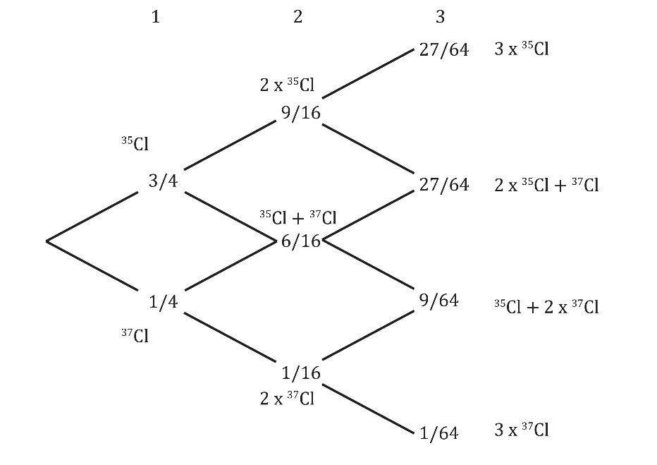

Figure 1: the probability tree for molecules containing up to three chlorines

(d) The relative height of the peak at mass/charge (m/c) 72 is the best clue here. The peak at 72 is due to ${}_{}^{35}{Cl}{}_{}^{37}{{Cl}^{+}}$, so we are expecting the ³⁵${{Cl}_{2}}^{+}$ peak to be 9/6 times higher – ie height 19.4%. The peak due to $C_{2}O_{2}N^{+}$ would therefore be 80.6% on the current scale. Because the peak at m/c 70 was the most abundant in the low resolution mass spectra, the whole scale would be different in high resolution with the new most abundant peak being m/c 77 (assuming the same fragmentation pattern). The relative height of the $C_{2}O_{2}N^{+}$ peak could be estimated from the carbon-13 satellite at m/c 72 but this is likely to be less accurate than using the chlorine isotope abundances since the satellite peak is so small.

- One – all the hydrogens are equivalent.

- It will have a delocalised system because there are resonance structures that can be drawn with three π bonds in the ring.

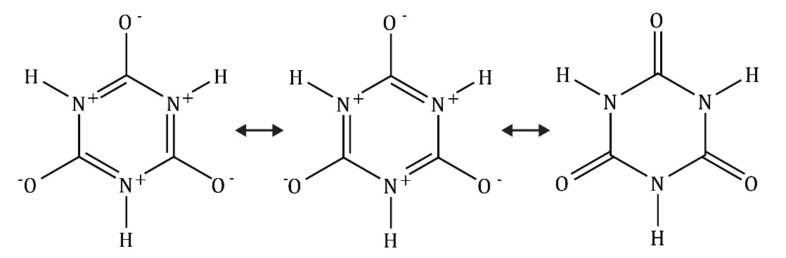

The delocalised ring is not as stable as benzene because of the large number of formal charges in the resonance structures.
- $$C_{3}O_{3}N_{3}{Cl}_{3}+3H_{2}O →3HOCl+ C_{3}O_{3}N_{3}H_{3}$$
- If we put absolute faith in the Pauling electronegativity value we conclude that the bond is purely covalent and the oxidation number of the chlorine is zero. The reaction with water is then similar to a disproportionation reaction. However, electronegativity values are not absolute values in the same way that thermodynamic data are; they are a rough guide. There are other electronegativity values, different from the ones that Pauling suggested, and these do not put nitrogen and chlorine as equal. If we lose complete faith in the electronegativity values then it seems reasonable to suggest that the hydrolysis is not a redox reaction (since water is neither an oxidising agent nor reducing agent). That suggests that the oxidation number of chlorine is +1 in the trichloroisocyanuric acid, as it is in the product $HOCl$.

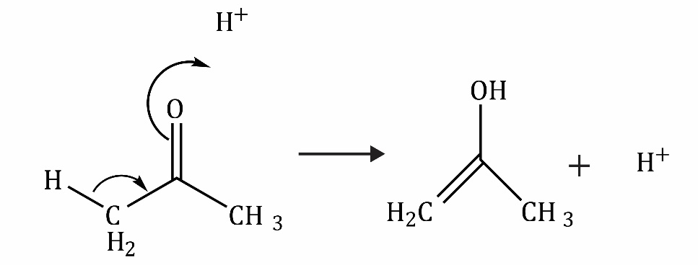

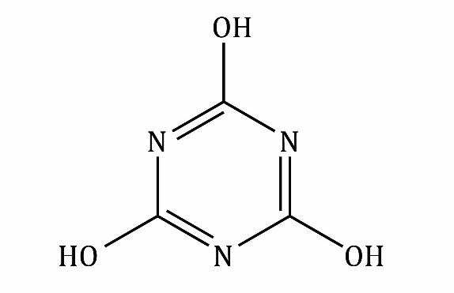

Interestingly it does not seem to form stable intermediates (with just one or two OH groups).

