Shipwrecks: concept cartoon
______________________________________

Introduction

There are two shipwrecks. One in deep water and the other in shallow water. The one in deeper water is less rusty. Why?

Instructions

Design a concept cartoon with four possible reasons for which shipwreck rusts faster. A concept cartoon should have a drawing in the middle showing the shipwrecks at different depths and four speech bubbles around it expressing opinions about why one will be rustier than another. The best cartoons will be those with the greatest number of plausible explanations.

Below are some ideas that you might include in your concept cartoon:
- The shallow seawater is warmer/cooler.
- The shallow seawater has more/less oxygen dissolved in it.
- The shallow seawater is moving with a faster/slower current or is stirred about more/less.
- The concentration of salt in solution varies with depth.
© Shutterstock

Challenge

The best explanations take the reasoning further and explain why…

...the shallow water might be warmer/cooler.

...the shallow water might have more/less oxygen in it.

...the shallow water might get stirred up more/less.

...the shallow water might have a higher/lower salt concentration.

Template

Use the concept cartoon template on the next page or, if you are feeling creative, design your own cartoon on plain paper.

If you don’t want to draw a shipwreck, you could present your opposing ideas as a set of ‘talking heads’ instead.

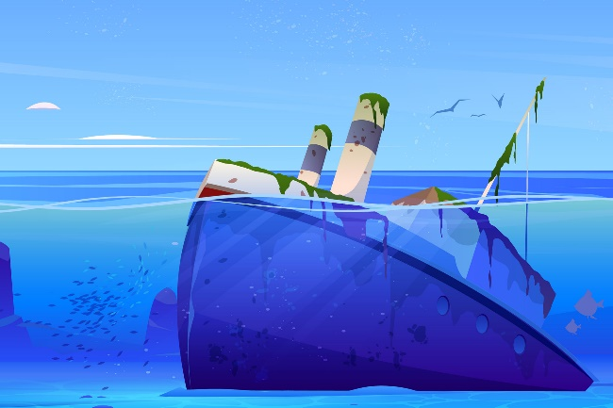
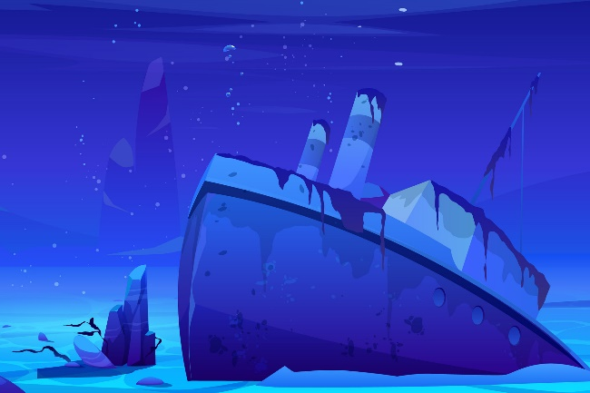
© Adapted from Shutterstock

© Shutterstock

