- The table shows some naturally occurring monomers that can form polymers.

- Complete the table.
 | 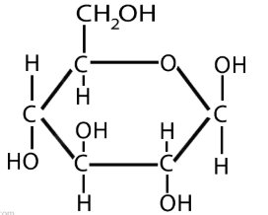 | 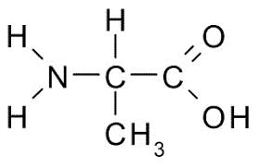 | 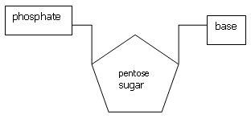
Name of type of monomer | Answer: Sugar. | Answer: Amino acid. | Answer: Nucleotide.
Name of polymer type | Answer: Starch or cellulose. | Answer: Protein. | Answer: DNA.
- What is a functional group in a molecule?
Answer: A part of the molecule that determines how it reacts (its chemical behaviour).
- Circle the two functional groups in this molecule:

- Sucrose is a sugar called a disaccharide.
This means that it is made of two sugar molecules joined together.
Sucrose is made from two other sugars called glucose and fructose.

Here are the structures of glucose and fructose:
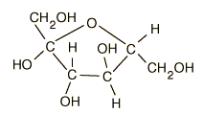
Fructose
Glucose

- Use the molecular structures of glucose and fructose to write their molecular formulas:

Glucose | Answer: C₆H₁₂O_{6.}
Fructose | Answer: C₆H₁₂O_{6.}
- On the diagram above, a dotted ring has been drawn around parts of the glucose and fructose molecules. This shows that a small molecule will be formed.
What is the name of this small molecule?
Answer: Water.
- Using the information in this question, write down the formula of the disaccharide formed called sucrose.
Answer: C₁₂H₂₂O₁₁.

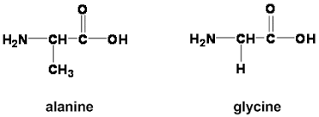
- This question is about the two molecules shown.

- These molecules belong to the same homologous series.
What is the name of the homologous series to which these molecules belong?
Answer: Amino acids.
- These molecules may react together to form a dipeptide.
A molecule of water is also formed.
Draw a ring around the parts of the molecules that would result in the formation of a molecule of water.
Answer: See answer above.
- State the name of the type of reaction taking place when these two molecules react together in this way.
Answer: Condensation or condensation polymerisation (if more than two join).
- Draw the structure of the dipeptide formed when these molecules react according to the diagram above.
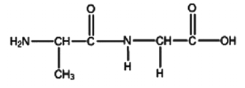

- The dipeptide in part c) can be abbreviated to ala-gly.
- Draw the structure of gly-ala.
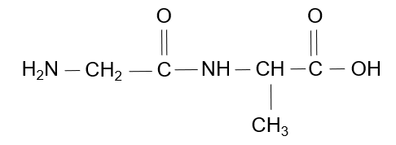

- Using your answers to part i) and part c), is ala-gly the same dipeptide as gly-ala? Give a reason.
Answer: Ala-gly is not the same as gly-ala.
The dipeptides are not symmetrical, and so the ordering makes a difference.

- This question is about the structure of DNA.
Use some of the words from the box to complete the sentences below.
condensation helix polynucleotide addition
intermolecular four water nucleotide
ring-shaped ionic six hydrogen chloride

DNA is an important polymer essential for life.

Monomers called nucleotides make DNA.

There are four different types of monomer.

When the nucleotide monomers join together to form DNA they also form water.

This means that this type of reaction is called a condensation polymerisation.

The DNA strand is made of a double helix of two very long polynucleotide strands that run in opposite directions.

These strands are held to each other by intermolecular forces.

