Covalent bonding

Learning objectives
- Define the term covalent bond.
- Recognise, use and interpret different types of diagrams of covalent bonding in small molecules.
- State the limitations of covalent bonding diagrams.

Introduction

Covalent bonding occurs when electrons are shared. Lots of different substances have covalent bonding and covalent bonding can be represented using different types of diagrams. In this activity, you will gain an understanding of these diagrams and their limitations.

Instructions
- Stick the structure strip in the margin of your exercise book/paper.
- Follow the prompts to write a summary of covalent structures and bonding. You might need to use a textbook, revision guide or website to help you. Take care to write in full sentences, describing the question within your answer and using appropriate keywords.
- When you have finished the structure strip you should have a good knowledge of covalent structures and bonding. Now, tackle the question below to apply your knowledge to a new context.

Keywords

You may wish to use some of the following words in your responses: covalent, bonding, giant, limitation, molecule, polymer.

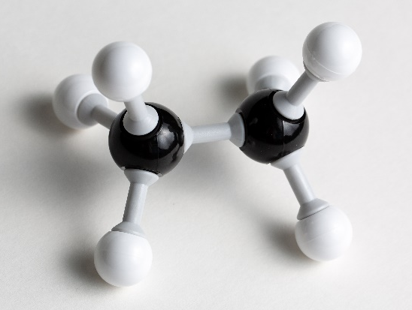
Follow-up question

The photograph shows a small molecule built using Molymods®. Give the formula of the molecule and draw the molecule as:
- A dot and cross diagram
- A ball and stick diagram
- A structural or skeletal formula
Structure strip  Covalent bonding | Structure strip  Covalent bonding | Structure strip  Covalent bonding | Structure strip  Covalent bonding | Structure strip  Covalent bonding
How are covalent bonds formed? | How are covalent bonds formed? | How are covalent bonds formed? | How are covalent bonds formed? | How are covalent bonds formed?
Covalent bonds can be found in small molecules, large molecules and giant covalent structures. Give examples of each. | Covalent bonds can be found in small molecules, large molecules and giant covalent structures. Give examples of each. | Covalent bonds can be found in small molecules, large molecules and giant covalent structures. Give examples of each. | Covalent bonds can be found in small molecules, large molecules and giant covalent structures. Give examples of each. | Covalent bonds can be found in small molecules, large molecules and giant covalent structures. Give examples of each.
Covalent bonds can be represented using different diagrams, including dot and cross diagrams.  Explain how you would go about drawing a dot and cross diagram of the covalent bonding in ammonia.  Fully explain each decision in your diagram construction. | Covalent bonds can be represented in different diagrams, including dot and cross diagrams.  Explain how you would go about drawing a dot and cross diagram of the covalent bonding in ammonia.  Fully explain each decision in your diagram construction. | Covalent bonds can be represented in different diagrams, including dot and cross diagrams.  Explain how you would go about drawing a dot and cross diagram of the covalent bonding in ammonia.  Fully explain each decision in your diagram construction. | Covalent bonds can be represented in different diagrams, including dot and cross diagrams.  Explain how you would go about drawing a dot and cross diagram of the covalent bonding in ammonia.  Fully explain each decision in your diagram construction. | Covalent bonds can be represented in different diagrams, including dot and cross diagrams.  Explain how you would go about drawing a dot and cross diagram of the covalent bonding in ammonia.  Fully explain each decision in your diagram construction.
Water is a simple covalent structure.  Draw water in each of these forms:  - Ball and stick model  - Dot and cross diagram  - Skeletal formula | Water is a simple covalent structure.  Draw water in each of these forms:  - Ball and stick model  - Dot and cross diagram  - Skeletal formula | Water is a simple covalent structure.  Draw water in each of these forms:  - Ball and stick model  - Dot and cross diagram  - Skeletal formula | Water is a simple covalent structure.  Draw water in each of these forms:  - Ball and stick model  - Dot and cross diagram  - Skeletal formula | Water is a simple covalent structure.  Draw water in each of these forms:  - Ball and stick model  - Dot and cross diagram  - Skeletal formula
State the limitations of using models to represent covalent molecules. | State the limitations of using models to represent covalent molecules. | State the limitations of using models to represent covalent molecules. | State the limitations of using models to represent covalent molecules. | State the limitations of using models to represent covalent molecules.

