Plastics in energy-saving homes: context-based questions

Learning objectives
- Review your knowledge and understanding of the synthesis and use of addition and condensation polymers.
- Review your knowledge and understanding of other linked topics: naming and formulas of organic compounds, environmental concerns from the use of organohalogen compounds, nucleophilic reaction mechanisms and intermolecular forces.
- Practise answering context-based questions using your knowledge, as well as unfamiliar information given in the question.

Introduction

This worksheet is based on the chemistry of the polymers and other compounds discussed in the article The science behind sustainable home insulation in Education in Chemistry, which can be viewed at: rsc.li/3GAhIoV

The questions are designed to review your knowledge and understanding of polymer chemistry, as well as other topics you have studied that relate to the reactions and properties of polymers.

It is helpful if you read the article before attempting the questions as this sets the context. However, any essential information not expected from your prior knowledge of chemistry is given in the questions.

Questions
- Polystyrene is an insulation material used in the construction industry. The structure of a short section of polystyrene is shown below.
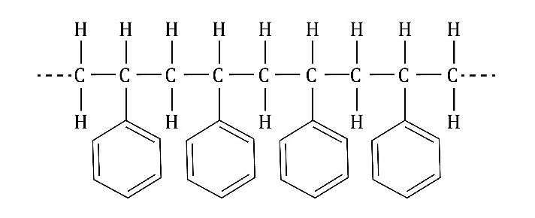
- Draw the structure of the repeat unit of polystyrene.

(1 mark)
- Draw the structure of the monomer which makes polystyrene.

(1 mark)
- State the type of polymerisation used to make polystyrene from its monomer.

(1 mark)
- The gases used in polystyrene insulation manufacturing have changed over recent years.
- Chlorofluorocarbons (CFCs) were originally used but were banned in the 1980s because they are harmful to the environment. Describe briefly how CFCs harm the environment.

(2 marks)
- HFC-134a was introduced as a less harmful replacement for CFCs. The structure of HFC-134a is shown below.
Give the IUPAC name for this compound.

(1 mark)
- HFCs are now being replaced by other compounds with lower global warming potential. One of the gases replacing HFCs is 1,3,3,3-tetrafluoropropene. Draw the skeletal formula of this compound.

(1 mark)
- Polyurethane is a polymer commonly used to make insulating foams. Polyurethane is made from two different monomers, shown below.
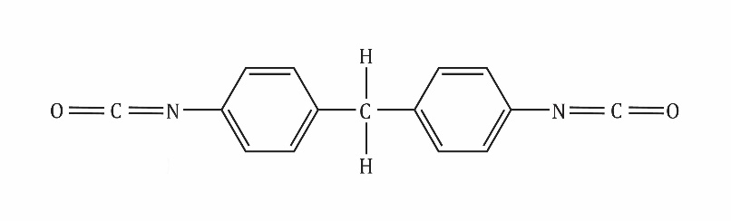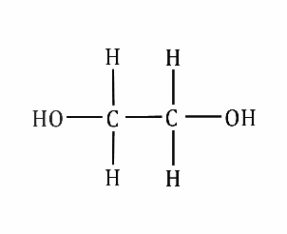

4,4’-diphenylmethane diisocyanate ethane-1,2-diol
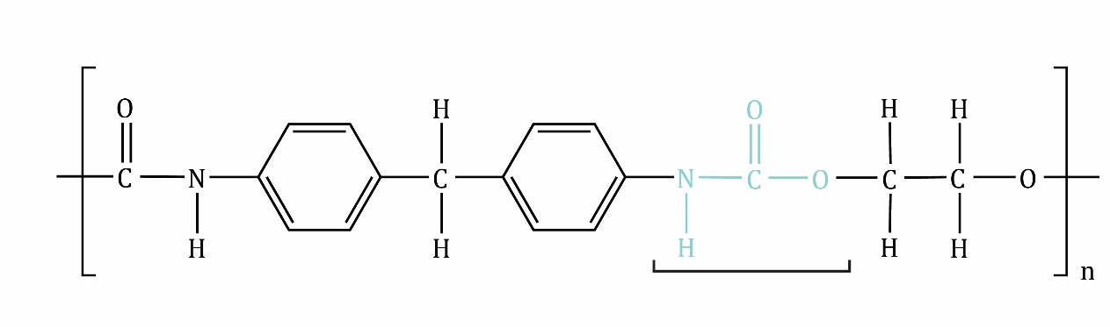
carbamate (urethane) linkage
- The alcohol group on the diol acts as a nucleophile in this reaction. State the meaning of the term nucleophile.

(1 mark)
- The diagram below shows part of the monomers. Copy the monomers and complete the first step of the mechanism by adding:
- any lone pairs of electrons involved in the first step,
- two curly arrows.
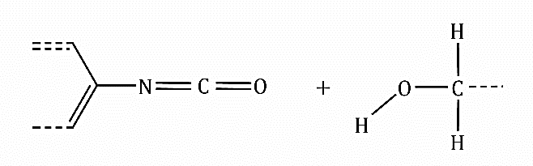

(3 marks)
- Polyurethane is not easy to recycle due to its high melting point. This is partly due to the strength of the intermolecular forces between the polymer chains.
- Use the structure of polyurethane given in question 3 to identify the type of intermolecular force that occurs between:
- the carbamate linkages in different polymer chains,
- the benzene rings in different polymer chains.

(2 marks)

- The diagram below shows a section of polyurethane chain. Draw this section and a second parallel section of polyurethane chain. Add the intermolecular force that connects the carbamate linkages in the different chains.
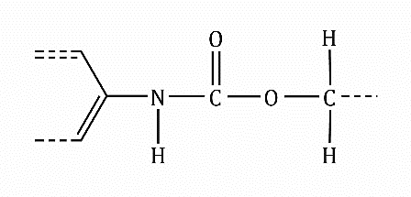

(1 mark)
- Polyurethane is not readily biodegradable. One area of current research is to improve this by adding polyester chains into the polymer structure.
- Draw the repeat unit of the polyester chain formed by reaction of ethane-1,2-diol (shown in question 3) and butanedioic acid (shown below).
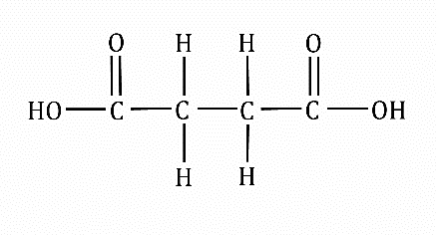

(2 marks)
- Suggest why polyester chains such as this are more biodegradable than polymers such as polystyrene.

(1 mark)
- Until new biodegradable polymers are developed, the main method of disposal of polymers used in the building industry is incineration.
Outline the advantages and disadvantages of incineration as a method of disposal of polymers.

(3 marks)

Total: 20 marks
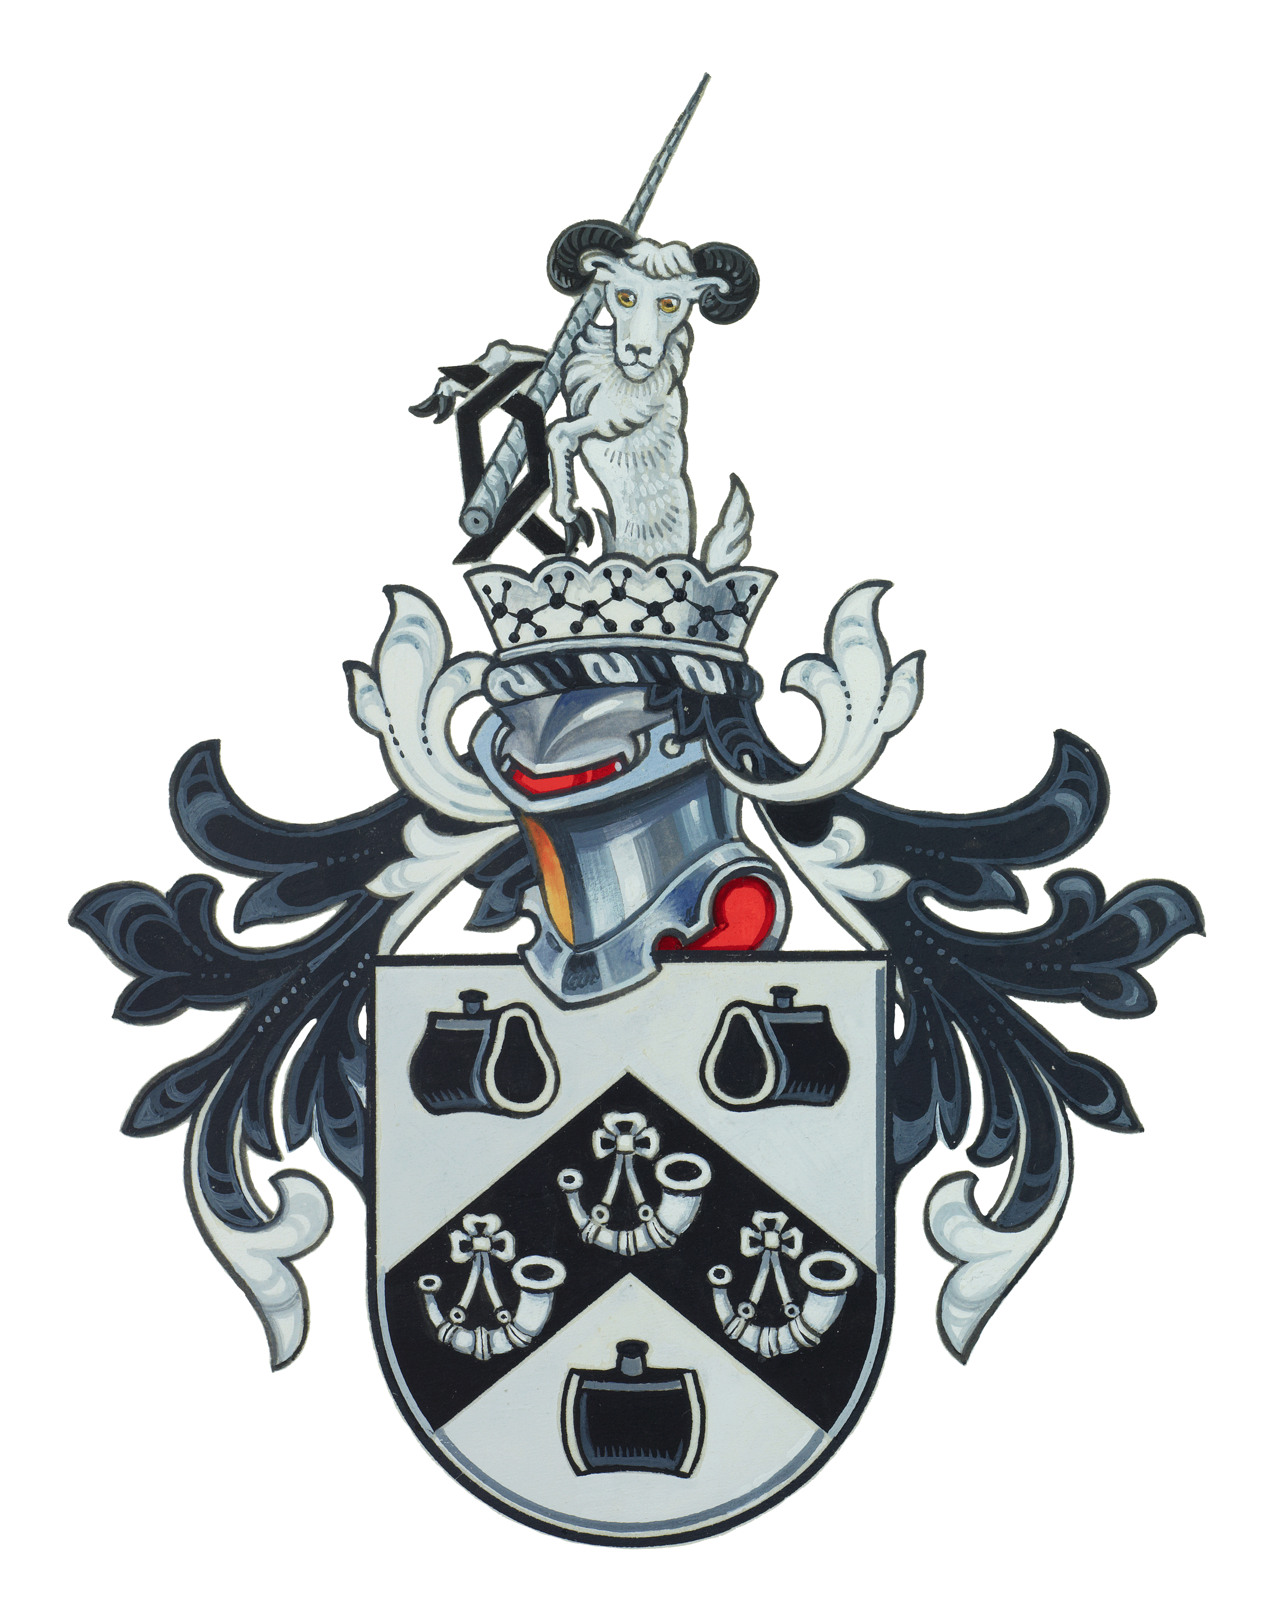

Source: © Horners’ Charity Fund

