From tap to toilet
Education in Chemistry
May 2019
rsc.li/2G1LCCy
Have you ever wondered what happens when you flush the toilet? Read through the article, What happens when I flush the loo? and find out how the contents of the flush is treated and how this treatment is different in the UK and in Singapore.
1. Mark the UK and Singapore on the map of the world below.
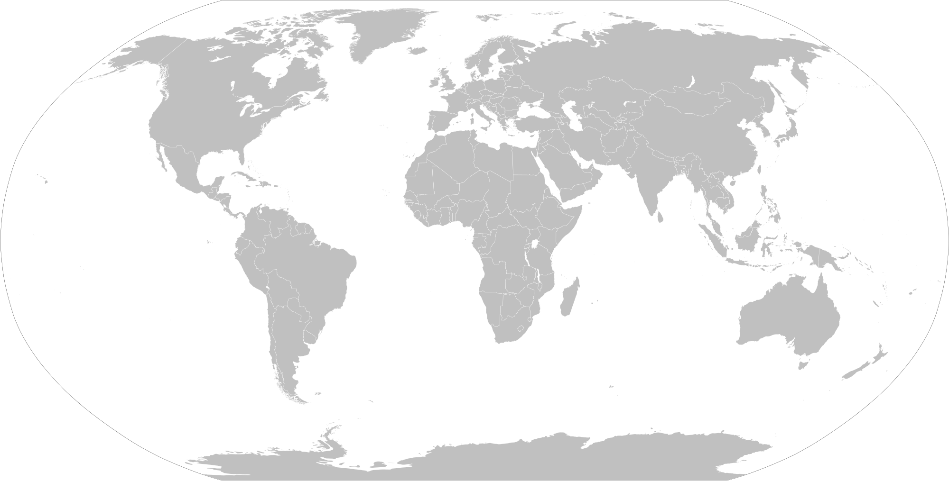
2. The article describes how waste water treatment can be split into four different stages:
- Preliminary screening.
- Primary treatment.
- Secondary treatment.
- Tertiary treatment.
Each of the statements below applies to one or more of these stages. Match each statement to the stage to which it applies.
Uses ultra-fine filters. | Solid particles settle out of the liquid portion by gravity. | Fishes out large pieces of waste. | Reduces the organic components in the water.
Lowers the BOD (biological oxygen demand). | Requires additional chemical treatments. | Microbes break down all the unsavoury stuff. | Forms a sludge that can be used to fertilise fields.
3. Which of these stages is currently used in the Singaporean system but not in the UK system?
4. Would you be happy to drink water that has been recycled from the contents of a toilet flush?
Justify your opinion.

Answers

1.

Singapore
United Kingdom (England, Northern Ireland, Scotland and Wales)
2. Preliminary screening
- Fishes out large pieces of waste.
Primary treatment
- Solid particles settle out of the liquid portion by gravity.
- Forms a sludge that can be used to fertilise fields.
- Reduces the organic components in the water.
- Lowers the BOD (biological oxygen demand).
Secondary treatment
- Microbes break down all the unsavoury stuff.
- Lowers the BOD (biological oxygen demand).
Tertiary treatment
- Uses ultra-fine filters.
- Requires additional chemical treatments.

3. The tertiary treatment phase is currently used in the Singaporean system but not in the UK system. Similar approaches have also been adopted in Australia and parts of the US.

4. Student personal opinion with suitable justification.

