Phytomining

This resource accompanies the article The magic money tree? in Education in Chemistry which can be viewed at: https://rsc.li/3xDGktk

Learning objectives
- Use key words associated with phytomining.
- Sequence the processes involved in phytomining.
- State an advantage and disadvantage of phytomining.
- Describe how plants can be used to extract metals from low grade ores.

Summary of resources

Phytomining resource | Description | Learning objectives
Powerpoint presentation | A resource for the teacher to deliver the relevant information describing phytomining. | N/A
Cloze activity | Learners use key words to complete sentences to describe phytomining. This activity is available as both a printable worksheet and an interactive worksheet. | Learners will meet learning objective 1 and partially meet learning objectives 3 and 4.
Sequencing activity | Learners rearrange the sentences to describe the process of phytomining. There are two levels of differentiation available. | Learners will meet learning objective 2 and partially meet learning objectives 3 and 4.
Storyboard activity | Learners create a storyboard using images and text to describe the process of phytomining. Teachers can provide different combinations of the worksheet and support sheet to offer a range of differentiation options. | Learners will meet, or partially meet depending on the differentiation option provided, all of the learning objectives.

Answers

Phytomining cloze

Large scale extraction of minerals (metal compounds) from the earth to make metals using traditional mining techniques is only cost effective when there are high concentrations of the mineral in the ground. We call such a mineral, a high grade ore.

When there are only small amounts of mineral in the ground, called a low grade ore, then a process called phytomining, involving growing plants, is economic to use.

Plants called hyperaccumulators are grown in soil containing the low grade ore minerals. They absorb the minerals via their roots and what they don't use is stored and concentrated in their leaves. When the plants are big enough, they are burnt in air and the impure metal compound is found in the ash.

Chemical processes such as displacement* and electrolysis* are used to then purify the metal from the ash.

*Displacement and electrolysis could be used in either order.

Phytomining sequencing activity

5. Soil containing low grade ore, with a low concentration of minerals (useful metal compounds) can NOT be extracted using traditional mining.

2. Hyperaccumulator plants are grown in the contaminated soil.

6. The plants absorb the mineral through their roots.

3. The plants use the mineral to grow and store any excess in their leaves.

7. When the plants are big enough, they are harvested and burnt in air to give an ash containing impure metal.

1. Chemical processes such as displacement or electrolysis are used to purify the metal.

8. One advantage of phytomining is that you can extract the metal from low-grade ores and it is cost effective to do so.*

4. One disadvantage of phytomining is that it is a much slower process to extract a metal.*

*The advantage and disadvantage could be given at any point in the sequence so long as the six process sentences are in the correct order.

Phytomining storyboard
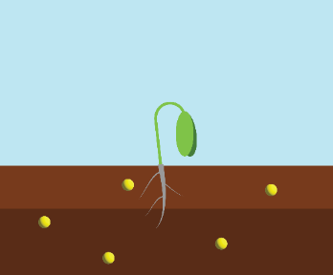 | 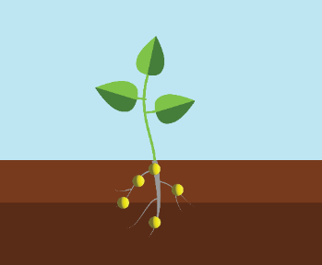 | 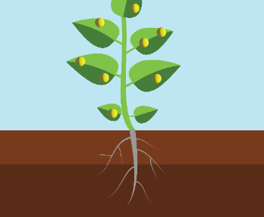 | 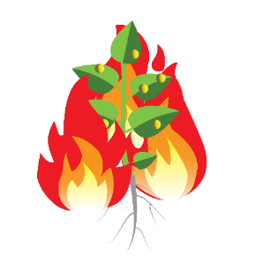
Plants called hyperaccumulators are grown in contaminated soil, where small amounts of minerals (low grade ores) are found. | Plants absorb the minerals (low grade ore) via their roots. The minerals are not toxic to the plant. | The plants use the minerals to grow (for example in enzymes) and what they don't use is stored and concentrated in their leaves. | When the plants are big enough, they are burnt in air to form ash.
 | 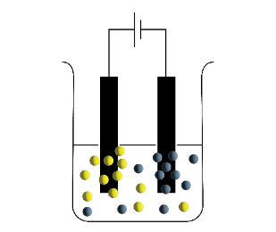
The impure metal compound is found in the ash. | Chemical processes such as electrolysis and displacement are used to then purify the metal from the ash. | One advantage of phytomining compared to traditional mining is; this can extract valuable metals from low grade ores when it is not usually economic to do so. | One disadvantage of phytomining compared to traditional mining is: it is a slower process as you need to wait for the plants to grow.

