- This question is about molecules in the table.
Complete the table.
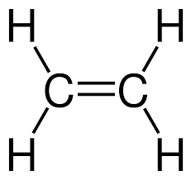

Tick if a polymer
Name of substance
Unsaturated or saturated
Observation when orange bromine water added

- This question is about the molecule below.

- Name the molecule.

- Draw a section of the polymer in which two repeating units are shown bonded together.

- What is the name of the polymer in part b)

- Describe what happens to the carbon double bond in the molecule in part a) when it makes a polymer.

- What type of polymerisation occurs to make the polymer in part b)?

- The equations below show monomers forming polymers.
Complete each equation by drawing the structure of the monomer or polymer in the box.

b)

c)

d)

- Polymers are very useful, but there are problems associated with their use.
Briefly describe why each of the following is a problem.
- The resources needed to make them.

- Disposal in landfill sites.

- Disposal by combustion.

