- Crude oil is a complex mixture of compounds called hydrocarbons.
Hydrocarbon molecules may be either straight chain or ring structures.

Carbon atoms have 4 covalent bonds.
Hydrogen atoms have 1 covalent bond.
- Draw structures showing all bonds for the following hydrocarbons.
Methane, CH₄ | Propane, C₃H₈
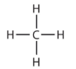 | 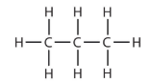
Pentane, C₅H₁₂ | Butane, C₄H₁₀
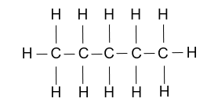 | 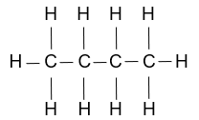

- Give the molecular formula and structure of the missing molecule in part a).
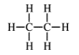
Answer: Missing formula is C₂H₆.

- Place the four molecules in part a) in order of boiling point, lowest first.
Answer: Methane, propane, butane, pentane.

All of the hydrocarbons shown in part a) belong to a homologous series.
These hydrocarbons are also saturated.
- What is the name of the homologous series?
Answer: The alkanes.
- What is the meaning of the term ‘saturated’?
Answer: Hydrocarbons containing carbon single bonds only.
- What is the general formula of the alkanes?
Answer: C_{n}H_{2n+2.}

- Use the names, formulae or structures to work out which of the molecules are hydrocarbons and which are alkanes.
Place a tick or cross in the box.

 | Hydrocarbon | Alkane
H₂O | Answer: x | Answer: x
C₅H₁₂ | Answer: | Answer:
C₄H₈ | Answer: | Answer: x
C₂H₅OH | Answer: x | Answer: x
Pentane | Answer: | Answer:
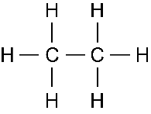 | Answer: | Answer:
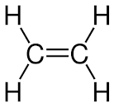 | Answer: | Answer: x
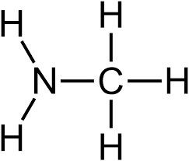 | Answer: x | Answer: x

- This is a hydrocarbon puzzle.
Write down the molecular formula of the alkane using the following clues.
- It contains 5 carbon atoms.
Answer: C₅H_{12.}
- It contains 18 hydrogen atoms.
Answer: C₈H_{18.}

- It contains 6 carbon-carbon single bonds per molecule.
Answer: C₇H_{16.}
- It has the highest boiling point of the first 10 alkanes.
Answer: C₁₀H_{22.}
- A molecule known as centane.
Answer: C₁₀₀H_{202.}

