Spacing grid example
Education in Chemistry
September 2019
rsc.li/2NqeJTm
Use a spacing grid like this to give pupils retrieval cues.
Draw the bonding in sodium chloride (NaCl) and water (H₂O).
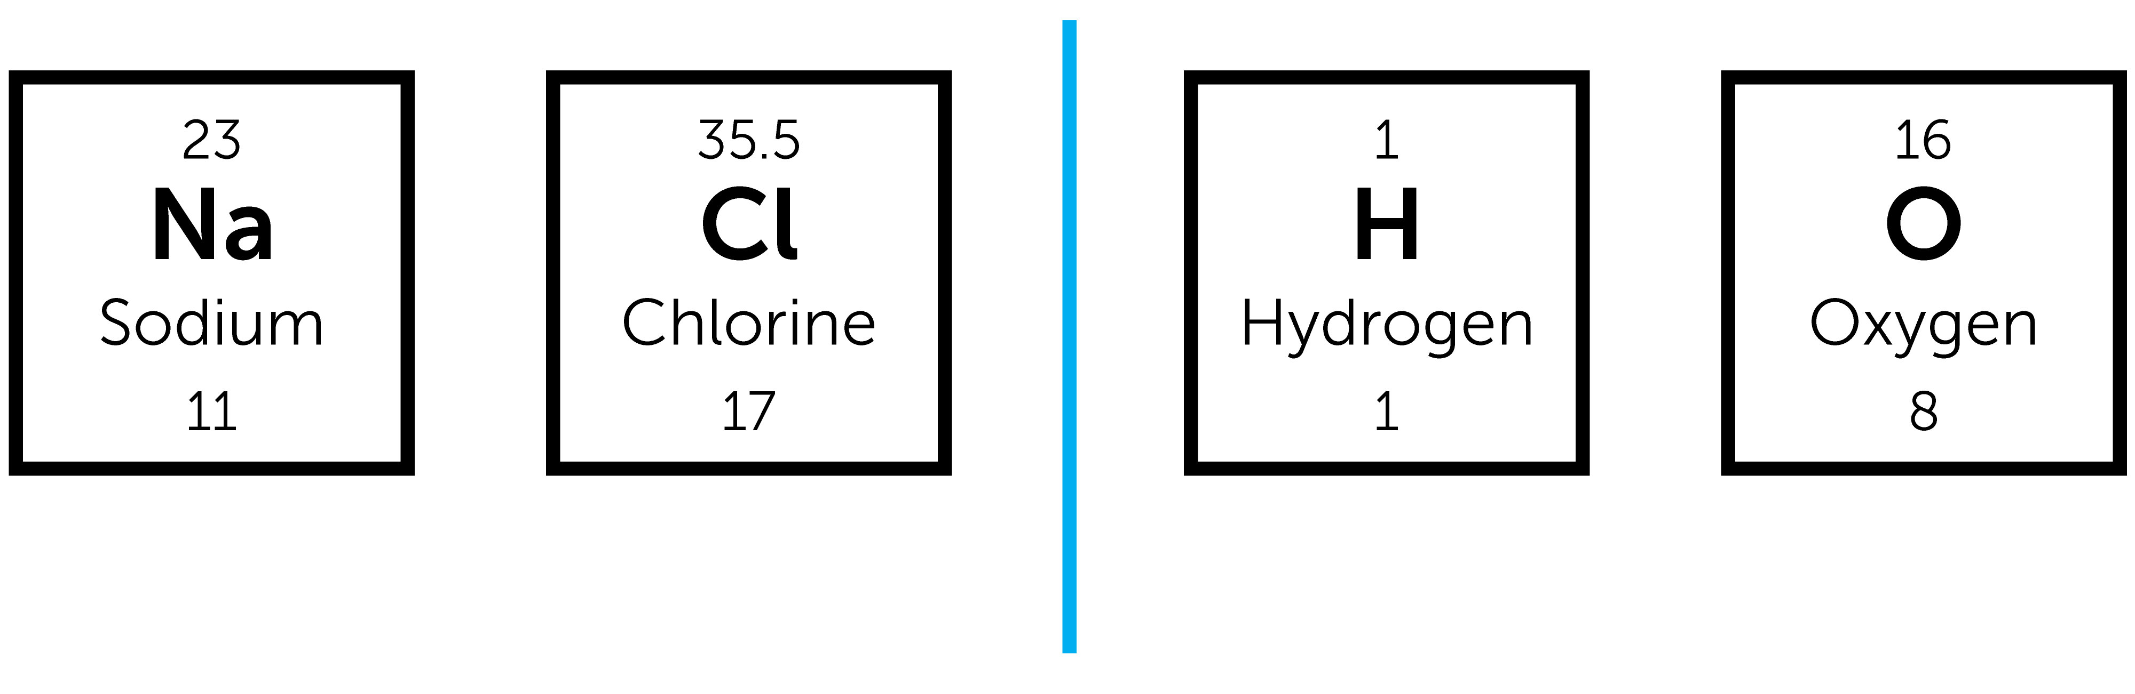

Explain how sodium chloride has a high melting and boiling point, but water has a low melting and boiling point.

What other properties do ionic compounds have?

Using this model of closely packed positive metal ions and a sea of delocalised electrons, explain why metals:
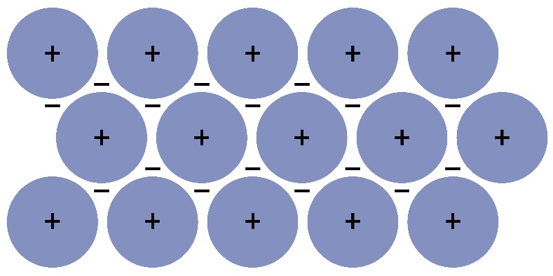
- Have high melting and boiling points:

- Are good conductors of heat and electricity:

- Are malleable and ductile:

Allotropes of carbon – name each one. What can you remember?
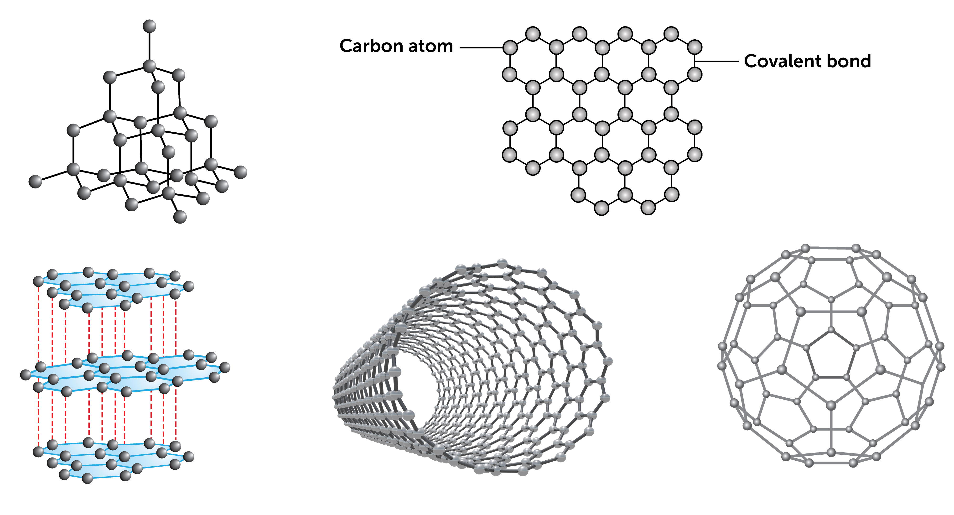

How are the above allotropes (other than diamond) able to conduct electricity?

