Producing ‘gold’ coins on a microscale

This resource is part of a collection of ideas and activities for chemistry lessons in the festive season. Find more at: rsc.li/3h40uXc.

A student sheet with questions, teacher notes including answers, plus integrated instructions are available at rsc.li/3TZmRLN.

Equipment (per group)
- 6 V DC source or 9 V battery
- 2 electrical leads
- 2 crocodile clips
- 2 steel paper clips
- Petri dish
- Measuring cylinder, 10 cm³
- Measuring cylinder, 25 cm³
- Beaker, 50 cm³
- Bunsen burner
- Heat proof mat
- Tongs
- Wash bottle or dropping pipette
- Cloth
- Copper coin (copper foil can be used if you do not have access to copper coins)
- Zinc foil
- Sodium hydroxide, 0.4 mol dm⁻³
- Zinc sulfate(VI), 0.1 mol dm⁻³

Safety equipment: safety spectacles

Preparation

Prior to the start of the lesson, clean the copper coins or strips of copper foil. Using plastic forceps, immerse the copper coins or foil in a beaker of warm 0.5 mol dm⁻³ nitric acid for a few seconds. Rinse the copper coin/strip with water and dry with a cloth.

Equipment set-up

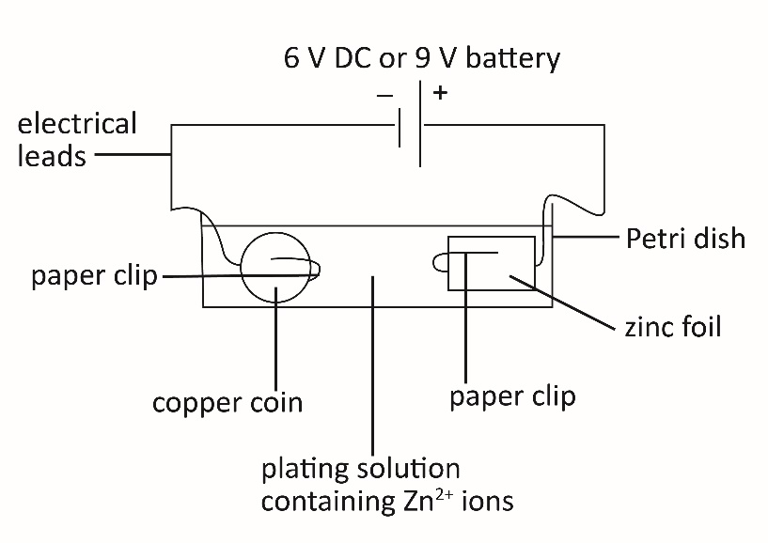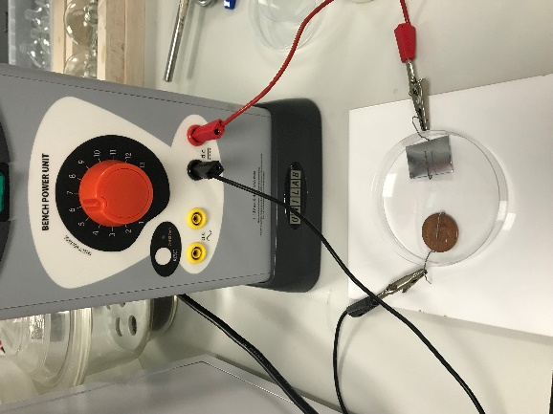

Safety
Read our standard health and safety guidance and carry out a risk assessment before running any live practical.
Refer to SSERC/CLEAPSS Hazcards and recipe sheets.
Hazard classification may vary depending on supplier.
Chemical supplied for the practical | Preparation
Nitric(V) acid, 0.5 mol dm⁻³  HNO₃(aq)  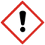  WARNING  Irritant (skin, eyes)  May produce toxic fumes | Nitric(V) acid, concentrated  HNO₃(l)  MW = 63.01 g mol⁻¹  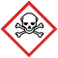  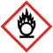  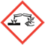  DANGER  May intensify fire; oxidiser  Causes severe skin burns and eye damage Toxic if inhaled  Corrosive to the respiratory tract
Sodium hydroxide solution, 0.40 mol dm⁻³  NaOH(aq)  WARNING  Irritant (skin, eyes) | Sodium hydroxide solid  NaOH(s)  MW = 40.00 g mol⁻¹  DANGER  Causes severe skin burns and eye damage

Zinc sulfate(VI), 0.10 mol dm⁻³  ZnSO₄ (aq)  WARNING  Irritant (eyes) | Zinc sulfate(VI) heptahydrate solid  ZnSO₄.7H₂O (s)  MW = 287.54 g mol⁻¹  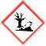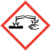  DANGER  Harmful if swallowed  Causes serious eye damage  Very toxic to aquatic life with long lasting effects
Sulfuric(VI) acid, 1.0 mol dm⁻³  H₂SO₄(aq)  WARNING  Irritant (skin, eyes) | Sulfuric(VI) acid, concentrated  H₂SO₄ (l)  MW = 98.07 g mol⁻¹  DANGER  Cause severe skin burns and eye damage
Copper coin
Cu(s)
Currently not classified as hazardous
Zinc foil
Zn(s)
Currently not classified as hazardous

Hazards
- Wear safety glasses.
- Beware of sharp edges when manipulating the zinc foil.
- Take care to avoid skin contact with the electrolyte solutions.
- Work in a dry area. Make sure that the power supply is switched off when the equipment is put together and that it is switched off again when dismantling.
- Hot coins could cause burns. Allow to cool before handling.

Disposal
- Dilute the plating solution in a bucket of water and pour down a foul water drain.
- Dilute the sulfuric acid solution down to 0.1 mol dm⁻³ and pour down a foul water drain.
- Dilute the nitric acid solution down to 0.1 mol dm⁻³ and pour down a foul water drain.

