What’s in a meteorite? Answers
Education in Chemistry
September 2021
https://rsc.li/3fLsefJ
Meteorites give us clues about the elements present on other planets. This worksheet explores some data on the compounds found in meteorites.
The data shown in the table give the % concentration of different compounds in the Dhofar 007 meteorite, a 21 kg meteorite that fell in Oman in 1999. For easier reference, each compound has been given a letter from A–M. Other trace elements were also present and these make up the remaining %.
 | A | B | C | D | E | F | G | H | I | J | K | L | M
Compound | SiO₂ | TiO₂ | Al₂O₃ | Cr₂O₃ | FeO | MnO | MgO | CaO | Na₂O | K₂O | P₂O₅ | H₂O | FeS
% concentration | 46.70 | 0.31 | 11.70 | 0.37 | 14.80 | 0.48 | 10.20 | 10.50 | 0.53 | 0.01 | 0.06 | 0.21 | 3.94

- Circle the letters of the compounds which are made up of only non-metal elements.

ADK AKL DKL DHK
J
- Give the letter of the compound which is present in the smallest percentage concentration.
M
- Give the letter of the compound which is not an oxide.

- Give the letters of the six most abundant compounds in the meteorite. (Answers can be in any order).
A C E G H M
______ ______ ______ ______ `______ ______

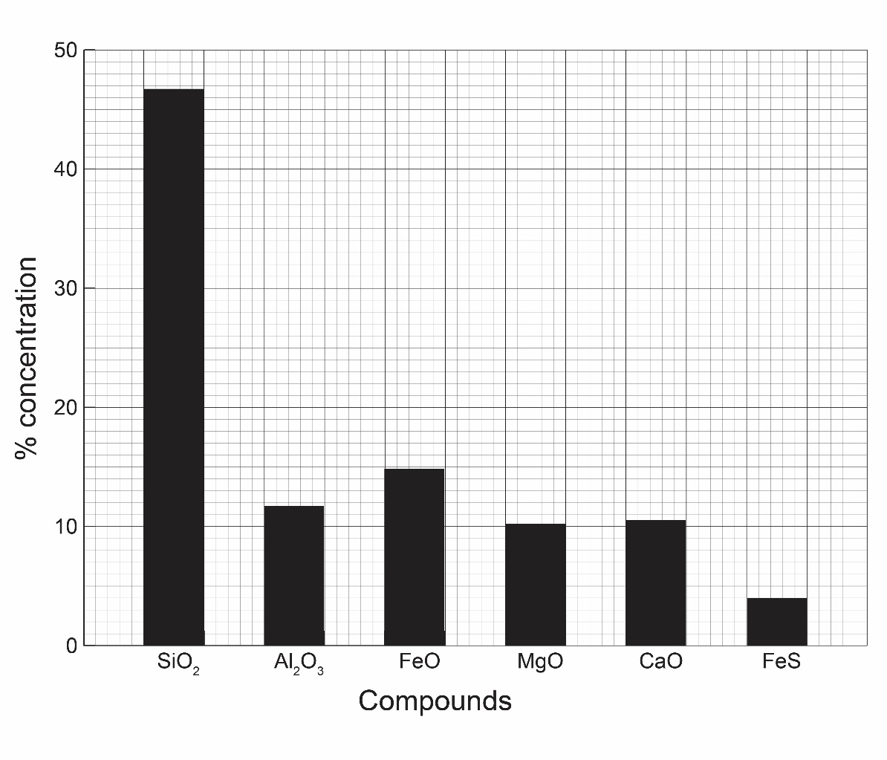
- Complete the bar chart to show the % concentration of the six most abundant compounds.

Look for:

correct labelling of axes,

accurate plotting of the bars,

same width of bars,

consistent labelling of the X axis (eg formula or letter, not both),

bars can be in any order.

- Explain why a bar chart is the best type of graph to show the % concentration of the six most abundant compounds.
The data to be plotted on the x-axis is categoric or discontinous data (letter of compound, or compound formula) not continuous data.

- What is the most abundant element in the meteorite? Oxygen
Explain your answer. Oxygen is present in nearly every compound in the meteorite.
Trace elements are elements that are present in tiny amounts. The most abundant trace element in the meteorite is nickel which has a quoted measurement of 870 ppm. The unit ppm means ‘parts per million’ so there are 870 particles of nickel in every million particles.
- Convert the ppm measurement for nickel to % and suggest why ppm is a useful way of showing the data for trace elements.
Conversion:
$$\frac{870}{1,000,000}×100=0.087$$
Reason: In ppm the numbers are all above 1, not small decimals. This makes them easier to compare.

