- Crude oil is a complex mixture of compounds called hydrocarbons.
Hydrocarbon molecules may be either straight chain or ring structures.

Carbon atoms have 4 covalent bonds.
Hydrogen atoms have 1 covalent bond.
- Draw structures showing all bonds for the following hydrocarbons.
Methane, CH₄ | Propane, C₃H₈
Pentane, C₅H₁₂ | Butane, C₄H₁₀

- Give the molecular formula and structure of the missing molecule in part a).

- Place the four molecules in part a) in order of boiling point, lowest first.

All of the hydrocarbons shown in part a) belong to a homologous series.
These hydrocarbons are also saturated.
- What is the name of the homologous series?

- What is the meaning of the term ‘saturated’?

- What is the general formula of the alkanes?

- Use the names, formulae or structures to work out which of the molecules are hydrocarbons and which are alkanes.
Place a tick or cross in the box.

 | Hydrocarbon | Alkane
H₂O
C₅H₁₂
C₄H₈
C₂H₅OH
Pentane
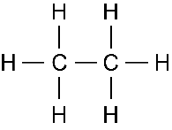
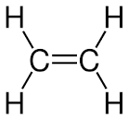

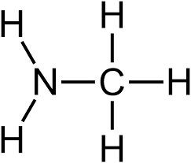

- This is a hydrocarbon puzzle.
Write down the molecular formula of the alkane using the following clues.
- It contains 5 carbon atoms.

- It contains 18 hydrogen atoms.

- It contains 6 carbon-carbon single bonds per molecule.

- It has the highest boiling point of the first 10 alkanes.

- A molecule known as centane.

