Producing ‘gold’ coins on a microscale

Learning objectives
- Understand that electroplating is an important industrial application of electrolysis.
- Electroplate a coin.
- Describe how to electroplate a metal.
- Explain what happens at each electrode during electroplating.

Introduction

Electroplating is the process of covering a metal object with a thin layer of another metal. The technique is often used to make cheap jewellery look expensive! For example, a ring made from a cheap metal like copper can be electroplated with either gold or silver. The result looks like a gold or silver ring without the high cost. Electroplating is also used to protect metals from corrosion. For example, the inside of a steel food can is electroplated with less reactive metal such as tin. The layer of tin provides a physical barrier protecting the steel from oxygen and water.

In this practical activity you are going to produce a ‘gold’ coin. First you will electroplate a copper coin with zinc. Then, by heating the plated coin in a flame, you will produce a brass layer giving it a ‘gold’ effect.

Method

Safety and hazards
- Wear safety glasses.
- Beware of sharp edges when manipulating the zinc foil.
- Take care not to get the electrolyte solutions on your skin.
- Work in a dry area. Make sure the power supply is switched off when you are putting the equipment together and that you switch it off again when you are dismantling the equipment.
- Hot coins can cause burns. Allow them to cool before you handle them.

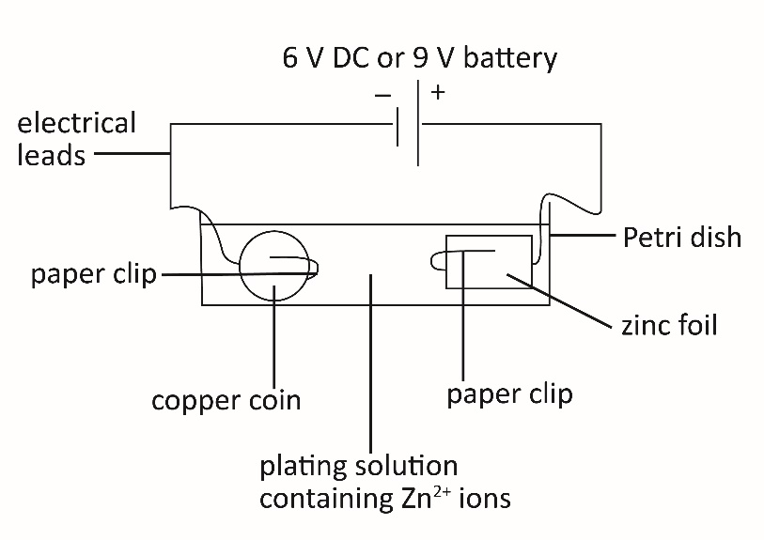

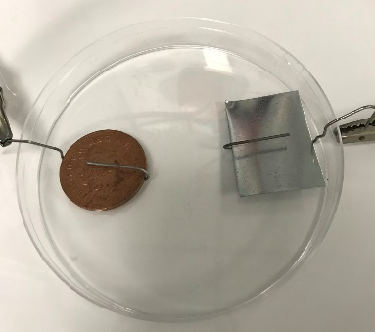
Set up the electroplating bath using a Petri dish and paper clips
- Straighten out the long ‘legs’ of the paper clips and place the coin and the zinc foil in the paper clip holders.
- Place both electrodes into the Petri dish.
- Attach the ‘long leg’ of the paper clip to a crocodile clip.

Make up the plating solution, which is an electrolyte containing Zn²⁺ ions
- Measure 12 cm³ sodium hydroxide (NaOH) and 2 cm³ zinc sulfate (ZnSO₄) solutions using two different measuring cylinders.
- Add the sodium hydroxide and zinc sulfate solutions to a beaker.
- When all the white precipitate has dissolved pour the solution into the Petri dish.

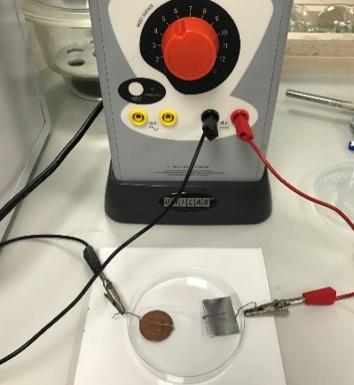
Do the electroplating
- Using an electrical lead, connect the paper clip attached to the zinc to the positive connection of a 6 V DC power supply (or 9 V battery).
- Using an electrical lead, connect the paper clip attached to the copper coin to the negative connection of a 6 V DC power supply (or 9 V battery).
- When the coin looks ‘silver’, turn off the power and disconnect the wire from the paper clip holding the coin.
- Remove the coin with paper clip from the petri dish using tongs.
- Rinse the coin with water, then remove the paper clip holder.
- Dry the coin and polish it with a cloth.

Heat the coin
- Using tongs, gently pass the coin through a blue Bunsen burner flame until the coin looks golden.
- Place the coin on a heat proof mat and allow it to cool before handling.

Questions
- Electroplating is an important industrial process. Give two uses of electroplating.

___________________________________________________________________________

___________________________________________________________________________

- Give two reasons why objects are electroplated.

___________________________________________________________________________

___________________________________________________________________________

- Describe what you saw at the negative electrode.

______________________________________________________________________________

- Explain why the object to become electroplated has to be the negative electrode. (You should refer to metal ions in your answer.)

______________________________________________________________________________

______________________________________________________________________________

______________________________________________________________________________

- This question is about the electrolyte.
- What type of substance can be an electrolyte?

______________________________________________________________________________

- Explain why an electrolyte conducts electricity.

______________________________________________________________________________

- In this experiment, a layer of zinc metal forms on the copper coin. Explain how the zinc metal forms from the zinc ions in the electrolyte?

______________________________________________________________________________

______________________________________________________________________________

______________________________________________________________________________

- Complete the equation for the reaction at the negative electrode.

${Zn}^{2+}$( ) $+$ $e^{-} →Zn(s)$

- During the electrolysis, zinc ions are removed from the solution. Having a positive electrode made from zinc foil keeps the concentration of zinc ions in the electrolyte constant. Explain how. Write a half-equation for the reaction at the positive electrode.

______________________________________________________________________________

______________________________________________________________________________

______________________________________________________________________________

- Suggest a reason why the ‘silver’ coin turned ‘gold’ when it was carefully passed through a Bunsen flame.

______________________________________________________________________________

- Select the correct statements for the conditions required to silver plate a metal fork. Give a reason for your answer.

Option | Negative electrode | Positive electrode |  | Electrolyte
A | Silver | Metal fork |  | Silver nitrate solution
B | Zinc | Metal fork |  | Copper sulfate crystals
C | Metal fork | Silver |  | Silver nitrate solution
D | Metal fork | Silver | Solid silver nitrate

_____________ is correct, because ______________________________________________

_______________________________________________________________________________

Long-answer question
- A student wants to electroplate a screw with nickel metal. Describe and explain the process of electroplating a screw with nickel. Include half-equations for the reaction at each electrode.

Use the prompts in the table below to help structure your answer.
Electroplating an iron screw
Define electroplating.
State the meaning of electrolyte and name the ion that must be present for nickel plating.
What is the negative electrode made from?

What will you observe at the negative electrode? Write an equation.
Explain why the positive electrode is made from nickel foil.
Write an equation for the reaction at the positive electrode.

