Go with the flow
These notes accompany the video demonstration Go with the flow from Education in Chemistry which can be viewed at: https://rsc.li/4bC9wm9

The random motion of particles explains many spontaneous phenomena. Although diffusive processes in gases can be seen fairly quickly, similar demonstrations in liquids can be frustratingly slow. A carefully placed crystal of potassium permanganate (KMnO₄) will take most of a lesson to dissolve and spread across the base of a beaker.

In this variation of the Traube cell reaction, a bubble of blue liquid is seen to first float and then sink as water diffuses out into the surrounding yellow liquid, which demonstrates in seconds the diffusion of water molecules. You can explore diffusion and density with 11–14 learners using this demonstration. You can also use this demonstration with 16–18 learners to develop their understanding of transition metal chemistry and hone their standard solution preparations.

Level

This demonstration is ideally suited to lessons on the particle model and diffusion for learners aged 11–14. It could also complement teaching transition metal chemistry to post-16 learners.

Equipment (per group)
- 10 cm³ of a 0.4265 M copper(II) sulfate (CuSO₄) solution
- 40 cm³ of a 0.2808 M potassium hexacyanoferrate(II) (K4Fe(CN)₆) solution
- Boiling tube or large test tube (20 × 150 mm)
- Clamp and stand, or 250 cm³ cell culture flask
- Dropping pipette (see tips)

Preparation

The copper(II) sulfate and potassium hexacyanoferrate(II) solutions, when made up as detailed in the kit list, should result in the densities of two solutions being around 0.2% apart, so it’s essential to be careful with the preparation of the solutions. Stock should be produced accurately in at least a 100 cm³ volumetric flask, which can then be used for multiple demonstrations.

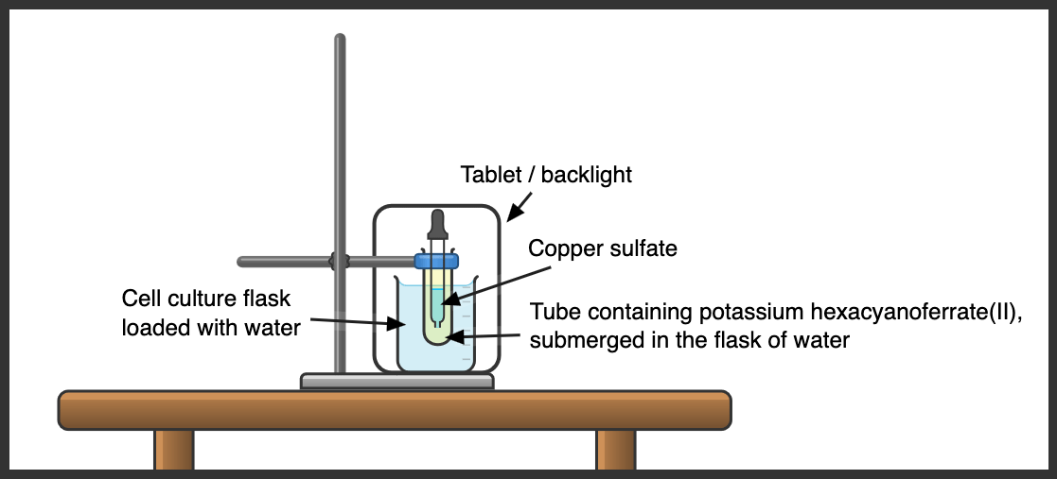Record the mass of a 100 cm³ volumetric flask before carefully weighing out 10.65 g of copper(II) sulfate pentahydrate (CuSO₄.5H₂O) and transferring it into the volumetric flask. Add 50–75 cm³ of deionised water to the flask and swirl to fully dissolve the copper(II) sulfate. Then slowly add deionised water to the flask up to the line, mix thoroughly and record the final mass. Repeat the process in another weighed 100 cm³ volumetric flask with 11.86 g of potassium hexacyanoferrate(II) (K₄[Fe(CN)₆].3H₂O). Be aware, potassium hexacyanoferrate(II) is yellow and must not be confused with the orange potassium hexacyanoferrate(III).

Clamp the boiling tube and pour in 40 cm³ of the yellow potassium hexacyanoferrate(II) solution leaving space at the top for displacement by the pipette. Decant roughly 10 cm³ of the blue copper(II) sulfate solution into a small beaker to avoid contaminating stock with the pipette.

Safety and disposal notes
- Wear eye protection.
- Avoid exposing potassium hexacyanoferrate(II) to any heat sources. CLEAPSS members should consult HC079 (bit.ly/49b46N8).
- Copper(II) sulfate is harmful if swallowed and can cause serious eye damage. Avoid contact with skin. CLEAPSS members should consult HC027c (bit.ly/3UKCcDh).
- For disposal, filter off precipitate and dilute solutions with plenty of water. Dispose of diluted solutions down a foul-water drain.

In front of the class

Fill the pipette with enough blue copper(II) sulfate solution to deliver a pea-sized droplet. Insert the dropper carefully, minimising disturbance to the yellow solution, until the tip is 1–2 cm above the base of the tube. Inject the droplet and remove the pipette quickly (this helps to initiate the upward motion if your solutions are too close in density). A red-brown membrane forms around the droplet and it will begin to rise. After a few moments at the surface, the droplet falls to the base of the tube where, over the next two minutes it will visibly shrink and the membrane will shrivel.

This process can be repeated until the density of the surrounding yellow solution matches that of the blue solution being introduced.

Teaching goal

After adding the copper(II) sulfate to the potassium hexacyanoferrate(II) solution, a colloidal solid membrane of copper hexacyanoferrate(II) will form around the droplet. The balanced equation for this reaction is:

2 Cu²⁺ (aq) + Fe(CN)₆^{4–} (aq) → Cu₂Fe(CN)₆ (s)

Densities can be calculated by dividing the mass of the liquids in the flasks by 100. The blue solution has a density close to 1.062 g cm^{–3} whereas the yellow solution should be close to 1.065 g cm^{–3}. This small difference in density causes the blue droplet to rise slowly.

Students should be aware of the process of diffusion – the movement of particles from areas of high to low concentration through random motion. If a membrane separates particles, this can prevent some substances from diffusing as readily. In this case, water diffuses into the yellow potassium hexacyanoferrate(II) solution, which, even though it has a lower concentration of solute, it has a higher concentration of water. This may seem counterintuitive to students, so remind them that you are interested in the concentration of the water in each solution. The water particles are lighter than hexaaquacopper(II) ions so, once the water has diffused out, the density inside the droplet increases and it sinks. You can calculate the concentration of the water in the solutions to show that the concentration of water is higher in the blue solution.

In this example, 6.81 g of copper sulfate and 10.34 g of potassium hexacyanoferrate(II) were dissolved, which means that the concentrations for the water are roughly 55.2 mol dm^{–3} and 53.4 mol dm^{–3} in the blue and yellow solutions, respectively. This explains why water would diffuse out of the droplet.

