Carbon dioxide gets stoned – teaching ideas
Education in Chemistry
May 2017
rsc.li/EiC317-carbon-capture
This article presents some familiar chemistry in the context of the development of new carbon capture technologies. Pupils will regularly encounter the global problem of carbon dioxide emissions and climate change through news and popular media. You can use this article to enhance your teaching of combustion of alkanes, greenhouse gases, conservation of mass, and the rock, carbon and limestone cycles.

Directed activity related to text (DART) (ages 11–16)
Exam questions requiring a longer written response (6–8 marks) often present familiar chemistry in an unfamiliar context and require students to read text and extract key information. Much of the chemistry in this article is familiar to 14–16-year-old students, though the idea of carbon capture won’t have been directly studied.
DART activities require pupils to engage with the text rather than just reading it passively. DARTs can be as simple as a set of questions related to a piece of text or a comprehension exercise. For older pupils, a focused task similar to the 6–8-mark examination questions is useful.
With activities like this, differentiation is important. Task 3a looks for advantages and disadvantages and is suitable for pupils who are beginning to develop this reading skill. Task 3b requires a higher level of analysis where pupils categorise phrases and summarise them.

Tasks
- Read the whole article and underline unfamiliar words.
- Once you have read the whole article once, reread the section headed ‘The technology’.
3a. Using different coloured pens, highlight phrases in the article that state the advantages and disadvantages of the CarbFix method of carbon capture.
3b. The issues surrounding scientific developments can be categorised into the ‘SEE’ framework covering social, environmental and economic impacts. Use the information in the article to summarise the impact of carbon capture into these categories.
Download a copy of the article as a pdf or MS Word document at rsc.li/EiC317-carbon-capture

Burning candle demonstration (ages 14–16)
Carbon capture technologies are attempting to address the problem of carbon dioxide emissions. To appreciate the context of this article, students need to grasp the chemistry behind climate change and fossil fuels. This demonstration burns a candle in room air producing carbon dioxide and water, which are then captured by the apparatus.
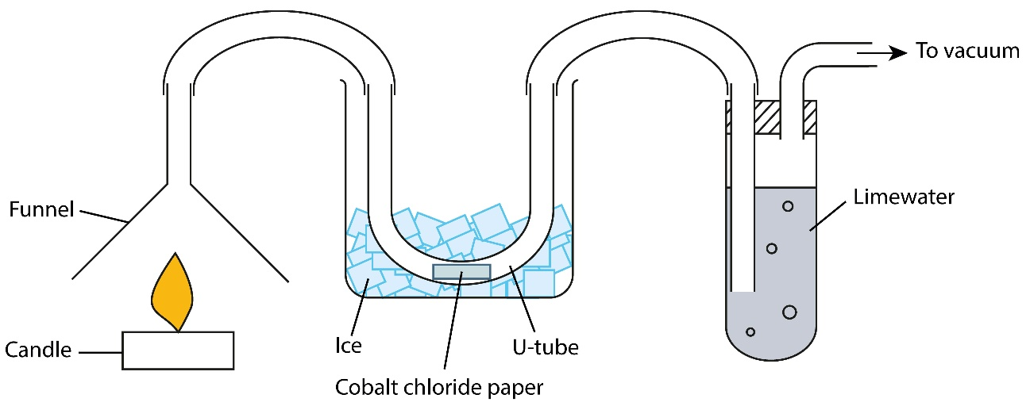
Setting up the demonstration including two balances nicely illustrates the ideas around conservation of mass. A balance under the candle will show a mass decrease. A balance under the limewater will show a mass increase not equal to the mass lost from the candle. The mass changes can be measured during the demonstration at suitable intervals and graphs plotted.
You can then ask the students to consider why the mass changes are not the same. They should notice that the hydrogen from the waxy hydrocarbon has formed water in the combustion process and this isn’t being captured by the limewater. Students will tend to overlook that the mass of oxygen added to the carbon and the hydrogen atoms in the hydrocarbon is difficult to quantify, and also that other products (from incomplete combustion) may be formed and not trapped by the limewater.
This demonstration brings together lots of chemistry and can be used to revisit concepts from earlier topics. Questions that could be explored in discussion or written work include:
- What is the purpose of the ice around the u-tube?
- What does a colour change in the cobalt chloride indicate?
- What would happen to the mass of the candle and the limewater?
- How do the products of combustion change when the amount of oxygen available is varied?
- How many carbon atoms are in ‘wax’? Is wax a pure substance?
Download instructions for this demonstration from Learn Chemistry: rsc.li/2oUJXZh

Class practical: porosity of rocks (ages 11–14)
The porosity of rocks experiment is often used in studying the rock cycle – this article provides some additional context to that chemistry. In the classic experiment, rocks are soaked in bowls of water to determine the porosity. Using this article, the experiment can be given a new purpose as only porous rocks will be suitable for carbon capture. The aim of this experiment is to rank the rocks in order of their suitability and see if any of the samples in your school rock box is better than the basalt discussed here.
The experiment opens up some nice opportunities to introduce calculations and get pupils to think about relative measurements. Younger pupils will often initially think that the highest mass absorbed means the most porous rock and fail to take the size of the sample into account. The concept of relative measurement is important as pupils progress in chemistry and this is a good place to start looking at it.

Practical details
Prior to the experiment it is useful to test the various rocks in your sample box so you can make sure you get a good range of results. Pupils weigh the rocks and then soak them in bowls of water for 10 minutes. This downtime is a good point to read the article together (either in full or cut down into a couple of shorter paragraphs) in preparation for the analysis of results. You can give a results table, or pupils can design their own.

Analysis and conclusion
Once all the mass measurements have been taken, the pupils then need to carry out the calculations and determine the ranking. In writing the conclusion they need to revisit the original question – which rock is best for carbon capture? It’s also worth getting them into the habit of justifying their conclusions by linking to the data and, ideally, directly quoting it. For example, ‘Sandstone is the best rock for carbon capture as it is the most porous. This is shown by our experiment where it absorbed XXg of water per gram of rock, which was higher than the other samples.’
Higher-achieving pupils can be challenged to think about the assumptions made when coming to this conclusion. In this case, we assume the divalent cations needed for the reaction are present in all the rocks.
Download a student handout, and teacher and technician notes for this experiment at rsc.li/EiC317-carbon-capture

Debate: what if crude oil wasn't running out? (ages 14–16)
This article raises an interesting philosophical debate: if we can capture carbon dioxide, does that mean we can continue to use and abuse our planet’s resources?
The ‘what if’ question stem is very useful for creating open questions that challenge students to really think about the issues presented. Pupils can often be intimidated by very open questions. For pupils who find this too challenging and whose thinking stalls, it can be worth presenting them with a framework to consider. The SEE framework (social, environmental, economic impact) is useful here.
This question can be presented as an essay title, a piece of group work or a class debate.
Download this article and all the teaching resources at rsc.li/EiC317-carbon-capture

Article by Nina Notman, a science writer based near Baltimore, US. Teaching resources by Kristy Turner, a school teacher fellow at University of Manchester and Bolton School, UK

