Spot the entropy errors

This resource accompanies the article How to teach entropy at post-16 in Education in Chemistry, which can be viewed at: rsc.li/3EWpQhZ. The article provides tips, common misconceptions and further ideas for teaching the topic.

Learning objectives
- Identify misconceptions in entropy question responses.
- Explain why changes in entropy occur.
- Understand why some reactions are not feasible under standard conditions.

All the answers relate directly to the first objective because learners are asked to identify the mistakes in the sample answers provided.

Correct answers to questions 1, 2, 3 and 4 will demonstrate an understanding of the second learning objective.

Your learners’ answers to question 5 will demonstrate an understanding of the third learning objective.

How to use this resource

Learners often find thermodynamics difficult to grasp because of the abstract nature of the properties, such as entropy and enthalpy. Use this resource to help your learners develop their metacognitive skills and improve their understanding of the topic.

Introduce the task by explaining that a group of learners have answered some questions. Unfortunately, they are not entirely correct. Your learners need to identify and explain the mistake(s) and provide the corrections. The questions and error-ridden learner answers are available in the student worksheet. They are also included in a PowerPoint presentation to support a teacher-led activity, for example a whole class discussion.

This resource can be used as a standalone homework activity towards the end of the topic too. Alternatively, individual questions can be used during a lesson as formative assessment or to reinforce learning. The activity could also be set as a small group task, which would allow your learners to articulate their ideas about entropy to their peers and support each other with calculations. The mistakes, explanations and correct answers are provided below and can be given to your class if peer or self-assessing.

Answers

- Mistakes and explanations:

The word molecule is incorrectly used. Only ionic compounds are present. They form giant crystal lattices in the solid state. Only covalently bonded compounds form molecules. The second reason is incomplete. The states of all products need to be included in the answer. The answer given would actually show a decrease in entropy as two moles of solid go to one mole of solid.

Correct answer:

${ΔS}_{system}$ is positive because the number of moles of products is greater than the number of moles of reactants. Three moles of solids go to one mole of solid, 10 moles of liquid and two moles of gas. Substances in the liquid and gas states have higher entropies than when in the solid state. Consequently, the system has become more disordered.

- Mistakes and explanations:

The unit of energy used in the calculation is incorrect, $kJ$ was used instead of $J$.

Incorrect sign for ${ΔS°}_{system}$.

${ΔS°}_{system}$ is calculated from $ΣS° \left(products\right)- ΣS° \left(reactants\right).$ In the learner answer, $ΣS° \left(reactants\right)- ΣS° \left(products\right)$was used incorrectly.

Correct answer:

$$ΣS° \left(products\right)=124+\left(10×70\right)+\left(2×192\right)$$
$$=\left(+\right)1208 J K^{-1}{mol}^{-1}$$
$$ΣS° \left(reactants\right)=427+(2×95)$$
$$=\left(+\right)617 J K^{-1}{mol}^{-1}$$
$${ΔS°}_{system}= 1208 –617$$
$$=(+)591 J K^{-1}{mol}^{-1}$$

- Mistakes and explanation:

In the final calculation the enthalpy change has not been converted from $kJ$ to $J$.

The unit of entropy change of the surroundings are incorrect – the learner has used the unit of enthalpy change.

Correct answer:
$${ΔS°}_{surroundings}=-\frac{162000}{298}$$
$$=\left(+\right)543.8 J K^{-1}{mol}^{-1}$$

- Mistake and explanation:

The learner has incorrectly stated that the entropy stays the same. They have mentioned the increase in volume but not taken into account how this affects the entropy.

Correct answer:

The molecules of bromine diffuse into the top of the gas jar. Increasing the volume increases the number of ways that the bromine molecules can distribute themselves in that volume. The more ways in which molecules distribute themselves, the higher the entropy. Therefore, the system has increased in entropy due to the greater randomness or disorder of the gaseous molecules.

- Mistakes and explanations:

The language is imprecise and vague. Insufficient detail is provided. More scientific terms are needed to explain why the sodium chloride ions become more random. State symbols are missing from the equation. These are needed to clearly show what reaction is taking place.

Correct answer:

In solid sodium chloride the ions are in a fixed position and so the entropy is low. Pure liquid water has some order due to the presence of hydrogen bonds. When the solid sodium chloride dissolves in water, the crystal breaks up and the ions are free to move between the water molecules. The whole system becomes highly disordered, therefore the entropy increases. The symbol equation is:

$$NaCl\left(s\right)→ {Na}^{+}\left(aq\right)+ {Cl}^{-}\left(aq\right)$$

- Mistakes and explanations:

The melting and boiling points marked on the learner’s x-axis are incorrect as the temperatures have not been converted from $°C$ to $K$. The lines showing entropy in both the liquid and gaseous states should not be horizontal because entropy (within each state) continues to increase as the temperature increases.

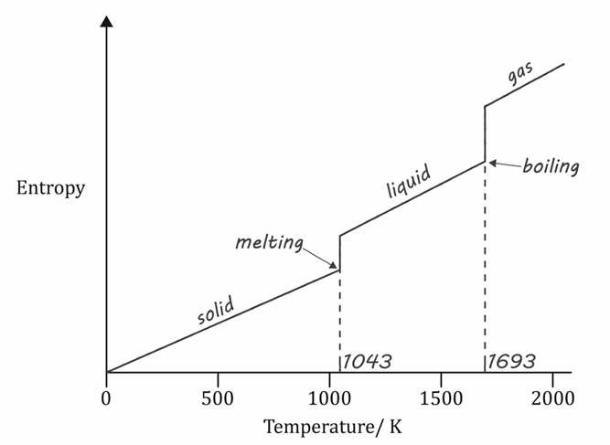
Correct answer:

- Mistakes and explanations:

The calculation for $ΔS°$ is incorrect. Only entropy change for the system needs to be calculated. The final answer is incorrect because the learner used the total entropy change and not the entropy change for the system in their calculation. The sign for $ΔG°$ is also incorrect (positive when the learner’s calculation produces a negative answer).

Correct answer:

$${ΔS°}_{system}=ΣS° \left(products\right)- ΣS° \left(reactants\right)$$

$$ΣS° \left(products\right)=44+214$$

$$=\left(+\right)258 J K^{-1}{mol}^{-1}$$

$$ΣS° \left(reactants\right)=\left(+\right)83 J K^{-1}{mol}^{-1}$$

$${ ΔS°}_{system}=258-83$$

$$=\left(+\right)175 J K^{-1}{mol}^{-1}$$

$$ΔG°= ΔH°-TΔS°$$
$$= 70,000-(298×175)$$
$$=\left(+\right)17,850$$
$$=\left(+\right)17.9 kJ {mol}^{-1}$$

- Mistake and explanation:

The answer is incorrect. Reactions are only feasible if $ΔG°$ is negative.

Correct answer:

No, the reaction is not feasible at 298 $K$ because $ΔG°$ is positive.

- Mistakes and explanation:

The unit is incorrect – it should be $K$. In the final line of their answer only a temperature is stated. You need to state what the temperature means.

Correct answer:

The reaction is feasible at temperatures greater than 400 $K$.

