Quantitative chemistry

The Mole

Moles and Mass

Work out the answers to the following simple calculations (1 t = 1 tonne = 1,000 kg);

- No. of moles in 10.0 g of O₂ + the mass in g of 2.41 moles of H₂O =
(2 marks)

- Mass in g of 0.2 moles of K₂CO₃ + mass in g of 0.5 moles of MgCO₃ =
(2 marks)

- No. of moles in 12.4 t of NaNO₃ ÷ no. of moles in 12.4 t of NaCl =
(2 marks)

- No. of moles in 25.9 g of sodium – no. of moles in 25.9 g of sodium chloride =
(2 marks)

- ? × molar mass of in g mol⁻¹ of calcium carbonate = no. of moles in 4.2 kg of SiCl₄
(2 marks)

Mass and concentration

Calculate the answers to the calculations below and place them (to the correct no. of sig. fig.) in the appropriate square. The arrows indicate the direction the numbers must follow. For the 10th mark complete the remainder of the Sudoku grid.
(1 mark for each answer)

WARNING Take care with your significant figures and RAMs in order to avoid the wrong digit in the wrong square! (Relative atomic masses, H 1.0; O 16.0; Na 23.0; S 32.1; Cl 35.5; Fe 55.8; Cu 63.5)

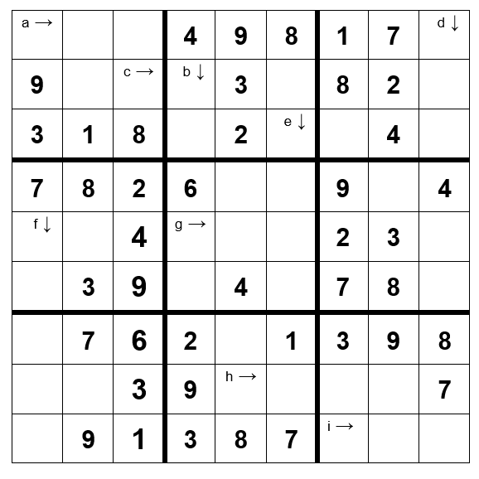
- The concentration of a solution of 265 moles of NaOH dissolved in 1 dm³ of water (3 sig. fig.)
- The volume of water in dm³ needed to dilute 176 moles of HCl to make a 1 mol dm⁻³ solution (3 sig. fig.)
- The mass of H₂SO₄ that should be dissolved in 1 dm³ of water to make a solution of concentration 0.72 mol dm⁻³ (2 sig. fig.)
- The volume of water in cm³ that must be added to 0.56 g of anhydrous CuSO₄ to produce a 0.1 mol dm⁻³ solution (2 sig. fig.)
- The number of moles of ammonia that must be dissolved in 2,696 dm³ of water to produce 2.0 mol dm⁻³ ammonia solution (4 sig. fig.)
- The concentration in mol dm⁻³ of an accurate solution of concentration 16.48537 mol cm⁻³ (5 sig. fig.)
- The mass of FeSO₄.7H₂O that must be dissolved in 1,582 cm³ of water to form a solution of concentration 2.0 mol dm⁻³ (to 3 sig. fig.)
- The volume in dm³ of water that 10 moles of NaCl must be dissolved in to produce a 0.0155 mol dm⁻³ solution of brine (3 sig. fig.)
- The concentration in mol dm⁻³ of a solution of NaOH with a concentration of 18,480 kg m⁻³ (3 sig. fig.)

Concentration and dilution

Place the answers to calculations 1 - 9 in order from left to right in the grid below to find which two solutions A - P react together.
(1 mark for each correct answer)
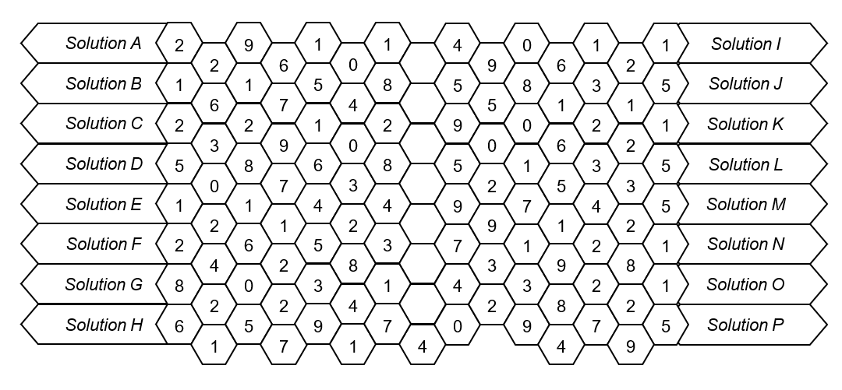
- How many moles of NaCl must be dissolved in 0.5 dm³ of water to make a 4 mol dm⁻³ solution.
- How many moles of NaOH must be dissolved in 25,000 cm³ of water in order to make a solution with a concentration of 0.8 mol dm⁻³?
- What volume of water in dm³ must 8 moles of NaHCO₃ be dissolved in to make a solution with a concentration of 0.25 mol dm⁻³?
- What volume of water in cm³ must 3 moles of KMnO₄ be dissolved in, in order to make a solution with a concentration of 4 mol dm⁻³?
- A technician found that 2000 cm³ of a 4 mol dm⁻³ solution of copper sulphate was needed for the reaction to go to completion. How many moles of copper sulphate reacted?
- A student needs to add 8.75 × 10⁻³ moles of NaOH to neutralise the acid in his sample. How many cm³ of a 0.35 mol dm⁻³ solution should he add?
- A chemist wants to dilute a stock solution of 10 mol dm⁻³ NaOH to make a solution with a concentration of 1 mol dm⁻³. What volume of water must be added to 100 cm³ of the 10 mol dm⁻³ solution?
- Lucy wants to make up a solution with a concentration of 2 mol dm⁻³. What volume of water in dm³ must she add to 500 cm³ of 6 mol dm⁻³ stock solution?
- Alex must add what volume of water in cm³ to 45 cm³ of a 9 mol dm⁻³ solution of H₂SO₄ to make a 1.5 mol dm⁻³ solution?

Which two solutions need to be mixed in order to get a reaction?

Moles summary

Mark the student’s answers to the questions below (shown to the right). Mark all 10 correctly to get the full 10 marks.

- Magnesium reacts with acid as shown; Mg + 2 HCl → MgCl₂ + H₂
(a) How many moles of Mg reacts with 1 mole of HCl 1 mole
(b) How many moles of Mg must be reacted to produce 1 mole of H₂ 1 mole

- Potassium reacts with water to produce potassium hydroxide and hydrogen gas.
- Write a balanced equation for the reaction
K + 2 H₂O → K(OH)₂ + H₂
- How many moles of potassium must be reacted with an excess of water to produce 0.075 moles of potassium hydroxide?
0.075 moles

- The dehydration of hydrated copper sulphate is a reversible reaction;
CuSO₄.5H₂O ⇌ CuSO₄ + 5 H₂O
- What mass water is produced when 0.25 moles of hydrated copper sulphate is heated?
22.5 g
- What mass of hydrated copper sulphate must be heated to produce 18 g of H₂O?
249.6 g

- The equation for the complete combustion of methane is; CH₄ + 2 O₂ → CO₂ + 2 H₂O

- How many moles of carbon dioxide would be produced by the complete combustion of 8 g of CH₄?
0.5 moles
(b) What mass of oxygen is needed for the complete combustion of 32 g of methane? 64 g

- In an acid / base titration between ethanoic acid and sodium hydroxide the equation for the reaction is;
CH₃COOH + NaOH → CH₃COO⁻Na⁺ + H₂O
- How many moles of NaOH is needed to neutralise 50 cm³ of 0.1 mol dm⁻³ CH₃COOH?
5 x 10⁻³ moles
- What volume of 0.1 mol dm⁻³ ethanoic acid is needed to neutralise 75 cm³ of 0.125 mol dm⁻³ NaOH?
93.8 cm³

The ideal gas equation

The following balloons all contain 10 g of gas. Calculate the number of moles of each gas in the balloon and complete the conditions each balloon must be under (R = 8.314 J K⁻¹ mol⁻¹)
(1 mark for each correct answer)

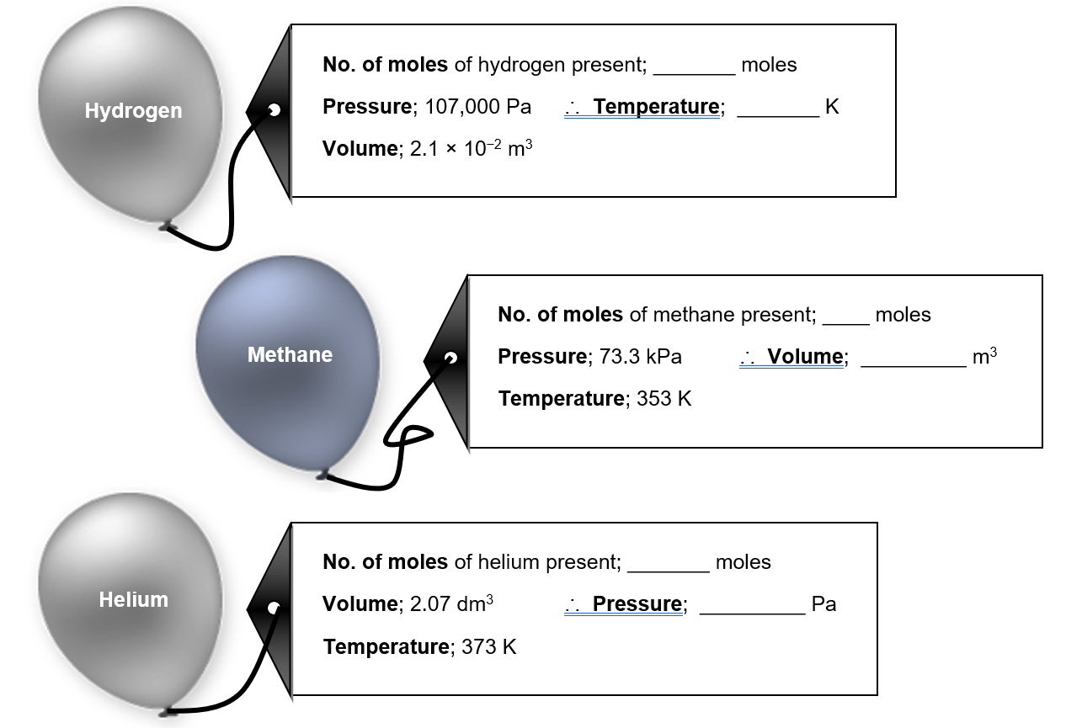
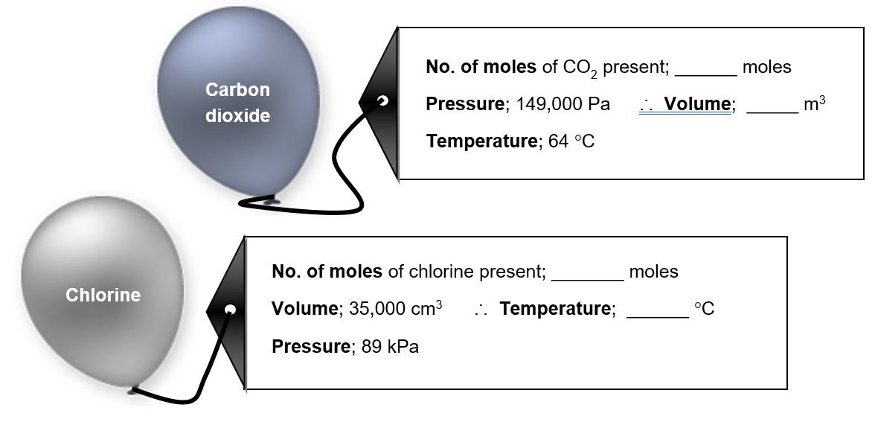

Molar gas volume

According to Avogadro’s Law, as long as the pressure and temperature are kept the same, equal volumes of gases contain equal numbers of moles of gas.

Under standard temperature and pressure (273 K and 101,325 Pa) 1 mole of any gas has a volume of 22.4 dm³.

Use Avogradro’s law to find out which gas syringes contain identical numbers of moles of gas.
(1 mark for each correct pairing, 1 mark for correct number of moles of gas)

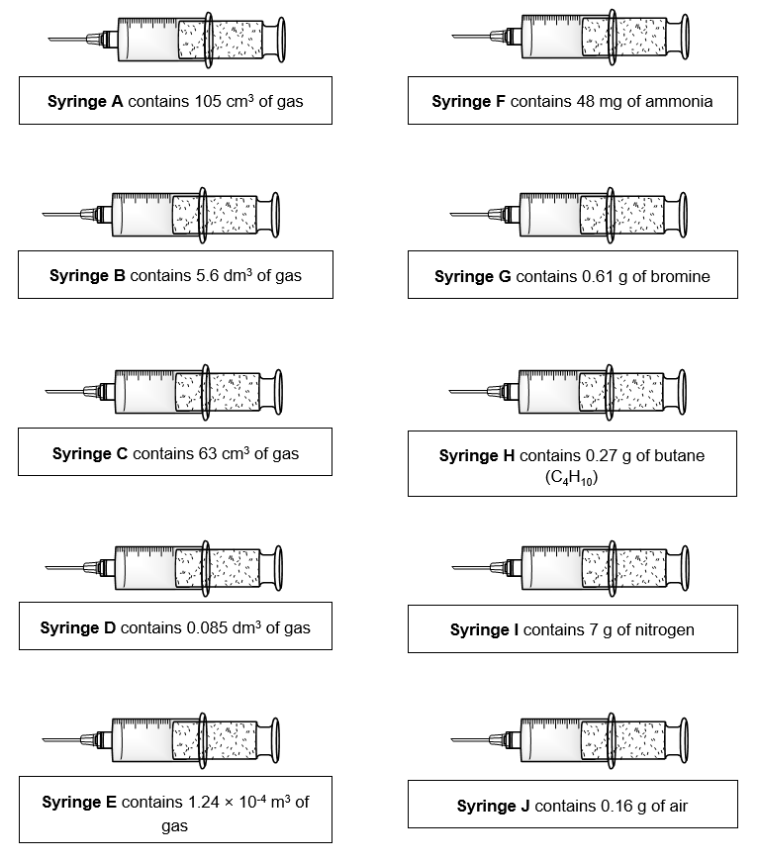

Empirical and molecular formula

The technicians at the University have discovered a number of bottles containing amino acids which have lost their labels. In order to identify them, they carried out elemental analyses. Use the information provided to match the compound to its label;
(1 mark for each correct empirical formula, 1 mark for each correct match)

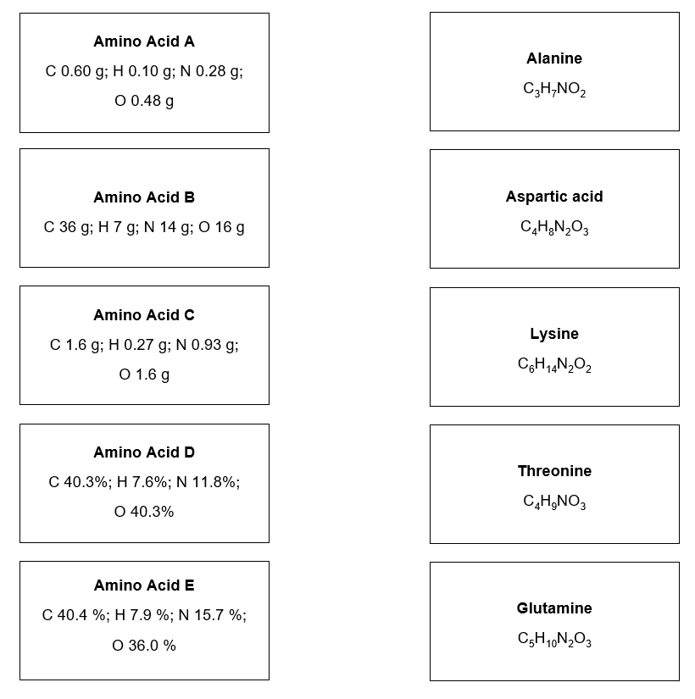

Percentage yield and Atom economy

Percentage yield and atom economy are two numbers which help us gauge how efficient a reaction is for making a specific chemical. The atom economy tells us in theory how many atoms must be wasted in a reaction. The percentage yield tells us about the efficiency of the process.

- Oxygen can be produced by a number of processes. Two possible processes are shown below;

Electrolysis of water; 2 H₂O → 2 H₂ + O₂
Catalytic decomposition of hydrogen peroxide; 2 H₂O₂ → 2 H₂O + O₂

By calculating the percentage atom economy of each process, decide which process is better for producing oxygen.
(3 marks)

- Two students complete the synthesis of paracetamol from 4-aminophenol as shown by the equation below;
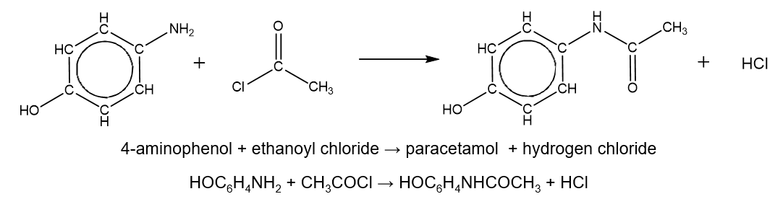
Both students react 2 moles of 4-aminophenol with excess ethanoyl chloride.
Student 1 makes 1.5 moles of paracetamol.
Student 2 makes 220 g of paracetamol.

Which student has the better percentage yield?
(4 marks)

- Copper can be made by either roasting copper sulphide or by the reduction of copper carbonate with carbon. The equations for the two processes are shown below.

CuS + O₂ → Cu + SO₂
0.24 moles 0.18 moles
2 CuCO₃ + C → 2 Cu + 3 CO₂
0.56 moles 0.36 moles

By comparing the percentage atom economy and the percentage yields of the processes as shown, evaluate which is the better method from an industrial viewpoint.
(3 marks)

Titration calculations

On Friday 23rd June the police found John Smith collapsed at his dining table over his plate of fish and chips. He had been poisoned. Police took vinegar samples from the three local fish and chip shops and, in an attempt to isolate the origin of poor John’s fish and chips, analysed the concentration of the ethanoic acid in the vinegar by titration against NaOH of known concentration.

Help the police out by calculating the concentration of ethanoic acid in each of the vinegar samples;
(2 marks for each correct concentration)

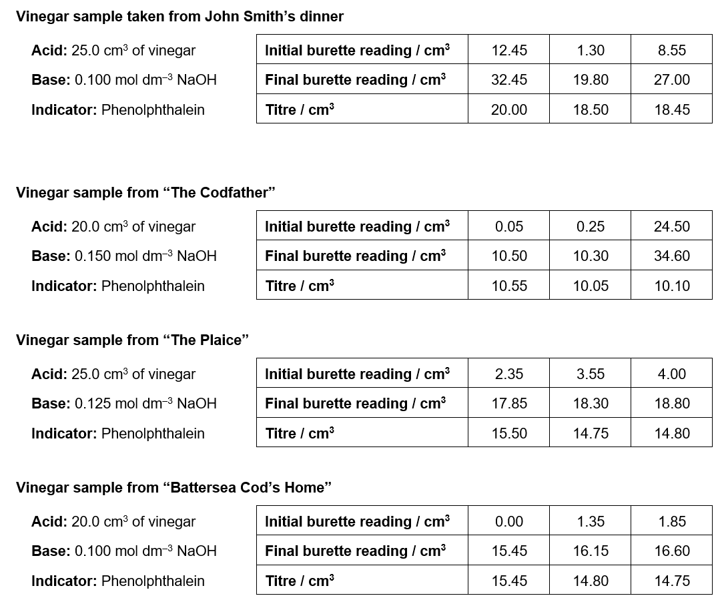

John Smith’s fish and chips had come from…

(2 marks)

Quantitative Chemistry – Answers

The mole

Moles and maths
- 43.7
- 69.8
- 0.688
- 0.683
- 0.25

Moles and concentration
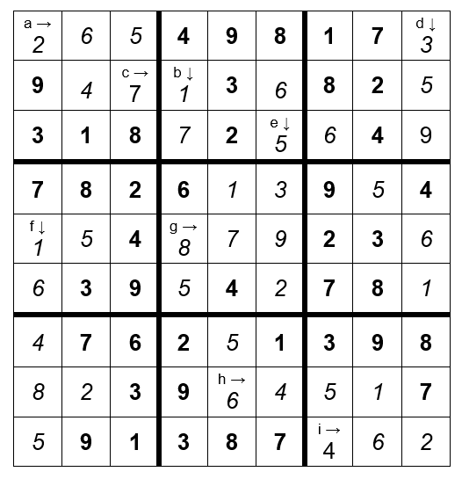

Concentration and dilution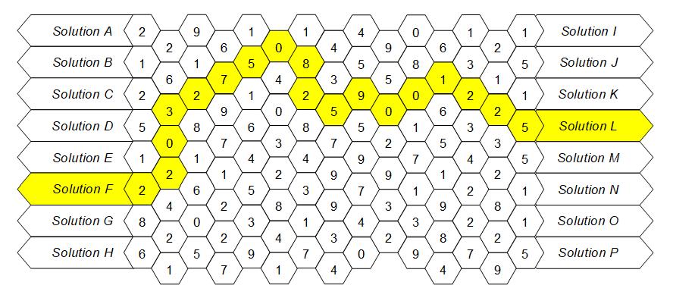

Moles summary
1. (a) 1 mole (correct answer, 0.5 moles)
(b) 1 mole
2. (a) K + 2 H₂O → K(OH)₂ + H₂ (correct answer; 2 K + 2 H₂O → 2 KOH + H₂)
(b) 0.075 moles
3. (a) 22.5 g
(b) 249.6 g (correct answer; 49.9 g)
4. (a) 0.5 moles
(b) 64 g (correct answer; 128 g)
5. (a) 5 × 10⁻³ moles
(b) 93.8 cm³

The ideal gas equation
Hydrogen; 5 moles, 54 K
Methane; 0.625 moles, 0.025 m³
Helium; 2.5 moles, 3,745 kPa
Carbon dioxide; 0.227 moles, 4.27 × 10⁻³ m³
Chlorine; 0.141 moles, 2387 °C

Molar gas volume
Syringe A links with syringe H; no. of moles = 4.7 × 10⁻³ moles
Syringe B links with syringe I; no. of moles = 0.25 moles
Syringe C links with syringe F; no. of moles = 2.8 × 10⁻³ moles
Syringe D links with syringe G; no. of moles = 3.8 × 10⁻³ moles
Syringe E links with syringe J; no. of moles = 5.5 × 10⁻³ moles

Empirical and molecular formulae
Amino acid A has an empirical formula of C₅H₁₀N₂O₃ and is therefore glutamic acid
Amino acid B has an empirical formula of C₃H₇NO and is therefore lysine
Amino acid C has an empirical formula of C₄H₈N₂O₃ and is therefore aspartic acid
Amino acid D has an empirical formula of C₄H₉NO₃ and is therefore threonine
Amino acid E has an empirical formula of C₃H₇NO₂ and is therefore alanine

Atom economy
- Electrolysis of water: 2 H₂O → 2 H₂ + O₂ Atom economy = 32 / 36 × 100% = 88.9%
Catalytic decomposition of hydrogen peroxide; 2 H₂O₂ → 2 H₂O + O₂
Atom economy = 32 / 68 × 100% = 47.1%
∴ producing oxygen by the electrolysis of water has the better atom economy

- Student 1’s percentage yield = 1.5 moles / 2 moles × 100% = 75%
(1 mark)

Student 2’s percentage yield;
Molar mass of paracetamol = 151.0 g mol⁻¹
∴ no. of moles paracetamol made by student 2 = 220 g / 151.0 g mol⁻¹ = 1.46 moles
(1 mark)
∴ student 2’s percentage yield = 1.46 moles / 2 moles × 100% = 73%
(1 mark)
∴ student 1 has the better percentage yield
(1 mark)

3. Roasting CuS: Atom economy = 49.8% Percentage yield = 75%
Reduction of CuCO₃: Atom economy = 49.0% Percentage yield = 64%
∴ obtaining copper from CuS is the better method based on the atom economy of the process and the percentage yields given.

(1 mark for both atom economy’s correct; 1 mark for both percentage yields correct; 1 mark for the evaluation)

Titration calculations
Concentration of vinegar taken from John Smith’s dinner;
Average titre = 18.475 cm³
No. of moles of NaOH = 1.85 × 10^{–3} moles
∴ Concentration of vinegar = 0.0739 mol dm^{–3}

Concentration of vinegar taken from “The Codfather”;
Average titre = 10.075 cm³
No. of moles of NaOH = 1.51 × 10^{–3} moles
∴ Concentration of vinegar = 0.0756 mol dm^{–3}

Concentration of vinegar taken from “The Plaice”;
Average titre = 14.775 cm³
No. of moles of NaOH = 1.85 × 10^{–3} moles
∴ Concentration of vinegar = 0.0739 mol dm^{–3}
Concentration of vinegar taken from “Battersea Cod’s Home”;
Average titre = 14.775 cm³
No. of moles of NaOH = 1.48 × 10^{–3} moles
∴ Concentration of vinegar = 0.0739 mol dm^{–3}

Therefore, John Smith’s fish and chips had come from either “The Plaice” or “Battersea Cod’s Home”

