Evaluate the evidence
Education in Chemistry
July 2018
rsc.li/2tBSMXI
This activity accompanies the article ‘Check my working’. Read the article and then consider this scenario.
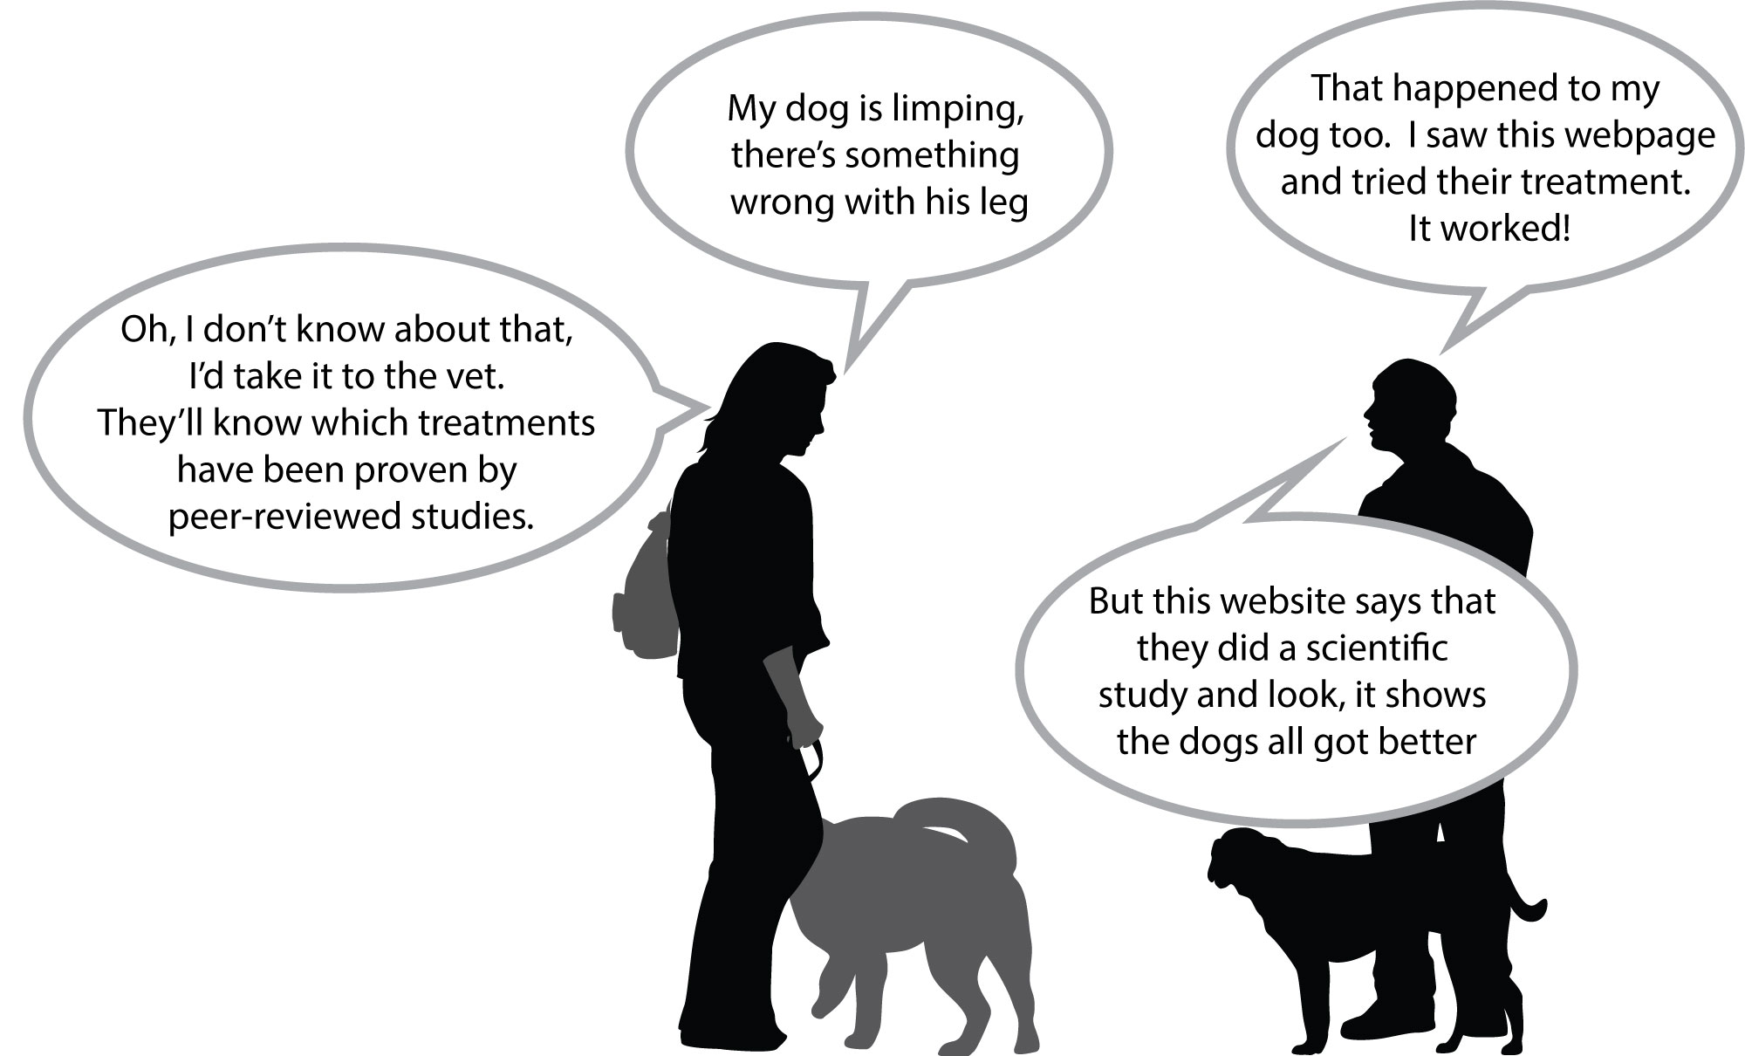
This is an extract from the website one of the dog-owners mentions:
The effect of green-lipped mussel extract on joint swelling in dogs
C N Herbie and T D Kanine
Dogs Meds Online Research Centre, Harlin, UK

Summary: Green-lipped mussel extract contains a unique form of hyaluronic acid proven to reach the joint within two hours, helping to lubricate and cushion the joint. Treatment was shown to improve joint swelling in dogs after one weeks’ treatment.
Method: Dogs were given green lipped mussel extract every day for a week. Owners were given a questionnaire to report the effect.
Results: All of the owners commented positively that the treatment had improved their dog’s mobility.
Conclusion: Green-lipped mussel extract is recommended for the treatment of joint swelling in dogs.

Use these questions to decide if you trust the claim that joint swelling will improve for all dogs after taking green-lipped mussel extract, and whether you would recommend it for publication.
Checklist | Comment
- Has the author been clear about the sample size in their study? Have they stated how many dogs were involved in the study?
- Did the author describe the procedure they used to gather data?
- Did the author describe how they analysed the data?
- Is there sufficient information to enable someone else to repeat the study?
- Is the conclusion consistent with the evidence?
- Did the author discuss how well their conclusion agrees with the claims made by other groups?
- Have the authors declared any conflicts of interest?
- If you were peer reviewing this study, would you recommend it for publication?
- If you wouldn’t, what feedback could you give the authors to help them improve their work.

