Chromatography of sweets

This resource accompanies the article Spoiling our Funfetti in Education in Chemistry which can be viewed at: rsc.li/3IXqcI5

Equipment

Per group:
- Beaker, 250 cm³
- Small soft paint brush
- Two paper clips (preferably plastic-coated)
- Chromatography paper, approximately 20 cm x 10 cm
- Pencil
- Ruler
- Communal hairdryer (optional)
- Supply of M&M’s® of various colours
- Access to tap water in a beaker to use with the paint brush

Preparation
- You can supply the sweets on a spotting tile for stability. As an alternative to using a paint brush, learners can add three drops of water to each sweet on the spotting tile and transfer the coloured liquid to the chromatography paper using melting point tubes.

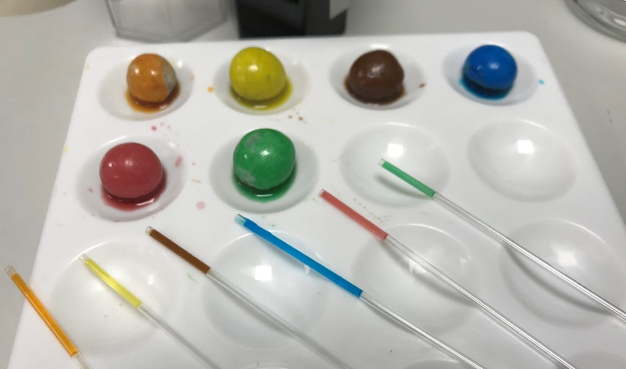
- Whatman® chromatography paper works best for this experiment but, if unavailable, large sheets of ordinary filter paper can be cut up instead.
- If M&M’s® are unavailable, this experiment can be carried out with liquid food colourings or powdered food colourings dissolved in water (available from scientific suppliers only). Do not use gel food colouring. Chromatography of Smarties® is less successful as they use natural food colourings.

Safety and hazards

Read our standard health and safety guidance and carry out a risk assessment before running any live practical. Teachers have a responsibility to carry out their own risk assessment.

Hazard classification may vary depending on supplier.
- Learners should wear safety glasses.
- Do not use Peanut M&M’S® due to the risk of allergic reaction from peanuts.
- Learners should not attempt to eat or lick the sweets which are for laboratory use only.
- Check packaging for any possible allergy or hazard if you are using a different type of sweets or food colouring.

Disposal
- Dispose of used chromatography paper and waste sweets with general waste.
- Wash and reuse melting point tubes (if used).
- Dispose of waste liquid food colouring suitable for food consumption (if used as an alternative) down the drain with plenty of water.

