Separating salt from rock salt
Education in Chemistry
January 2018
rsc.li/EiC118-preciouswater
This exercise accompanies the above article ‘Precious Water’.

STAGE 1: Put the salt, sand and rocks in the beaker

STAGE 2: Add water to the beaker

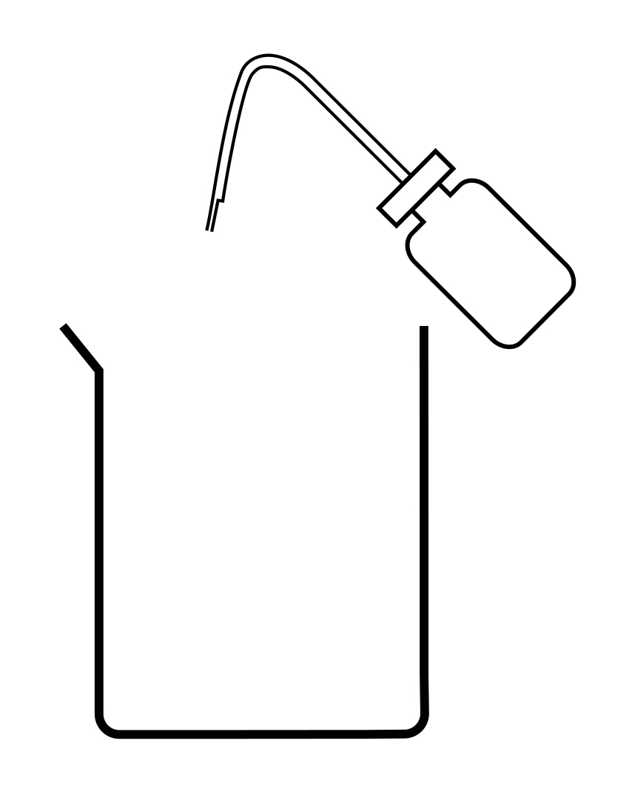

STAGE 3: Stir

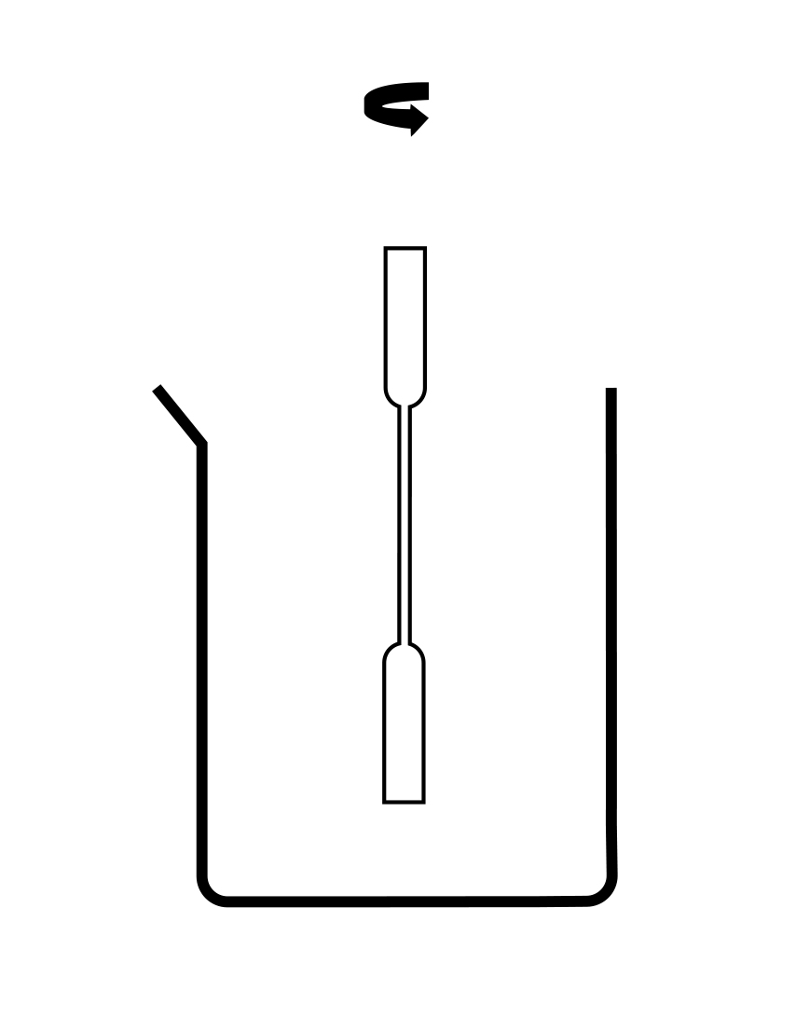

STAGE 4: Filter the mixture

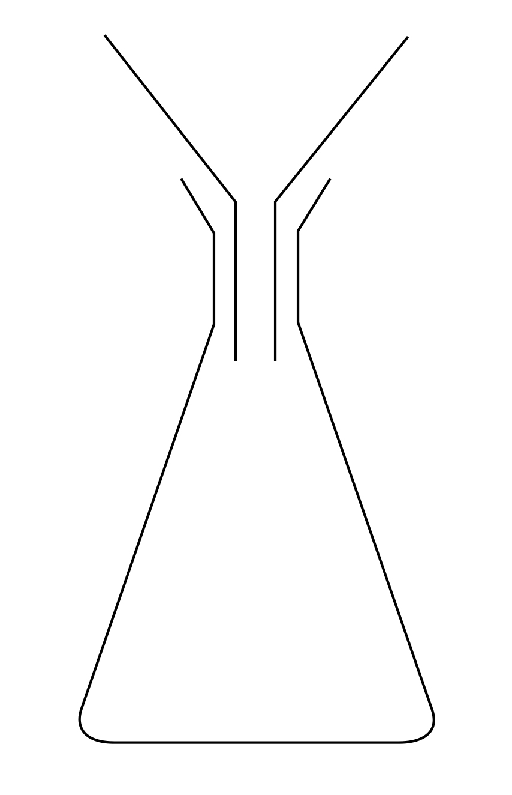

STAGE 5: Heat

