The grand end of term quiz
Education in Chemistry
January 2021
rsc.li/3pRcEmd

Round 1: science fiction

None of these chemicals are real, but who cares?
Q1. What colourful device would you power with a kyber crystal?
Q2. Captain America’s shield is made from which element?
Q3. What can you make with lacewing flies, leeches, bicorn horn, knotweed, fluxgrass, boomslang skin and a strand of hair?
Q4. What famous starship is powered by dilithium?
Q5. Which upcoming movie starring Timothée Chalamet is about a battle over the spice Melange?

Round 2: what’s happening?

Test your knowledge with these GCSE questions.
Q1. A hydrogen and a chlorine atom bond together, each contributing one electron to a shared pair. What type of bonding has occurred?
Q2. One atom of one isotope of calcium has an atomic number of 20 and a mass number of 42. How many protons does it have?
Q3. Chlorine has a boiling point of −35°C and a melting point of −101.5°C. What state would it be in if I cooled it to −20°C?
Q4. How many times smaller is 1nm relative to 1cm?
Q5. Why do metals conduct electricity?
(In case you have covered different areas of the syllabus so far…)
Bonus questions
Q6. I need to separate two different coloured substances from each other. What technique should I use?
Q7. I pour a solution through filter paper. What is the term for the particles left on the filter paper?

Round 3: chememojis

Can you work out what term is lurking behind these symbols?

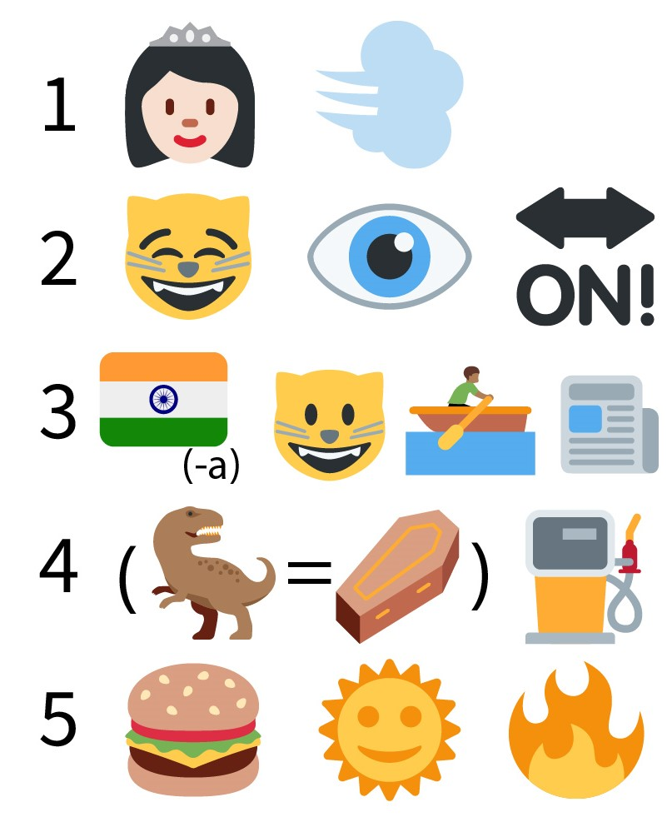

Round 4: name that element

Name the element being described in the question.
Q1. When combined with iron, I make mild steel.
Q2. I’m the most abundant element in the universe.
Q3. When two of me bond to oxygen, I make you laugh.
Q4. My chemical symbol is K, although the letter isn’t in my name!
Q5. When exposed to oxygen, I turn green.

Round 5: current science

Have you been paying attention to science news?
Q1. In September, scientists found phosphine in a planet’s atmosphere, which could be evidence of alien life. On what planet did they make the discovery?
Q2. What disease is caused by SARS-CoV-2?
Q3. Two letters of the alphabet aren’t in the name of any element on the periodic table. Name either of them.
Q4. What brand of washing powder shares its name with the European Space Agency's new space telescope?
Q5. 2019’s Nobel prize for chemistry was won for batteries typically used in laptops and smartphones. What chemical element do these batteries use?

Bonus round: musical elements

For advanced students only! Can you work out the artists sounded out by these elements’ symbols?
Q1. Lanthanum – Dysprosium – Gallium – Gallium
Q2. Tantalum – Yttrium – Lawrencium – Sulfur – Tungsten – Hafnium – Tellurium
Q3. Sulfur – Americium – Samarium – Iodine –Thorium
Q4. Carbon – Argon – Dysprosium – Boron
Q5. Boron – Tennessine

