Desert survival: student sheet

Learning objectives:
- Use knowledge of solids, liquids, and gases to decide how mixtures might be separated, including through evaporating and condensing.
- Observe that some materials change state when they are heated or cooled.

Introduction

Your aircraft has just crashed in the desert, and the last cupful of water has been spilled on the dry sand. You immediately scoop up the wet sand and put it into a plastic bag.

Your task

How can you get that vital water back? You have just 90 minutes before you die from dehydration...

Equipment & materials

General

The following items are available from the wrecked aircraft, or its occupants: plastic bags, yoghurt pots, aluminium foil, aluminium foil trays, beer cans, plastic lemonade bottles, rubber bands, wire, string, old pair of tights, blocks of expanded polystyrene or foam rubber. Pliers, craft knives.

Furthermore, the desert environment provides unlimited quantities of sand, and a source of radiant energy – a lamp is provided to simulate the desert sun.

Per group

A plastic bag containing wet sand.

Desert survival: teacher notes

Planning
Time | 90 minutes
Group size | 2–4
Curriculum links | Evaporation and condensation

Possible approaches

Some suggested approaches are outlined below. More advice on how to use these resources can be found here: https://rsc.li/3ApCfqr
- A wide, clear plastic tube could be provided, so that the principle of extraction of water using centrifugal force could be explored, like a spin dryer.
- A plastic dish covered in foil could be used with a sealed porous pot inside containing the wet sand. The bottom of the dish should be insulated. At the top a lamp is shone on the dish.
- A basic distillation using junk items: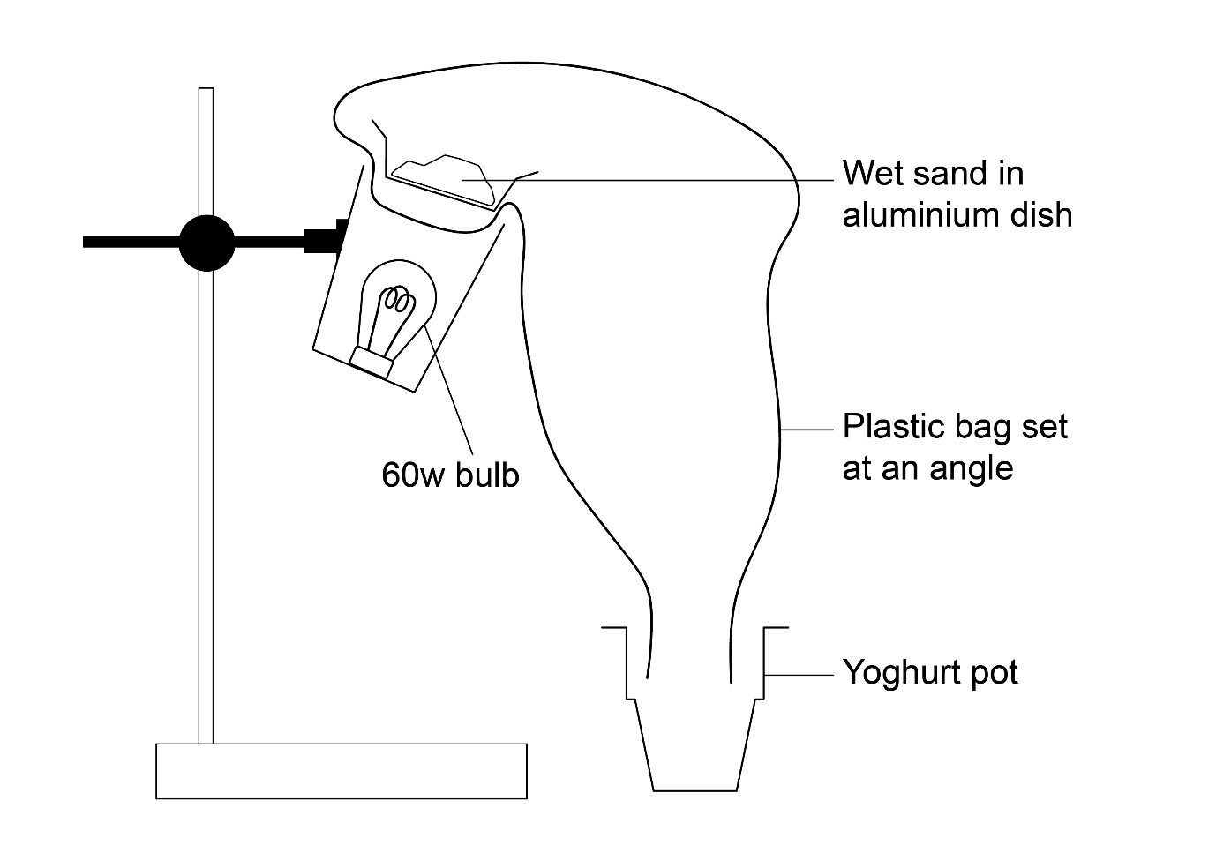

Technician notes

A lamp with a 60W bulb is needed to simulate the desert sun (check that it is safely wired and earthed). A stage floodlight would be exciting if available.

Wet sand is made up of 100 g sand mixed with 25 cm³ water per bag.

Health & safety notes

This is an open-ended problem solving activity, so the guidance given here is necessarily incomplete. Teachers need to be particularly vigilant, and a higher degree of supervision is needed than in activities which have more closed outcomes. Students must be encouraged to take a responsible attitude towards safety, both their own and that of others. In planning an activity students should always include safety as a factor to be considered. Plans should be checked by the teacher before implementing them.

Read our standard health & safety guidance and carry out a risk assessment before running any live practical. Refer to SSERC/CLEAPSS Hazcards and recipe sheets.

Please consider the dangers of using water near electric mains.

There should be no need for eye protection; unless the separation method chosen takes an unusual turn. Some help on colling steam may be necessary.

Write-up and assessment

Suggested write-up

Taped interviews conducted with the 'survivors' of the plane crash on their return to the UK by science reporters. The novel water 'extractors' already making headline news need the students' personalised explanations.

Evaluation of task

These are suggestions only:
- Just before they are about to die, the 'survivors' (groups) present the water they have freed from the sand.
- Measure the volume of water collected by each group. The winning group is that with the largest volume of water.
- In the event of a tie, the group with the most appetising sample of water will be declared the winners.

Extension work

Cross-curricular possibilities with the geography department – ie water supply in desert regions.

