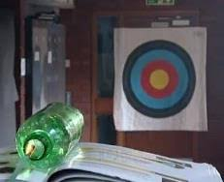
- The methane rocket
A mixture of methane and oxygen in the proportion of 1 : 2 (by volume) can be exploded in a plastic bottle.

This experiment can be watched at https://youtu.be/xDlGSkTbh2A.

In this experiment, methane reacts violently with oxygen to form two products.
- Name the two products made in this reaction?
Source: Royal Society of Chemistry
Answer: Carbon dioxide and water.
- Complete the symbol equation for the reaction:

CH₄ + 2O₂ CO₂ + 2H₂O
- Using your answer to part b), explain why the proportion of methane to oxygen must be 1 : 2.
Answer: The stoichiometric numbers in the symbol equation are in the ratio of 1 : 2 for methane to oxygen, and this is also the same as the ratio in which the volumes react.

- The bottle has a volume of 2.00 dm³.
Calculate the volume of methane and oxygen in the bottle, in cm³. Show your working.
Give your answers to 4 significant figures.
Answer: The fraction due to methane is $\frac{1}{3}$ and oxygen is $\frac{2}{3}$.
Unit conversion: 2.00 dm³ = 2000 cm³.
So volume of methane = $\frac{1}{3}$ × 2000 = 666.6… cm³ = 666.7 cm³ (to 4 significant figures).
Volume of oxygen = 2000 – 666.6… = 1333.3… cm³ = 1333 cm³ (to 4 significant figures).
- Explain why the bottle moves when the gases are ignited.
Answer: Methane reacts exothermically with oxygen, and also reacts very quickly (when the volume ratio is 1 : 2).
Hot gases are produced that expand rapidly and exit the nozzle of the bottle. This forces the bottle in the opposite direction.
- Methane is a saturated hydrocarbon.
Explain what ‘saturated’ means.
Answer: It is only made of single bonds (no double bonds to mention in this particular case).
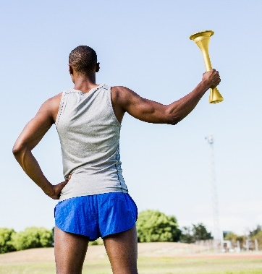
- The torch used to start the modern Olympic Games uses a mixture of propane and butane.

When propane and butane burn in air, they produce heat energy, and a flame.
- Propane and butane are chemical compounds.
Name the two elements that make these compounds.
Source: Envato Elements
Answer: Hydrogen and carbon.

- State the name of the compounds that contain the elements in part a).
Answer: Hydrocarbons.
- To which homologous series do propane and butane belong?
Answer: The alkanes.
- Below are the incomplete molecular structures for propane and butane.
Complete these structures.
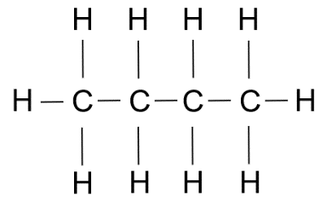
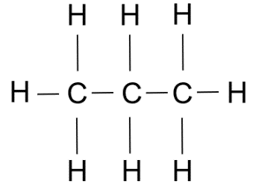

Butane
Propane

- Using your answers to part d), explain what is meant when these substances are described as ‘saturated’.

Answer: Hydrocarbons containing carbon single bonds only.
- Complete the symbol equations to show what happens when these gases burn in air:

Propane: C₃H₈ + 5O₂ 3CO₂ + 4H₂O

Butane: C₄H₁₀ + $\frac{13}{2}$O₂ 4CO₂ + 5H₂O

The ratio in which propane and butane are mixed together as a fuel in the torch (by volume) is 2 : 1.
- What fraction of the fuel is butane?
Answer: $\frac{1 }{3}$
- An Olympic torch contains 37.8 cm³ of fuel.
Calculate the volume of butane in the fuel.
Show your working.
Answer: $\frac{1 }{3}$ × 37.8 = 12.6 cm³
- In a different Olympic torch, the same fuel was used as in the previous torch.
The volume of propane in the mixture was 9.80 cm³.
Calculate the volume of the fuel.
Show your working.
Answer: $\frac{2 }{3}$ of the volume of the fuel is due to propane.
So $\frac{2 }{3}$ × total volume = 9.80,
so total volume = $\frac{3 }{2}$ × 9.80 = 14.7 cm³.

