Investigating bonding spectrums

Learning objectives
- Understand the types of bonding and intermolecular forces that occur in a range of elements and compounds.
- Understand that bonding type is not always clear cut and can gradually change across a range of substances.
- Understand how physical properties depend on the type of bonding.

Getting started
Element | Electronegativity  (Pauling scale)
K | 0.8
Na | 0.9
Al | 1.6
Pb | 1.8
Ge | 2.0
H | 2.2
C | 2.6
Cl | 3.2
O | 3.4
Table 1 – Source: https://www.rsc.org/periodic-table

In this activity, you will use a variety of elements and compounds to investigate how bonding type can gradually change. These are shown on the set of cards your teacher will give you.

The cards are not labelled with the name of the substance, so you need to use your knowledge of their structure and bonding to arrange them in order as you answer the questions.

Answer the questions below on a separate sheet of paper.

Questions
- Introduction
- Table 1 gives electronegativity values for the elements in the following questions. Explain the meaning of the term ‘electronegativity’.
- State the type of bonding and structure you normally expect to exist in:
- A metal element.
- A non-metal element.
- A compound containing both
metal and non-metal elements.
- A compound containing only
non-metal elements.

- The spectrum from covalent to ionic bonding
- Select the cards that show structures of aluminium chloride, chlorine and potassium chloride.
- For each of the three substances:
- Use the data in Table 1 to calculate the difference in electronegativity (if any) between the elements.
- Describe the type of bonding between the atoms, referring to the extent of any electron sharing and how the atoms or ions are held together.
- Place the substances in order from covalent to ionic.
- State one physical property that could be used to distinguish the bonding type and describe how it would change across this covalent to ionic spectrum.
- The spectrum of strength of electrostatic attraction between molecules and ions
- Select the cards that show structures of methanol (CH₃OH), methanal (HCHO), sodium methoxide (CH₃CONa) and ethane (C₂H₆).
- Describe the type of bonding between the molecules or ions, referring to the origin and extent of the electrostatic attraction that holds the particles together.
- Suggest one physical property that could be used to distinguish the bonding type across this strength of electrostatic attraction spectrum.

- The spectrum from covalent to metallic bonding
- Select the cards that show structures of three elements from group 14 (also known as group 4) of the periodic table: germanium, carbon (diamond) and lead.
- Place the elements in order of decreasing electronegativity.
Element | Electrical conductivity at 273 K | Electrical conductivity at 373 K
Diamond | Very low | Very low
Germanium | Low | High
Lead | Very high | Very high
Table 2
- Use the information about electrical conductivity in Table 2 to describe the type of bonding between the atoms of each element at 273 K, referring to the extent of any electron sharing or delocalisation and how the electrostatic attraction holds the atoms together.

- Germanium is described as a semiconductor because its electrical conductivity increases significantly when heated. Suggest an explanation for this property in terms of what is happening to its bonding.

Bonding cards

Cut out the cards below and use them to create the three different spectrums of bonding described in the questions above.
A  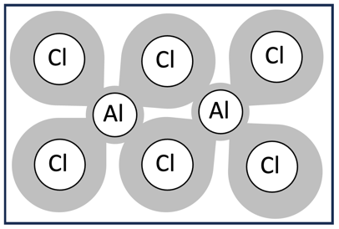 |  | B  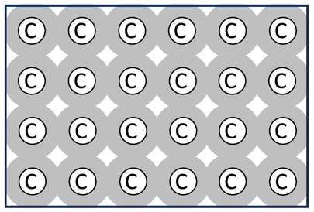 |  | C  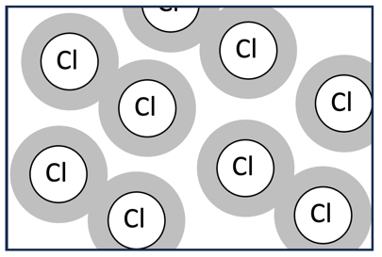
D  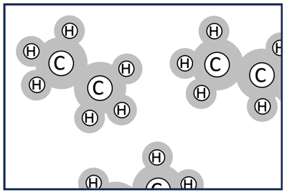 |  | E  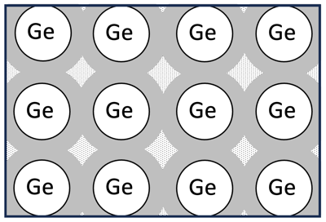 |  | F  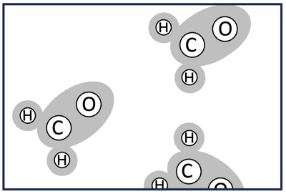
G  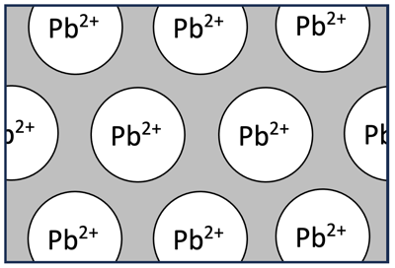 |  | H  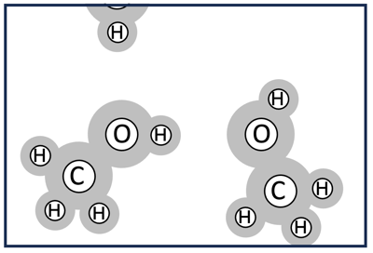 |  | I  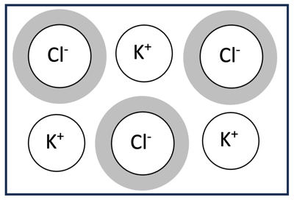
J  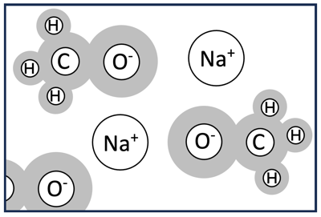 |  | Note that, in these diagrams, the shaded region represents the approximate location of the electrons that were in the outermost occupied energy level of the atoms.

