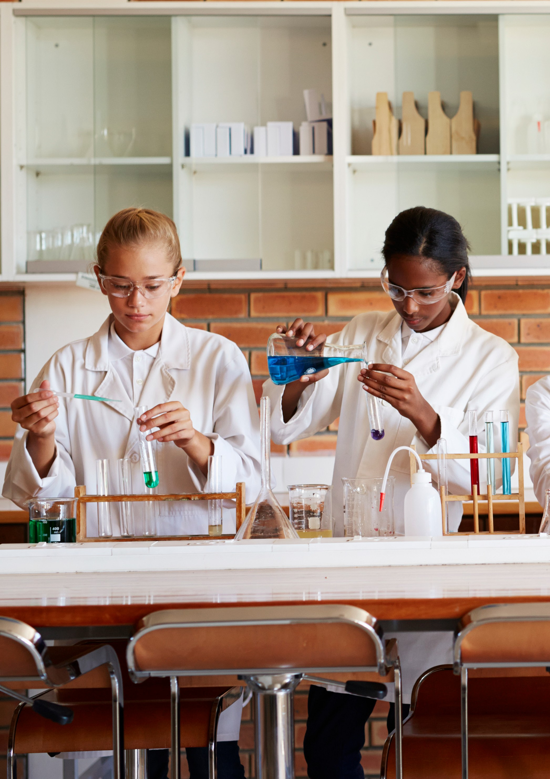

Chemistry in Curriculum for Wales
Chemistry skills template (progression step 4)
rsc.li/3sHf7jc
Registered charity number: 207890

Chemistry in Curriculum for Wales: chemistry skills template
Chemistry in Curriculum for Wales Chemistry skills template
(progression step 4)
This template offers a model to summarise the chemistry skills developed during progression step 4 in Curriculum for Wales’s Science and Technology Area of Learning and Experience (AoLE), as outlined in ‘Chemistry in Curriculum for Wales: curriculum planning support (progression step 4)’. The template encompasses formula literacy skills with understanding the impact chemistry has on the world around us. This is the language of chemistry which works alongside ‘working scientifically’ and is integral to progression for further study of the subject. There is a blank template and a second that has been completed to show what kind of response might be expected of a learner. The aim is to exemplify some of what a learner should be capable of towards the end of this progression step to ensure enough challenge is offered to learners in line with the guidance in the Curriculum for Wales, especially for non-specialist teachers of chemistry.
Alternatively, this template could be used as a worksheet to help summarise skills developed over a series of lessons. It is available in an editable word document to allow teachers to add or remove sections for differentiation purposes. For example, the more challenging sections on equations and atom economy could
be removed for lower attaining learners and pictures of the reactants and products could be added to help make the learning more real. An example of an adapted blank template is also included. Ultimately, as previously stated, the goal of this document is to give an idea of the appropriate level of challenge for a learner at this stage.
On page 6 further support is offered for the final question on each template: what impact does this reaction have on our world around us? Some additional prompt questions and illustrative examples are provided.
An editable version of this template and further support is available at rsc.li/3sHf7jc.

Science and Technology AoLE: chemistry skills template for progression step 4 (blank)

What have you been learning about?
Type of reaction involved
 | Reactant(s) | Observations during reaction | Product(s)
Name
Formula
State
Formula mass
Word equation
Symbol equation with state symbols
Balanced symbol equation
Percentage atom economy of reaction
What impact does this reaction have on our world around us?
Consider significance, usefulness, sustainability, pollutants and energy requirements for reaction

Science and Technology AoLE: chemistry skills template for progression step 4 (exemplar)

What have you been learning about? | Swansea’s copperopolis: the beginning of the copper industry  Copper is extracted from its ore (in this example copper oxide is used but this can also be copper carbonate) using carbon. The copper extracted is most commonly used for electrical wiring and hot water pipes.  (more information could be included here by teacher or by student filling in the sheet about  the context)
Type of reaction involved | Metal extraction – displacement reaction
 | Reactant(s) | Observations during reaction | Product(s)
Name | Copper oxide (copper ore)  Carbon (coal) | - Gas given off  - glows red when heated  - colour change from black to shiny reddish-brown | Copper (pure metal)  Carbon dioxide
Formula | CuO C |  | Cu CO2
State | Both solid |  | copper – solid (once cooled)  carbon dioxide - gas
Formula mass | Mr(CuO) = 63.5 + 16 = 79.5  Ar of C = 12 |  | Ar of Cu = 63.5  Mr(CO2) = 12 + (16x2) = 44
Word equation | copper oxide + carbon → copper + carbon dioxide
Symbol equation with state symbols | CuO(s) + C(s) → Cu(s) + CO₂(g)
Balanced symbol equation | 2CuO(s) + C(s) → 2Cu(s) + CO₂(g)
Percentage atom economy of reaction | 2xCu / [(2xCu) + (CO₂)] x 100  = 127/ (127+44) x 100  = 74.26900584795322  =74.3% (3 s.f.)
What impact does this reaction have on our world around us?  Consider significance, usefulness, sustainability, pollutants and energy requirements for reaction | - Atom economy: approximately 75% of products is the desired product, could be said that  there’s not a lot of waste.  - However, waste product is carbon dioxide which is a greenhouse gas and contributes to  climate change.  - Had to heat reactants with a Bunsen burner which means a very high temperature is needed – this uses a lot of energy and on an industrial scale would mean a lot of fuel is used and if this fuel is not ‘green’ then this has an impact on our environment as burning more fossil fuels.  - Although almost three quarters of reactants are used in making the product the nature of the waste gas and energy requirements reduces how ‘green’ this reaction is.

Science and Technology AoLE: chemistry skills template for progression step 4 (alternative blank)

What have you been learning about?
Type of reaction involved
Observations
 | Reactant(s) | Product(s)
Include a picture
from your
experiment and the
names
Word equation
 | Are there any pollutants made?
 | Did you have to heat the experiment?
What impact does this reaction have on our world around us?
Consider significance, usefulness, sustainability, pollutants and energy requirements for reaction | Where does the energy or fuel come from to this?
 | What is the effect of all of this?

Support for the question: what impact does this reaction have on our world around us?
Below are some examples of further questions that could be asked to help students answer this question,
as well as some suggestions for content:

Significance of the reaction:
- What is the purpose of this reaction?
- What useful products are made?
- How does this enrich our lives?

Often a by-product(s) is made during a reaction in the form of a pollutant and these have harmful effects to us and/or the environment. For example:
- Methane and carbon dioxide are greenhouse gases and contribute to global warming and, in turn,
climate change.
- Acidic gases like sulfur dioxide and nitrous oxides might be produced that, when realised into the
atmosphere, mix with rainwater to form acid rain which can damage plant life.
- Heavy metals, such as lead and mercury, can build up in food chains (especially aquatic) and are
toxic to organisms if ingested.

Energy requirements:
- If reactants need to be heated for them to react, then considerations need to be made for where this heat energy comes from. For example, if fossil fuels are used to generate this heat then this also contributes to global warming and climate change as the products of complete combustion are carbon dioxide and water vapour.
- Some reactions require electricity (for machinery, electrodes and so on) and so the fuels used to generate this electricity need to be considered – renewable or non-renewable energy, pollutants made from this process.
- A discussion about greener alternatives could follow.
- Some reactions happen spontaneously at room temperature and do not require any additional energy and so they have less of an impact on the environment.

Sustainability:
- Raw materials are often natural resources that are finite. For example, many sources of metal
ores will have been exhausted within the next 50 years or so.
- Can the product be recycled or reused once it is no longer in use?
- A qualitative comment on the amount of waste produced during the reaction can be made. If there is only one product and no by-products (waste) this is far more desirable than a reaction that makes one product and two by-products.
- Is there any use for the by-products produced, hence reducing the waste? For example, in industry, the by-product carbon dioxide, could be captured and bottled and used for carbonating drinks therefore decreasing the waste produced, and also decreasing the amount of greenhouse gas emissions from this reaction.

