Candles in beakers investigation

Learning objectives
- Make predictions using your scientific knowledge and use them to form a hypothesis.
- Plan an appropriate investigation to test your predictions.

Concept cartoon

What do you think?
The candles will burn for the same time because the beakers are the same size.
The shortest candle will run out of wax quickest.
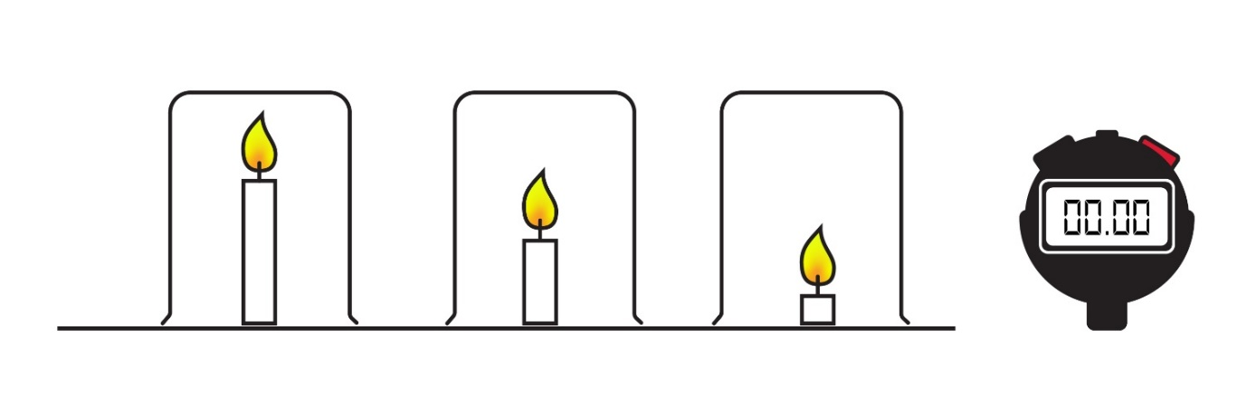
The shortest candle will go out first. Because carbon dioxide is more dense than air, it will settle to the bottom and put out the flame.
The shortest candle will generate the most convection because the flame is at the bottom of the beaker. So, it will burn the longest.

Write a hypothesis

We have decided to look at how changing the length of the candle affects how long it will burn for inside a beaker.

We think …

__________________________________________________________________________________

__________________________________________________________________________________

because …

__________________________________________________________________________________

__________________________________________________________________________________

__________________________________________________________________________________

Plan an investigation

Use the space below to design an investigation to test your hypothesis.
- How can you ensure that you carry out a fair test?
- How can you demonstrate to others that the data you will obtain is reliable?

Example experiment
- A new long candle was burnt for a short while so the wick was not new.
- It was secured to the bench and a one litre beaker was put over it upside down.
- The time taken for the candle to go out was measured and the experiment was repeated.
- The candle was cut down in length and the experiment repeated (the cut off pieces were included in the beaker so that the volume of air remained a constant).

Data from this experiment
Candle length/cm | Time candle burnt/s
 | Exp 1 | Exp 2 | Exp 3 | Average
11.5 | 27 | 20 | 18 | 21.7
6 | 22 | 24 | 18 | 21.3
2.5 | 19 | 24 | 19 | 20.7

Evaluation
- What does the data show? Describe the relationship between the length of the candle and the time that it burns in the beaker.

__________________________________________________________________________________

__________________________________________________________________________________

__________________________________________________________________________________
- Scientists publish their findings in scientific journals – is this data good enough to publish? Explain your answer.

__________________________________________________________________________________

__________________________________________________________________________________

__________________________________________________________________________________

- Scientists in the field of medicine do experiments which show slight changes in rates of certain diseases connected to diet. For example, an investigation they might do would address the hypothesis – people who eat a lot of oily fish have less chance of heart disease. How would they design their investigation to show meaningful results even though they are expecting only a small effect?

__________________________________________________________________________________

__________________________________________________________________________________

__________________________________________________________________________________

Follow-up task
- Can you devise your own concept cartoon about candles burning?

Your cartoon could:
- have alternative questions someone might ask
- have different shaped containers rather than all beakers
- alter the experiment so water is drawn up into the beaker as the candle burns
- have more than one candle in each beaker.

- Write a hypothesis for a new investigation based on your cartoon.

