Revision flashcards and flowchart
Education in Chemistry
March 2019
rsc.li/2Ws5HJr
Illustration aids understanding, which makes flashcards a useful revision tool. Students can place them in order on a flowchart or diagram; in this example, they will learn not only the details, but also how the details fit together. They can also combine this activity with self-explanation.

History of our understanding of atomic structure
Cut out the flashcards and then place them in order on the flowchart. Read each flashcard aloud to yourself, and explain the vocabulary and concepts.

FRONT |  | BACK
Who? | Model | What?
John Dalton |  | Substances made up of atoms
JJ Thomson | 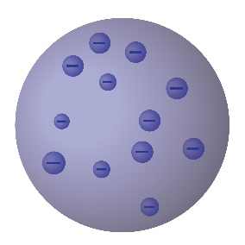 | Experiments with applying high voltages to gases at low pressure  electrons Plum Pudding model
Ernest Rutherford | 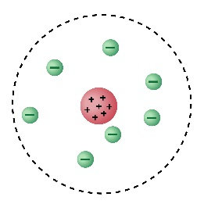 | Gold foil experiment electrons orbit nucleus which contains positively charged protons
Niels Bohr | 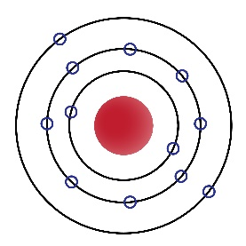 | The nucleus is in the centre and electrons orbit in different shells at set distances.
James Chadwick | 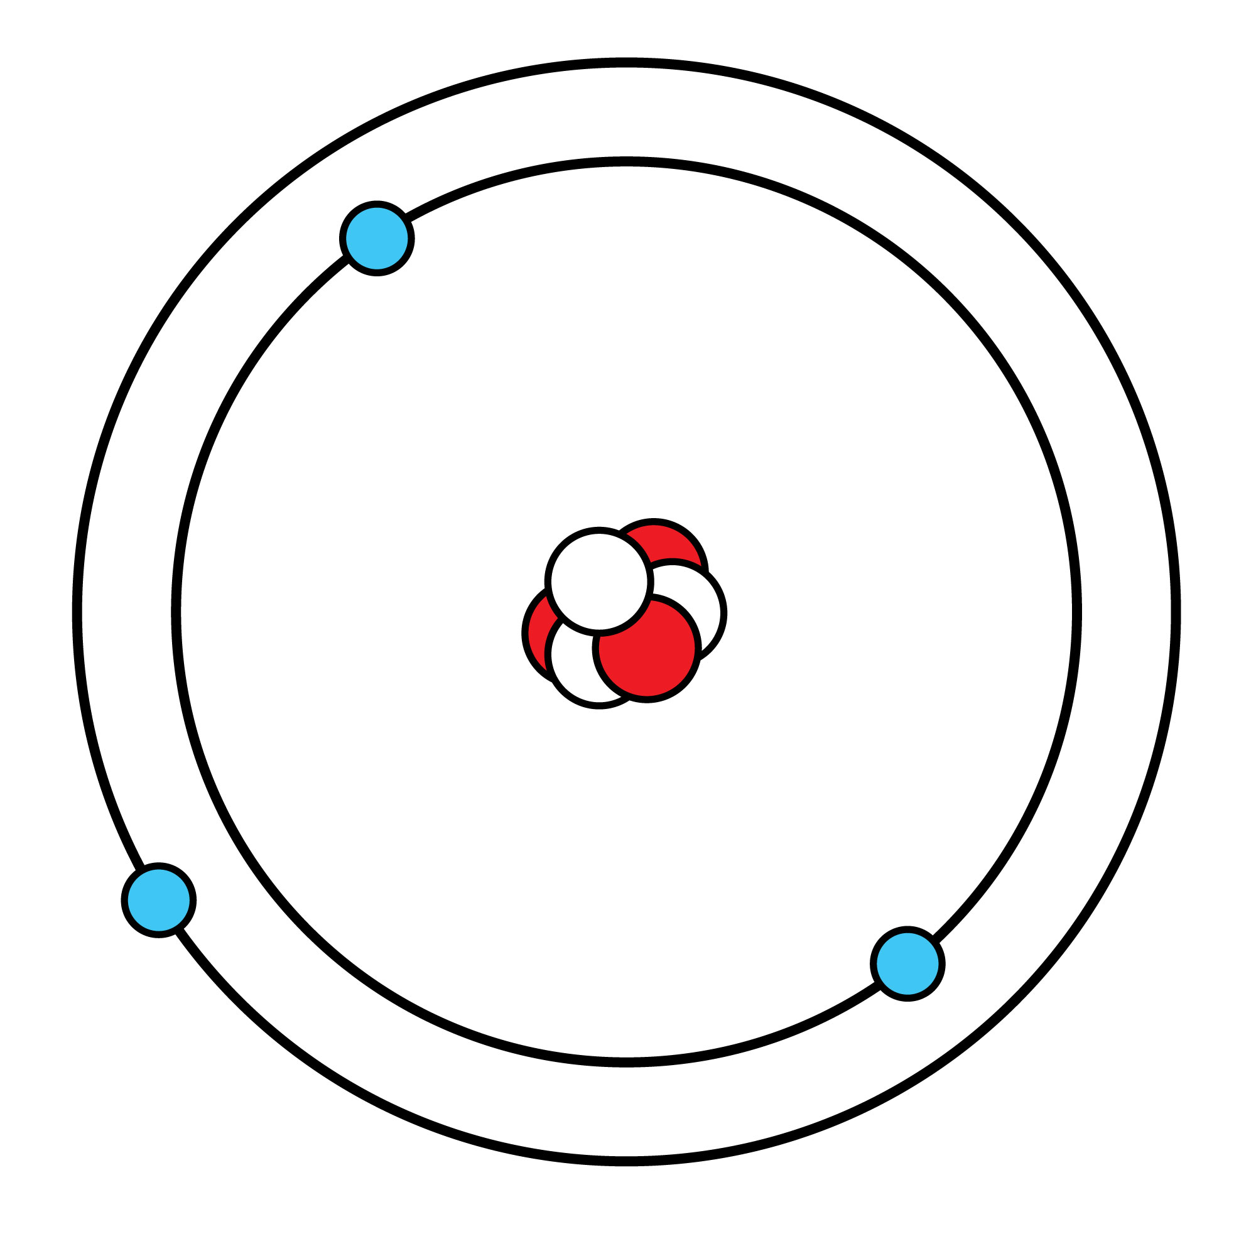 | Discovered the neutron

When | Who? | Model | What?
Early 1800s
Late 1800s
Early 1900s
Early 1900s
1930s

