Determining the structure of compounds

Learning objectives
- Understand, analyse and summarise a scientific text.
- Know that a combination of data from instrumental analysis is required to determine the structure of a compound.
- Determine the structure of compounds by analysing data from mass spectrometry (MS), infrared (IR) and nuclear magnetic resonance (NMR) spectra.

Background

Analytical chemistry is used in sport to test for prohibited substances. Analysts use structural determination techniques in anti-doping laboratories to ensure athletes are not taking performance enhancing drugs.

Nandrolone – bought as nandrolone decanoate (Deca-Durabolin) – is an anabolic steroid. Athletes may take steroids as dietary supplements to build up muscle mass and aggression. People who are HIV-positive and others whose muscles have become wasted through illness may also take these compounds.

Nandrolone is usually injected but may be present in dietary supplements taken orally. It is metabolised in the body to a compound called 19-norandrosterone.

Nandrolone’s and 19-norandrosterone’s structures are:

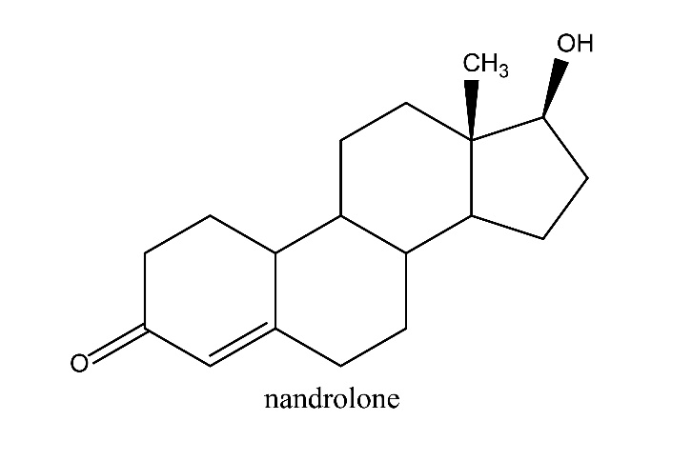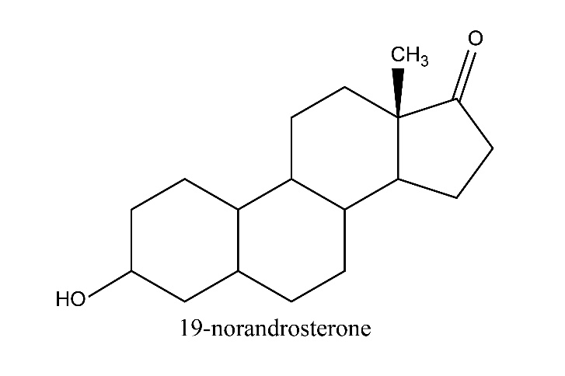

19-Norandrosterone passes out of the body in the urine and can be detected.

All the anabolic steroid drugs are similar in structure to the male sex hormone testosterone and the female sex hormone progesterone.

Testosterone’s and progesterone’s structures are:

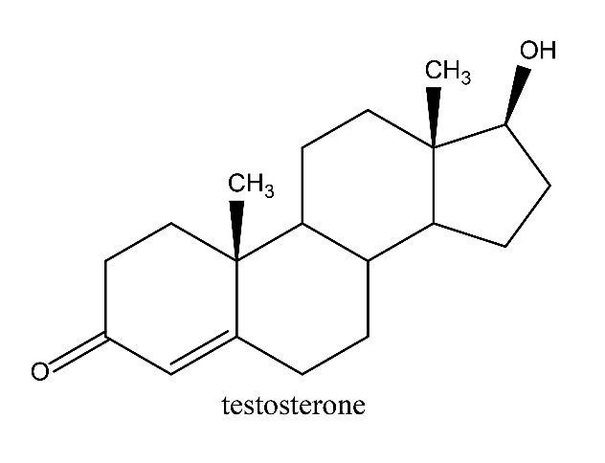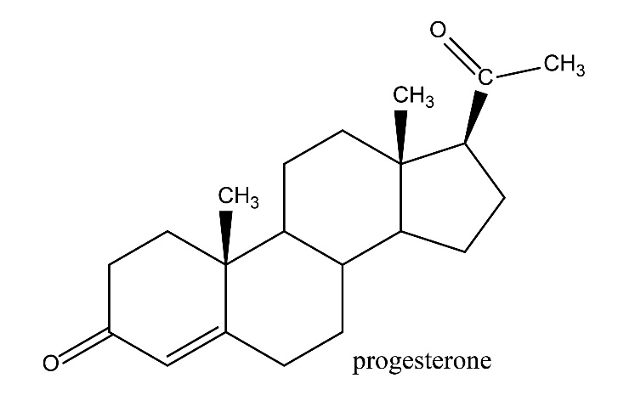

However, nandrolone is on the World Anti-Doping Agency’s prohibited list and banned at all times. This information is available to athletes who participate in any sport on the agency’s website. It is the athletes’ responsibility to check that they are not taking any banned substances. National anti-doping organisations, such as UK Anti-Doping, also deliver education so that athletes are informed on the rules.

Laboratories are required to detect levels of 19-norandrosterone at two nanograms per millilitre or lower. This is the level of 19-norandrosterone accepted by the International Olympic Committee (IOC) as ‘naturally occurring’. A level higher than this is a positive result.

Analytical chemists have developed high-resolution mass spectrometry (HR-MS), which is more sensitive than standard mass spectrometry. This helps detect 19-norandrosterone at the low level needed. HR-MS allows better detection of fragments without interference from other compounds. Analysts also use high performance liquid chromatography (HPLC) to get a clean separation of 19-norandrosterone before using the mass spectrometer. One major advantage of this technique is that the 19-norandrosterone can be detected for relatively long periods in the urine, so it is harder to avoid detection.

There are claims that the tests for 19-norandrosterone are flawed. Athletes argue the chemical can be present at a high level legitimately. A long-distance runner and a bobsleigh racer both queried their positive tests, stating they ate contaminated meat products – pig offal and non-organic beef, respectively. A boxer claimed to have failed his drugs test because he had sex with his pregnant wife, raising his levels. Others have stated that taking dietary supplements recommended by their national governing bodies, contaminated with a substance that produced 19-norandrosterone, caused their positive tests. More argued that the legal substance creatine, found in high-protein milkshakes, had trace amounts of the steroid added to it and was not stated on the label, making them unaware.

Scientists in Aberdeen claim that increased levels of 19-norandrosterone can’t be produced by taking legal dietary supplements, or by exercise, alone. A combination of both could give a positive test. As yet, we don’t fully understand the metabolic processes in the body that cause the level to increase.

Task 1

Use the information above to answer the questions and provide advice to athletes.
- What is 19-norandrosterone?
- State the differences in chemical structures between:
- Nandrolone and testosterone.
- Nandrolone and 19-norandrosterone.
- Describe what the body must do to make 19-norandrosterone from nandrolone.
- State the tests used to determine the presence of 19-norandrosterone.
- Explain why athletes are tested for 19-norandrosterone.
- Why is it difficult to test for the substance accurately?
- What would be the molecular ion peak and main fragments seen on a mass spectrum of 19-norandrosterone?
- Give at least one of the athlete’s ‘legitimate’ reasons for high levels of 19-norandrosterone.
- Discuss as a class whether nandrolone should stay on the banned list.

Summary

Write advice for anti-doping organisations to give to athletes about nandrolone. Share your ideas as a class.

Task 2

As mentioned in the background information, analytical techniques are used to detect and determine compounds. Below are real results obtained by analysing compounds using mass spectrometry, IR spectroscopy and NMR spectroscopy.

Work out the structure of the compound(s) assigned to you in as much detail as you can. You are given the empirical formula and the relative molecular mass of each compound as well as some clues. Make sure you have a data book or sheet available to help you identify key bonds and groups present.

Clues
- Compound 1 fragments so easily that we do not see the molecular ion peak – the highest is at 59, which is M-1.
- Compound 2 is produced during a nucleophilic substitution between an alkyl halide and an alkoxide ion.
- Compound 3 is obtained from heating plastic to a high temperature.
- Compound 4 is produced during the oxidation of methyl benzene in ethanoic acid.
- Compound 5 is an unknown.
- Compound 6 is produced as a product during the reduction of phenol.
- Compound 7 is extracted from a reaction mixture containing hydrochloric acid. The molecular ion is absent and the relative molecular mass is thought to be 73.

Compound 1

$$C_{3}H_{8}O$$

RMM 60

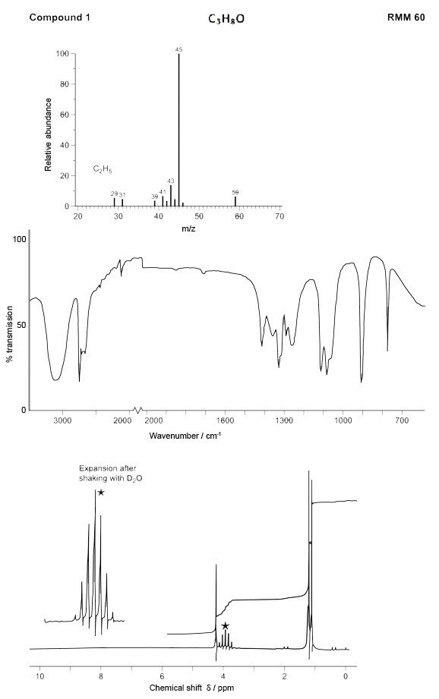

Compound 2

$$C_{8}H_{10}O$$

RMM 122

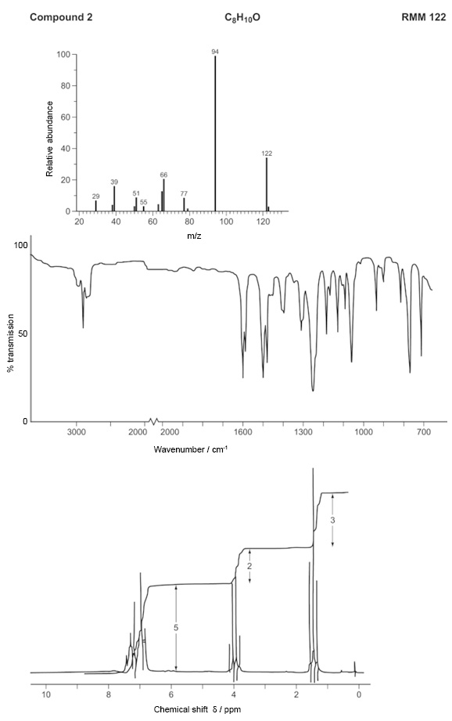

Compound 3

$$C_{5}H_{8}O_{2}$$

RMM 100

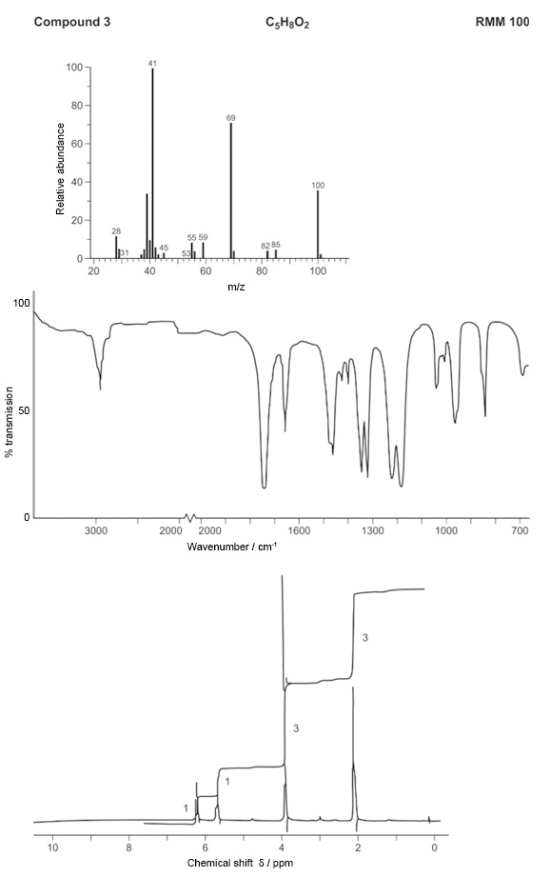

Compound 4

$$C_{9}H_{10}O_{2}$$

RMM 150

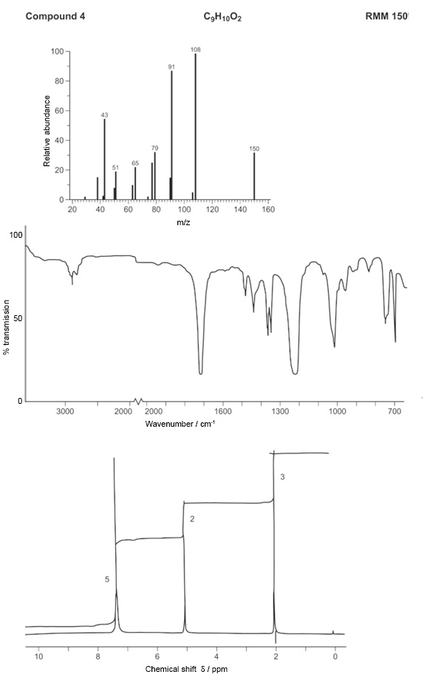

Compound 5

$$C_{8}H_{7}ClO$$

RMM 154

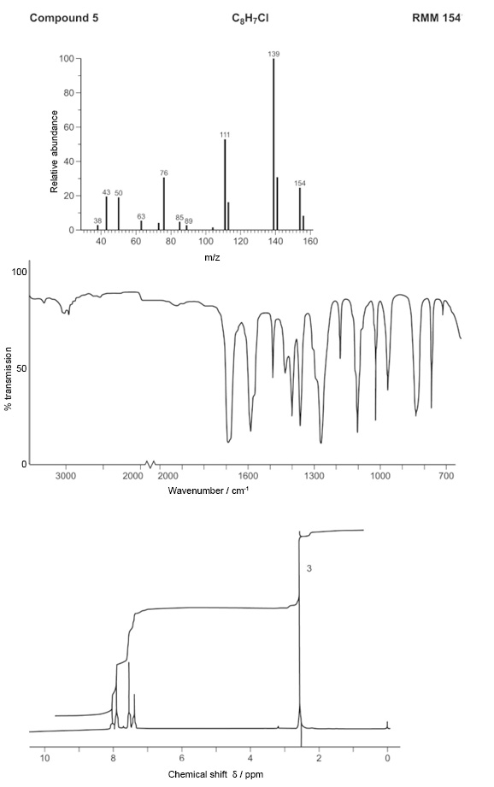

Compound 6

$$C_{6}H_{10}O$$

RMM 98

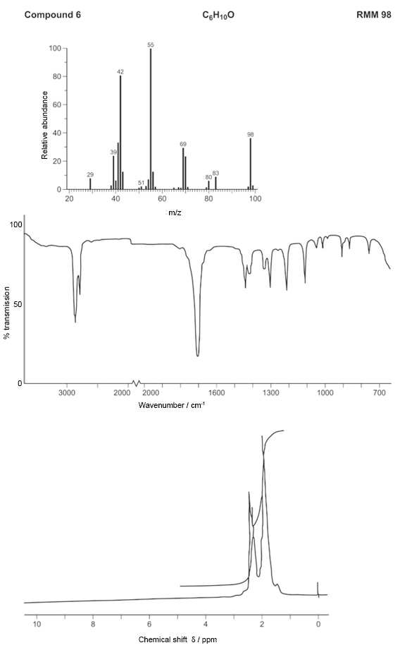

Compound 7

$C_{4}H_{11}N$

RMM 73

