Conservation of mass
Education in Chemistry
July 2020
rsc.li/2XcHadN
Explore how mass is conserved when a substance is dissolved or heated.

Dissolving sugar
A beaker of water and a beaker of sugar are put on both sides of some scales.
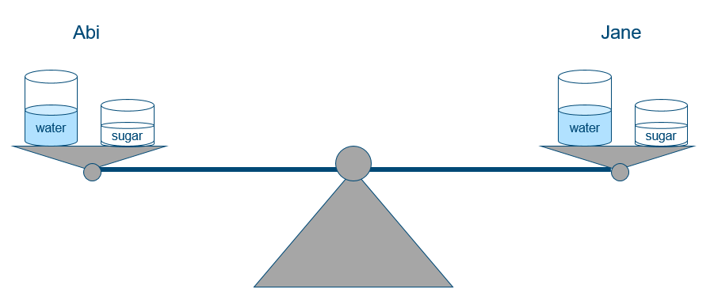
Jane takes her beaker of water off the scales and pours her sugar into it. She stirs it until she cannot see the sugar granules. Abi leaves her water and sugar alone.
- Sketch what you think the scales will look like if Jane puts her two beakers back on the scales. Explain your answer.

Heating copper(II) carbonate
A sample of copper(II) carbonate is added to a test tube and heated.
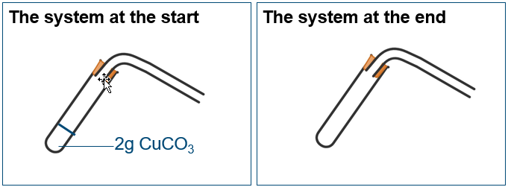
2 g CuCO₃

- Draw on and label all the substances that you think would be present in the same system at the end of the reaction.
Diagram two should contain copper oxide in the test tube and carbon dioxide in the air inside and surrounding the glassware.
- Use the diagram to explain what happens to atoms in copper carbonate when it decomposes.
The diagram shows that the atoms present in the copper carbonate have been rearranged to form copper oxide and carbon dioxide. The atoms in the products have the same mass as the atoms in the reactant.
- Suggest why some people incorrectly think this reaction disproves the law of conservation of mass.
They only measured the mass of the test tube. This would decrease in mass suggesting that atoms had been destroyed/used up in the reaction which would contravene the law of conservation of mass.
- Imagine a test tube containing calcium hydroxide (lime water) was added to the end of the delivery tube at the start of the reaction. What effect would this test tube of lime water have on:
  - the mass of the system?
It would increase as the system now includes the mass of the lime water and additional test tube.
  - the mass of carbon dioxide produced by the reaction?
It would remain the same. The mass of carbon dioxide produced is determined by the mass of copper carbonate, not by the lime water.
  - the overall mass change of the system?
It would remain 0 because the mass at the start = mass at the end just the system now includes the lime water.
  - the carbon atoms from the copper carbonate?
They will now end up in calcium carbonate rather than in carbon dioxide (Ca(OH)₂ + CO₂ CaCO₃ + H₂O).

