The reduction of a nitro group to an amine

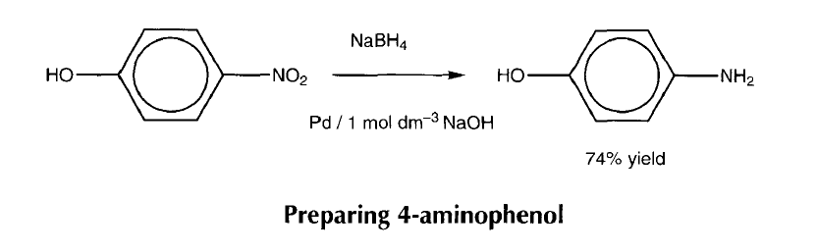

Health, safety and technical notes
- Read our standard health and safety guidance https://rsc.li/4btzk3P
- Wear eye protection.
- Sodium tetrahydridoborate(ll1) - harmful if swallowed, reacts with water to produce hydrogen; the reaction is more vigorous with acids - keep away from flames.
- 4-nitrophenol - irritant, will stain skin, wear gloves when handling.
- Sodium hydroxide solution (1 mol dm⁻³) - corrosive - avoid contact with eyes.
- Palladium on charcoal (5% or 1 Oo/o) - Irritant. Do not breathe dust.
- Hydrochloric acid (2 mol dm⁻³) - irritant.
- Sodium hydrogen carbonate - reacts with acids to produce carbon dioxide. The reaction can be delayed and violent. Add cautiously with constant agitation and how the flask over a dish to catch any spill-over.
- 4-aminophenol - harmful, possible risk of irreverisble effects, very toxic to aquatic organisms.
Note - This reaction needs careful temperature control.

Preparing 4-aminophenol

Chemicals (per group)
- 4-Nitrophenol
- Sodium tetrahyd ridoborate(III) (sodium borohyd ride)
- Sodium hydroxide (1 mol dm⁻³)
- Palladium on charcoal (5% or 1 O%, Aldrich)
- Hydrochloric acid (2 mol dm⁻³)
- Sodium hydrogencarbonate

Apparatus and equipment (per group)
- 2 Wide mouthed conical flasks or beakers
- Magnetic stirrer
- Thermometer
- Spatula
- Measuring cylinder
- Filter paper and funnel
- Water pump
- Buchner flask and funnel
- Microspatula
- Eye protection

Method
- Place 10 cm³ (10 mol) of 1 mol dm⁻³ sodium hydroxide in a conical flask.
- Add 0.56 g (1 4.7 mol) of sodium tetrahydridoborate(ll1) (sodium borohydride), followed by 50 mg of palladium on charcoal (5% or 10%; Aldrich).
- Cool in ice to -13 ◦C.
- Add 1.O g (7.2 mmol) of 4-nitrophenol in very small portions (half a microspatula at a time) over 30 minutes. Make sure the temperature is kept between 13-17◦C during the addition.
- After the addition is complete the mixture should be stirred for a further 15 min and acidified with 2 mol dm-3 hydrochloric acid (about 17 cm³).
- Filter the mixture to remove catalyst and adjust the filtrate to pH 7-8 by carefully adding solid sodium hydrogencarbonate a little at a time.
- Filter off the precipitate and wash with a little cold water to give 4-aminophenol (0.58 g; 74%) after drying.

Questions
- Sodiumtetrahydrido borate(III) (sodiumborohydride), NaBH, is relatively stable in aqueous sodium hydroxide (NaOH) but not in acid. Why?
- What is the role of the catalyst in the reduction of nitro groups? Can other methods be used for this reduction?
- Why can the product be separated from unreacted starting material at pH 82
- Why is sodium hydrogencarbonate used to make the reaction mixture basic at the end of the reaction, rather than sodium carbonate or sodium hydroxide?
- Why is the product soluble in a solution of a strong acid or in a solution of a strong base, but not in a solution of a weak base?

Answers
- In acid solution you would get hydrogen gas released, H+ + H- + H,
- The catalyst provides a surface for the reaction to take place on by forming weak association bonds with the catalyst surface. This in turn weakens the strong nitro bonds. Other methods that could be used are:
- Sn/conc HCI followed by NaHCO,
- H,/Pd
- LiAIH,
- NO, group in the starting material makes the phenol OH more acidic than in the product (NH, is less electron withdrawing) and therefore dissolves in the basic solution while the product precipitates out.
- Sodium carbonate and sodium hydroxide are strong enough bases to remove the H+ from the products as well. Sodium hydrogencarbonate allows differentiation between product and starting material.
- In strong acid or base a salt is produced that is water soluble. (A strong acid will protonate the -NH, to give -NH,+, ie soluble; a strong base will deprotonate -OH to give -0-al so soluble.)

