Fractional distillation and hydrocarbons: knowledge check
- The diagram shows crude oil being separated into fractions in a fractionating column.

Use the words listed to label each of the fractions produced.
liquified petroleum gas diesel kerosene
petrol heavy fuel oil bitumen

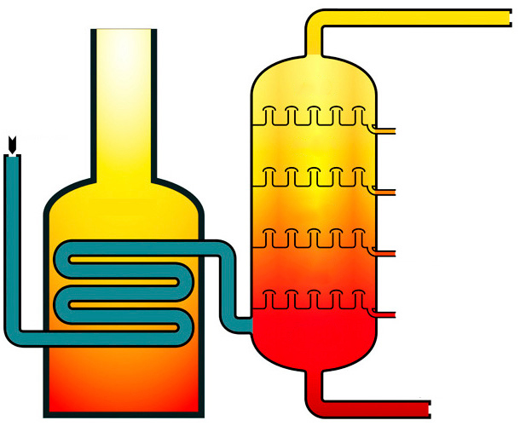
hot
cool
gas
furnace
crude oil

- Choose some of the correct sentence endings from those provided (A to H) to match each of the sentence starters in the table.

Write the correct letter into the box provided for each sentence starter. The first one has been done for you.
Crude oil contains … | H |  | A … evaporate and then condense.
Fractional distillation is used to … |  |  | B … cooler at the bottom
During fractional distillation, the hydrocarbon fractions … |  |  | C … melt and then freeze.
The hydrocarbons are separated according to … |  |  | D … separate crude oil into hydrocarbon fractions.
The fractionating column is … |  |  | E … hotter at the bottom.
 |  |  | F … their different boiling points.
 |  |  | G … separate pure water from salt water.
 |  |  | H … a mixture of hydrocarbons.

- Use some of the words to complete the gaps in the following sentences.
hydrogen C_{n}H_{2n+2} carbon two C₃H₈
C_{n}H_{2n} oxygen C₃H₆ three fractions C₂H₆

The mixtures of hydrocarbons collected from the fractionating column are called __________________ .

Hydrocarbons are compounds containing __________________ and __________________ only.

The hydrocarbons in crude oil are mostly alkanes, which have the general formula __________________ . For example, a molecule of ethane, which contains __________________ carbon atoms, has the formula __________________ .
- Use some of the words to complete the gaps in the following sentences.
bitumen higher weaker covalent bonds melt
intermolecular forces stronger condense
liquified petroleum gas lower

Small alkane molecules have weak _____________________________________ and low boiling points. They do not __________________ in the fractionating column and leave as _______________________________________________________________.

Larger alkane molecules have __________________ intermolecular forces. Energy is needed to break the intermolecular forces, so alkanes with larger molecules have __________________ boiling points.

Fractional distillation and hydrocarbons: test myself
Answer questions 2.1 to 2.2 by circling the correct answer(s). There may be more
than one correct answer in each question.
- Which two of the following formulas represent a hydrocarbon?
HCl
CO₂
C₂H₄
CH₃OH
C₆H₁₂O₆
CH₃COOH
C₅H₁₂
- Which alkane has the highest boiling point?
CH₄
C₇H₁₆
C₂₀H₄₂
C₇₀H₁₄₂
- The hydrocarbons in the liquified petroleum gas fraction contain between one and four carbon atoms.

Give two properties of these hydrocarbons.
[Hint: think about their boiling points, viscosity and ease of ignition.]

- Name two products that are produced in the incomplete combustion of methane.

- Complete the general equation representing the complete combustion of a hydrocarbon.
hydrocarbon + __________________ → __________________ + water
- Complete the balanced symbol equation representing the complete combustion of propane by adding the correct formulas, including state symbols, and numbers.
C₃H₈(g) + _________O₂(g) $→$_________ + _________

Fractional distillation and hydrocarbons:
feeling confident?
- The diagram shows the apparatus used by learners during the fractional distillation of a crude oil alternative. During the experiment, the learners collected four different fractions.
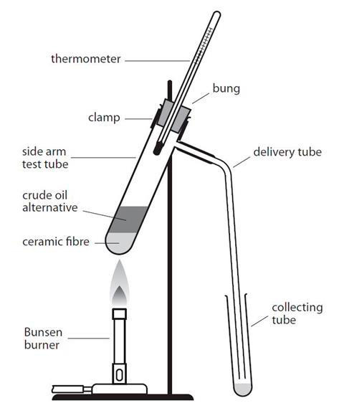

The table shows some of the observations recorded by the learners when they tested the properties of each fraction.
Fraction | Temperature range over which the fraction was obtained/°C | Colour | Viscosity | Ease of ignition
1 | 20–100 | very pale yellow
2 | 100–150
3 | 150–200 |  | doesn’t flow very easily | difficult to ignite
4 | 200–250 | brown

Make predictions about the missing observations and complete the gaps in the table using some of the words and phrases listed.
very difficult to ignite yellow high viscosity
easy to ignite green very easy to ignite
light brown low viscosity flows quite easily

- The table includes some of the names, molecular formulas and displayed formulas for the first four alkanes.

Complete the table by selecting the correct molecular formulas and displayed formulas from those listed.

butane methane pentane

C₂H₆ C₃H₈
Alkane | Molecular formula | Displayed formula
 | CH₄ | 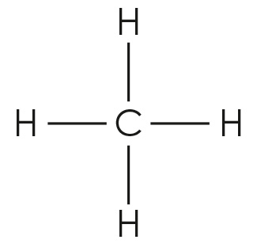
ethane
propane
 | C₄H₁₀

Fractional distillation and hydrocarbons:
what do I understand?
Think about your answers and confidence level for each mini-topic. Decide whether you understand it well, are unsure or need more help. Tick the appropriate column.
Mini-topic | I understand  this well | I think I understand this | I need more  help
I can describe the process of fractional distillation.
I can explain why crude oil can be separated into fractions.
I can identify a hydrocarbon from its molecular formulae.
I can write the general and molecular formulas for alkanes.
I can describe how the length of the hydrocarbon chain affects its boiling point.
I can compare the physical properties of the fractions.
I can compare complete and incomplete combustion.
Feeling confident? topics | I understand  this well | I think I understand this | I need more  help
I can predict the results of an experiment in which a crude oil alternative undergoes fractional distillation.
I can give the molecular and displayed formulas of the first four alkanes.

