Transition skills - basic mathematical competencies answer sheet

Rearranging equations

1.
a. $c =\frac{1000n}{v}$
b. $v= \frac{1000n}{c}$

2.
a. $m =d ×v$
b. $d = \frac{{m x 10}^{-3}}{v {x 10}^{-6}}$ = $\frac{m}{v x {10}^{-3}}$
1 mark for both parts of the fraction correct, 1 mark for cancelling down the × 10^{–6} to × 10^{–3}.

3.
a. $p= \frac{h}{λ}$
b. $v= \frac{h}{λm}$
1 mark for substitution of p = mv into the first equation and 1 mark for successful rearrangement.

4.
$v =\sqrt{\frac{KE}{0.5m}}$ or $v= \sqrt{\frac{2KE}{m}}$
1 mark for first rearrangement moving 0.5 m underneath the KE, 1 mark for dealing with the v² by addition of the square root.

BODMAS
1. a. 28
b. 40
c. 8
d. 45
e. 6
f. 40

2. a. 180
b. 5352
c. 180
Evaluation: Pressing equals after each operation leads to BODMAS errors.

Quantity calculus
- g cm–3
- 2.mol dm–3
- 3.g cm–3
- 4.mol dm–3 s–1
- 5.N m–2

- mol2 dm–6
- mol–1 dm3 s–1
- kPa–0.5
- mol2 dm–6
- mol dm–3

Expressing large and small numbers
1. a. 1.06 × 10⁶
b. 1.06 × 10^{–3}
c. 2.222 × 10²
2. 1 mark for sensible choice of × 10^{x} power, in this case × 10^{–2} or × 10^{–3} is most sensible. 0.5 marks for each number correctly converted.
3. a. 10⁴
b. 10¹⁴
c. 0.5 × 10^{–11} or 5 × 10^{–12}
d. 2.4 × 10²

Significant figures, decimal places and rounding
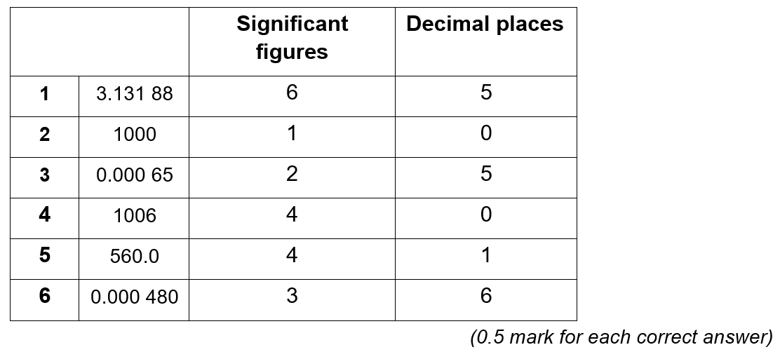
7. a. i. 0.0758
ii. 0.08
b. i. 231
ii. 231.46

Unit conversions 1 – Length, mass and time
1. 12 mm
2. 72.00 m
3. 270 s
4. 154 s
5. 2 h 25 min
6. 15.5 t
7. 26.5 g
8. 75 mg/tablet = 0.075 g/tablet
1 g ÷ 0.075 g/tablet = 13.3 tablets
Minimum number of tablets needed = 14
9. 30 g/min
NOTE In this example, as you are converting 1/the unit, you need to do the inverse of what is described in the diagram eg instead of ÷ 60, × 60.
10. 10.44 kg/h = 10 440 g/h = 174 g/min = 2.9 g/s

Unit conversions 2 – Volume
1. drinks bottle, 1 dm³; sugar cube, 1 cm³; washing machine, 1 m³
2. To convert a volume in cm³ into a volume in dm³, divide by 1000.
To convert a volume in cm³ into a volume in m³, divide by 1 000 000.
3. a. 1.6 dm³
b. 5.5 × 10^{–4} m³
c. 1350 cm³
d. 375 000 000 cm³
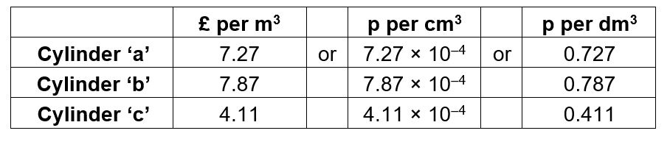
e. 0.006 54 m³
Therefore ‘c’ is the best value for money.

Moles and mass
1. a. 32.0 g ÷ 16.0 g mol^{–1} = 2 mol
b. 175 g ÷ 100.1 g mol^{–1} = 1.75 mol
c. 0.2 g ÷ 180.0 g mol^{–1} = 0.0011 mol
2. a 20 mol × 180 g mol^{–1} = 3 600 g
b 5.00 × 10^{–3} mol × 63.5 g mol^{–1} = 0.318 g
c 42.0 mol × 249.6 g mol^{–1} = 10 500 g
3. a. i. 3.09 g ÷ 0.0250 mol = 123.6 g mol^{–1}
ii. CuCO₃
b. molar mass of chromium carbonate = 4.26 g ÷ 0.015 mol = 284 g mol^{–1}
Cr₂(CO₃)
BONUS QUESTION
6.02 × 10²³ p ÷ 7 500 000 000 people = 8.03 × 10¹³ p per person or 803 000 million pounds per person!

Moles and concentration
1. a. 1.5 mol ÷ 0.25 dm³ = 6.0 mol dm^{–3}
b. 0.25 dm³ × 0.0150 mol dm^{–3} = 3.75 × 10^{–3} mol
c. 0.125 mol ÷ 0.85 mol dm^{–3} = 0.15 dm³
2. a. 5.0 g ÷ 84.0 g mol^{–1} = 0.0595 mol
0.0595 mol ÷ 0.100 dm³ = 0.60 mol dm^{–3}
b. 0.025 dm³ × 3.8 mol dm^{–3} = 0.095 mol
0.095 mol × 40.0 g mol^{–1} = 3.8 g
c. 2.5 g ÷ 129.9 g mol^{–1} = 0.0192 mol
0.0192 mol ÷ 1.3 mol dm^{–3} = 0.015 dm³
0148 dm³ = 15 cm³ (to 2 sig. fig.)

