The chemistry of chemical weapons
Education in Chemistry
November 2019
rsc.li/36092UV
The word Novichok means ‘newcomer’ in Russian. Novichoks are a family of nerve agents developed by the Soviet Union in the 1970s and 1980s to elude international restrictions on chemical weapons. However, Novichoks are not the only chemical weapons that present a threat to human life. In this activity you will look at the chemistry behind a number of chemical weapons that have been employed throughout history.

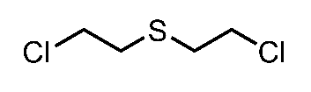
1. Mustard gas has a long history as a blister agent in warfare. First used in the First World War it causes severe burning of the skin, eyes and respiratory tract of anyone exposed to it.
Mustard gas

The mass spectrum of mustard gas is shown in Figure 1.
a. Explain the three peaks at m/z 158/160/162. State the relative abundance of each peak.
b. Suggest a structure for the fragments responsible for the peaks at m/z 109/111 and m/z 63/65.
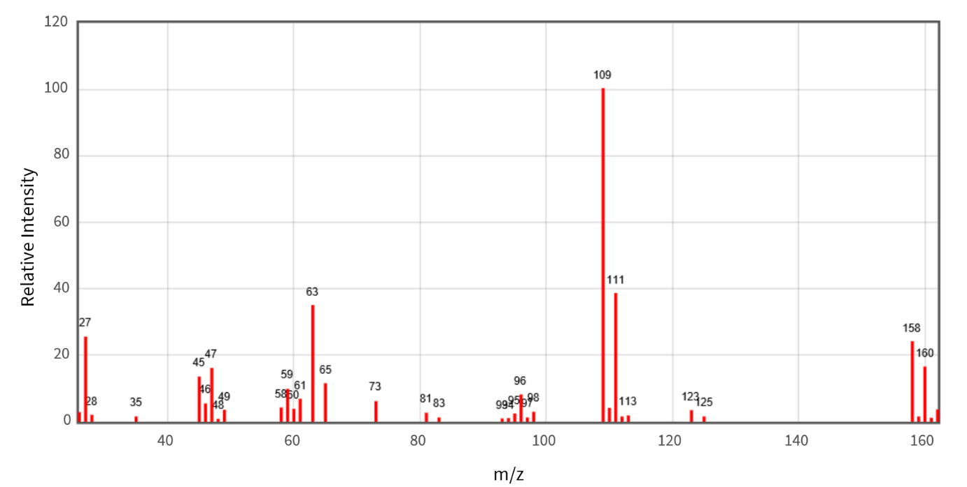
Figure 1– Mass spectrum of mustard gas; © NIST Mass Spectrometry Data Center

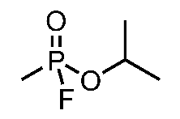
2. Sarin is a chemical warfare agent classed as a nerve agent. First synthesised by German scientists researching new pesticides it is thought to be approximately 500 times more deadly than cyanide.
a. Sarin is a chiral molecule. One enantiomer is known to be more active than the other due to its greater binding affinity to the enzyme acetylcholinerase.
Sarin
Draw the two enantiomers of sarin.
b. The lethal dose of sarin is about 0.5 mg. If the average adult breathes in approximately
10,000 l of air a day, calculate the time to the nearest second it would be before an adult received a lethal dose when 100 mg of sarin was released per m³ of air.

