Graphene fabrication gets rolling

Original article by Fernando Gomollón-Bel. Adapted by Nina Notman.

A new way to make graphene transforms the traditional sticky-tape method into something scalable

Chemists in Spain have developed a new method for producing graphene flakes cheaply and rapidly. The process may accelerate the commercial uptake of graphene because of its easy integration into industrial assembly lines.

In 2010, the Nobel prize in physics was awarded to Andre Geim and Kostya Novoselov, from the University of Manchester, for their discovery that flakes composed of a single layer of carbon atoms (graphene) can be peeled off from graphite using sticky tape. Since then, a number of processes for producing graphene at scale have been developed.

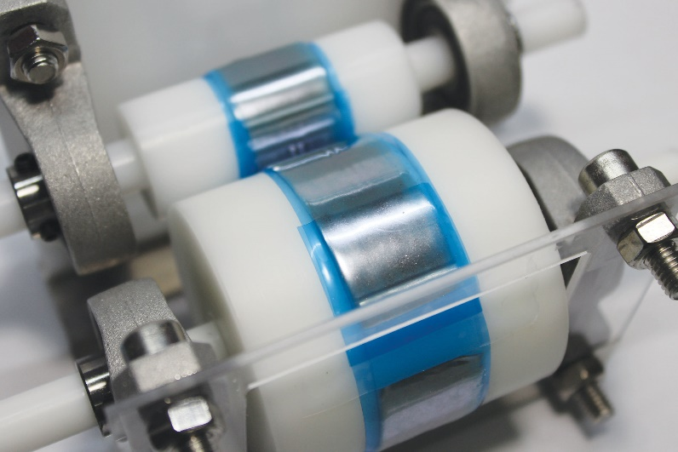
The significance of the new method, developed by Andrés Castellanos Gómez’s team at the Institute of Materials Science of Madrid, is its low-cost, fast speed and the size of the flakes produced. The large flakes it makes are particularly useful for simple transistors and photodetectors suitable for flexible devices and cost-effective sensors. Another advantage of this manufacturing approach over other methods is that it does not require any liquids. This matters because if graphene isn’t completely dry before use, its conductivity may be affected.

Source: © Y Sozen et al, Small Methods, 2023

A thin layer of carbon forms on the surface of one of the tapes after rolling the cylinders for only 20 seconds

A sticky innovation

Andrés uses the same tool as the Nobel prize winners – sticky tape. He wraps the tape around two rollers that are positioned so that they rub against each other when turned. Graphite flakes are then placed on a section of the tape, before the rollers are rotated until the tape is uniformly coated with graphene.

The current set-up produces 10 cm2 of graphene at a time. Andrés says the method can be easily scaled up to produce industrially useful amounts of graphene by using larger rollers and wider sticky tape. Andrés and his team have also used the same method to produce other 2D materials, including molybdenum disulfide and boron nitride.

This is adapted from the article High-throughput exfoliation gets graphene fabrication rolling in Chemistry World. Read the full article: rsc.li/3OODGJp

