- Ethanoic acid is the second member of the carboxylic acid homologous series.
An ethanoic acid molecule contains two carbon atoms, but also contains four hydrogen atoms and two 2 oxygen atoms.
- The atoms below can all be joined together to make a molecule of ethanoic acid.
The sticks from each atom are the covalent bonds they make.
Join together these atoms to make a molecule of ethanoic acid.
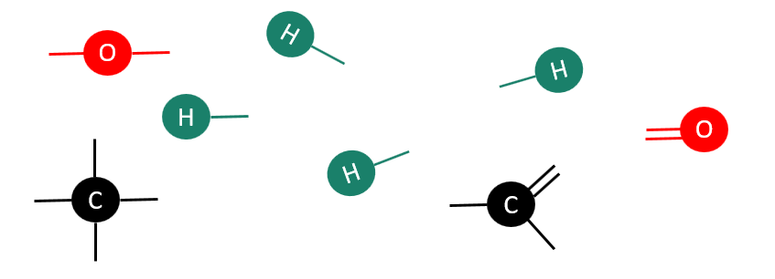
Draw your molecule in the space below the atoms.

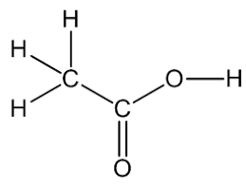

- The first member of the carboxylic acid homologous series is called methanoic acid.
The numbers of each type of atom in its molecule are in the table below.
Number of carbon atoms | Number of hydrogen atoms | Number of oxygen atoms
1 | 2 | 2

- Draw the structure of a methanoic acid molecule (use your answer to question 1 to help you).
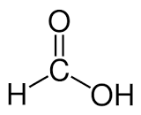

- What are the molecular formulae of the acids featured above?
Use your previous answers to help you.
Ethanoic acid | Answer: C₂H₄O₂
Methanoic acid | Answer: CH₂O₂

- Sean and Michelle would like to carry out different reactions using ethanoic acid.
They add each of the substances below to a sample of ethanoic acid.
Link together, by drawing a straight line, the substance on the left-hand side with its product on the right-hand side.

Substance added to ethanoic acid Products being formed
Magnesium ethanoate + water
Magnesium

Magnesium oxide
Magnesium ethanoate + carbon dioxide + water
Magnesium carbonate
Magnesium ethanoate + hydrogen
Magnesium hydroxide

- Each of the organic molecules below has two carbon atoms.
There is a carboxylic acid, an alcohol, an alkene, an alkane and an ester, but they are muddled up.

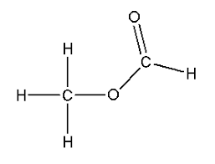
Complete the table by writing each letter (A–E) into the correct box.
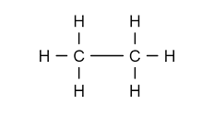
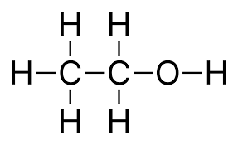

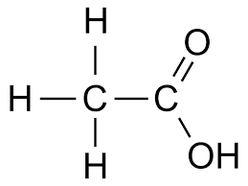
E
C
A
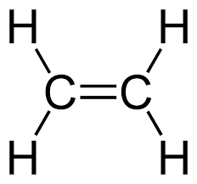

D
B

carboxylic acid | alcohol | alkene | alkane | ester
Answer: B. | Answer: A. | Answer: D. | Answer: E. | Answer: C.

- This question is about naming carboxylic acids.
A student has named the carboxylic acids below, but he has made some mistakes.
How many correct answers has he scored out of 5?
For any incorrect answers, add the correct names.

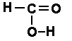  Methanol | Answer: Methanoic acid
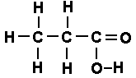  Pentanoic acid | Answer: Propanoic acid
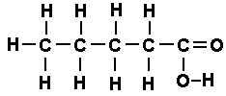  Propanoic acid | Answer: Pentanoic acid
Ethanoic acid | Answer: Ethanoic acid
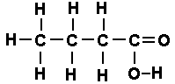  Butanoic acid | Answer: Butanoic acid

Overall score: 2/5

