Measuring the amount of vitamin C in fruit drinks – student sheet
In this experiment you will be finding out how much vitamin C there is in a fruit drink.
The chemical name for vitamin C is ascorbic acid. The basis of the experiment is as follows.

A known amount of iodine is generated by the reaction between iodate, iodide and sulfuric acid:
IO^{3–}(aq) + 5I–(aq) + 6H⁺(aq) → 3I₂(s) + 3H₂O(l)
A measured amount of fruit drink is added. The ascorbic acid in the drink reacts quantitatively with some of the iodine as the iodine is in excess:

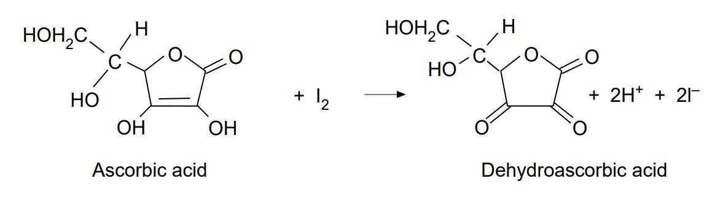

The excess iodine is then titrated against standard sodium thiosulfate solution:
I₂ (aq) + 2S₂O₃^{2–}(aq) → S₄O₆^{2–}(aq) + 2I–(aq)

From the titration results the amount of iodine that reacts with the sodium thiosulfate solution can be found.

Since the total amount of iodine originally formed is known the amount that reacts with the ascorbic acid is found by difference.

Therefore, the amount of ascorbic acid that reacts with this amount of iodine can be found.

Procedure
- Set up the microscale titration apparatus.
- Fill the apparatus with sodium thiosulfate solution.
- Using the glass pipette, add 2 cm³ of potassium iodate solution to the beaker.
- Measure, using the measuring cylinder, 3 cm³ of potassium iodide solution, then add this to the beaker. (Note: the potassium iodide solution is added in slight excess.)
- Add three drops of sulfuric acid. A yellow-brown colour appears due to iodine.
- Add a few drops of starch solution. A deep blue-black colour forms.
- Using the glass pipette, add 1 cm³ of the fruit drink to the beaker and swirl gently.
- Titrate the remaining iodine in the beaker against the sodium thiosulfate solution. (The beaker can be swirled very gently to mix the chemicals. Alternatively, the tip of a plastic pipette can be used as a mini stirring rod.) The disappearance of the deep blue-black colour marks the end-point.
- Do a duplicate titration and check the agreement between the two titres. If it is acceptable, take the mean value of the two titres and use it for your calculations.

Calculations
A specimen result and calculation is given below.
Study this carefully and use it as a guide for working out the vitamin C content of your fruit drink.

The volume of thiosulfate delivered during the titration = 0.74 cm³.
The concentration of thiosulfate = 0.010 mol dm^{–3}.
Therefore, the number of moles of thiosulfate =

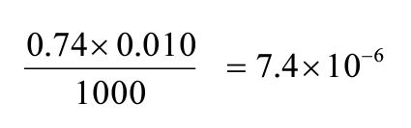

Therefore, the number of moles of iodine that this reacts with during the titration is 3.7 x 10^{–6}
The total number of moles of iodine produced in the reaction between iodate, iodide and sulfuric acid based on using 2 cm³ of iodate with a concentration of 0.0012 mol dm^{–3} =

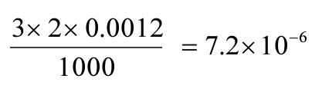
Therefore, the number of moles of iodine that reacts with the ascorbic acid is 7.2 × 10^{–6} - 3.7 × 10^{–6} = 3.5 × 10^{–6}.

Since 1 mole of iodine reacts with 1 mole of ascorbic acid then the number of moles of ascorbic acid is also 3.5 × 10^{–6}. The volume of the fruit juice used is 1 cm³.

Therefore, the number of moles of ascorbic acid in 1000 cm³ = 3.5 × 10^{–3}. The relative molar mass of ascorbic acid = 174.12 g.

Therefore, the mass of ascorbic acid (in 1000 cm³) = 174.12 × 3.5 × 10^{–3} = 0.609 g.

Therefore, the vitamin C content of the fruit drink = 61mg per 100 cm³.

Health, safety and technical notes
- Read our standard health and safety guidance here https://rsc.li/3SRKCow
- Wear eye protection.
- Sulfuric acid, 1 mol dm³ is a skin/eye irritant (see CLEAPSS Hazcard HC098a).
- Sodium thiosulfate, 0.010 mol dm⁻³, potassium iodate, 0.001 mol dm⁻³ and potassium iodide, 0.005 mol dm⁻³ solutions are of low hazard, as are the starch solution and fruit juices (see CLEAPSS Hazcards HC095a, HC080, HC047b).

