The quantitative analysis of various formulations of paracetamol

The British Pharmacopoeia method for the analysis of paracetamol involves heating it under reflux with 1 mot dm⁻³ sulfuric acid. This is a straightforward, acid catalysed, hydrolysis of an amide to an amine and a carboxylic acid. The 4-aminophenol which is formed is then titrated with an oxidising agent, ammonium cerium(lV) sulfate using ferroin as the indicator.

The first reaction is as follows:
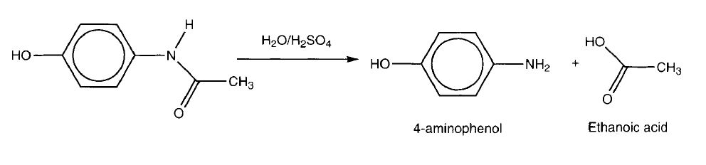
The titration step is much more interesting. 4-Aminophenol can easily be oxidised as follows:

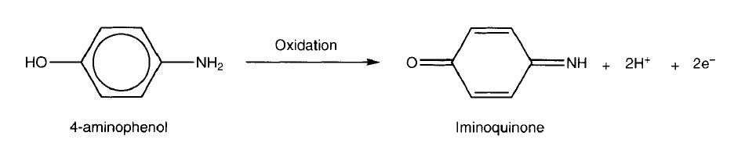
The role of the ammonium cerium(lV) sulfate is to oxidise the 4-aminophenol to the iminoquinone. Only after all the 4 aminophenol has been oxidised will the cerium (IV) reagent oxidise the ferroin indicator from Fe²⁺ to Fe³⁺ (ferriin).

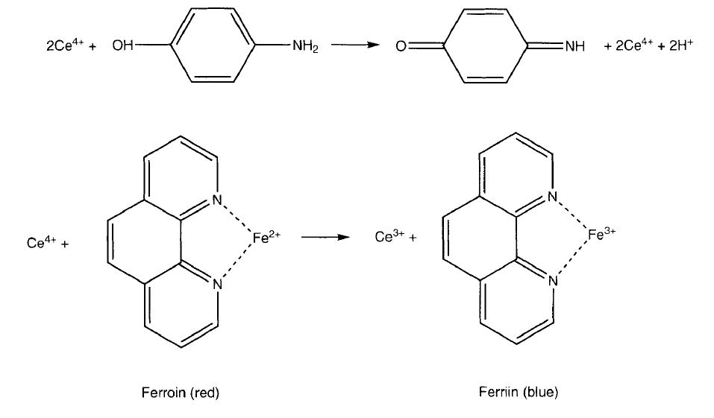
During the titration the solution should be red, and the yellow end point is the transition from red to pale blue.
It is easy to work out that, since 1 mole of Ce4+ is equivalent to 0.5 mole of paracetamol, the conversion factor given in the method is correct.

Health, safety and technical notes
- Read our standard health and safety guidance https://rsc.li/3OGYbr3
- Wear eye protection.
- Paracetamol formulations - do not ingest.
- Sulfuric acid (1 mol dm⁻³) - corrosive, especially when hot.
- Hydrochloric acid (2 mol dm⁻³) - irritant.
- Ferroin solution - hazards unknown. May cause skin irritation.
- Ammonium cerium(lV) sulfate - respiratory tract irritant, strong oxidising agent, keep away from flammable material.

Chemicals
- Sulfuric acid (1 mol dm⁻³)
- Hydrochloric acid (2 mol dm⁻³)
- Ammonium cerium(lV) sulfate (0.1 mol dm⁻³)
- Paracetamol
- Water
- Ferroin solution (0.1 o/o wt or 0.025 mol dm⁻³)

Apparatus and equipment (per group)
- Round bottom flask
- Quick fit reflux apparatus
- Heating mantle, or Bunsen burner, tripod and gauze
- Clamps and stand
- Spatula
- One 10 cm³ measuring cylinder
- One 50 cm³ measuring cylinder
- Burette
- Two conical flasks
- Beaker
- Eye protection

Procedure as outlined in the British Pharmacopoeia 1988

Method
- Dissolve 0.3 g of a mixture containing paracetamol n a mixture of water (10 cm³) and 1 mol dm⁻³ sulfuric acid (30 cm³).
- Boil under reflux for 1 hour, cool and dilute with water (100 cm³).
- To 20 cm³ of the resulting solution add cold water (40 cm³, 2 mol dm⁻³ hydrochloric acid (15 cm³) and ferroin solution (0.1 cm’, 0.1 wt% or 0.025 mol dm⁻³).
- Titrate with 0.1 mol dm⁻³ ammonium cerium(lV) sulfate (VS - volumetric standard) until a yellow colour is produced.
- Repeat the operation without the test material being present. The difference between the titration figures represents the amount of ammonium cerium(lV) sulfate required. Each cm³ of 0.1 mol dm⁻³ ammonium cerium(lV) sulfate is equivalent to 0.007560 g of paracetamol.

This method can be used to analyse the quantity of paracetamol present in many medicines that contain the drug.

Question
How could you prove that the first step in the quantitative analysis of paracetamol involves hydrolysis to 4-aminophenol?

Answers
Isolate the material and characterize it, determine the melting point and compare it with the previous one, also tlc, or follow the reaction by running tlc plates using paracetamol and 4-aminophenol as reference spots.

