Teaching rates of reaction post-16: assessment
Education in Chemistry
September 2021
rsc.li/3jV0WVq
A more creative way to assess whether students understand a concept is for them to apply their knowledge to solve a problem or to interpret and explain something. Try these four ideas.

Apply your knowledge of rates of reaction
- Watch the video of Rochelle’s salt reaction. What evidence suggests that the reaction is catalysed?
- Describe and explain what the following diagram depicts.
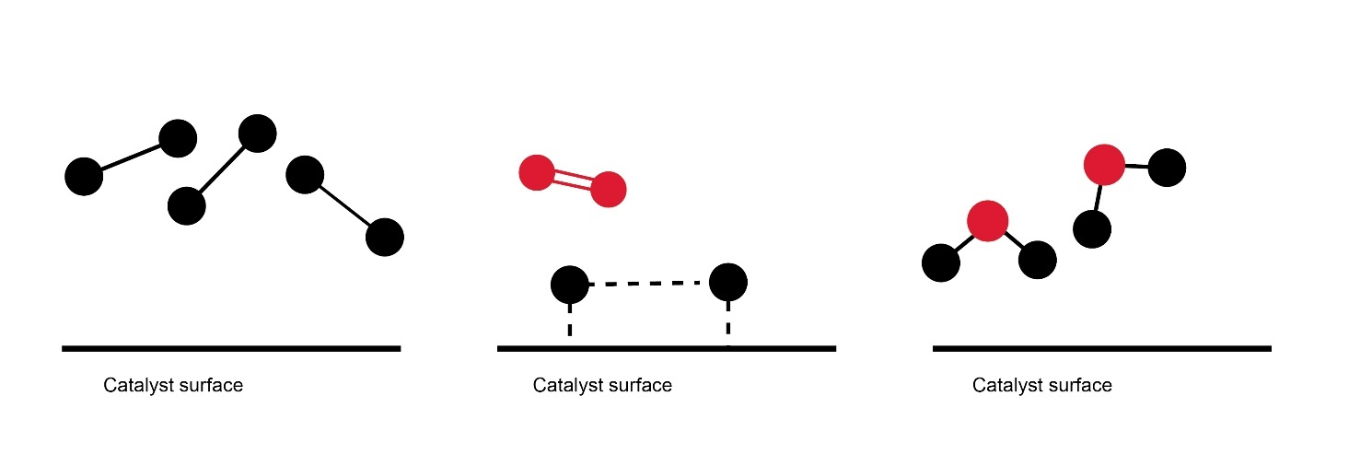
- Look at the equations. What represents the catalysts and what represents a transitional or intermediate state? What are the products? Write the overall equation for the reaction.
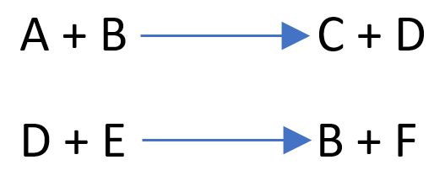
- Look at this reaction equation and identify the intermediate and catalyst species. Explain your answers.
