Redox equilibria

The electrochemical series

Good reducing agents (good at losing electrons)

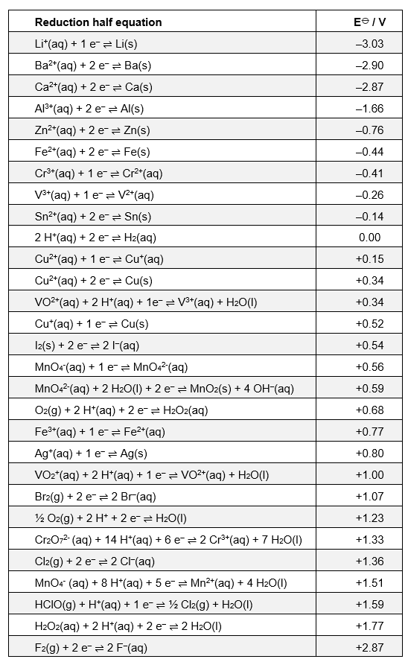

Good oxidising agents (good at gaining electrons)

Redox reactions

Faisal has written the following notes on redox reactions in preparation for his AS exams. However there are a few mistakes, many of which are commonly seen in exam answers. Help Faisal learn from his mistakes by correcting the errors so that he has an accurate set of notes to revise from.
(10 marks)
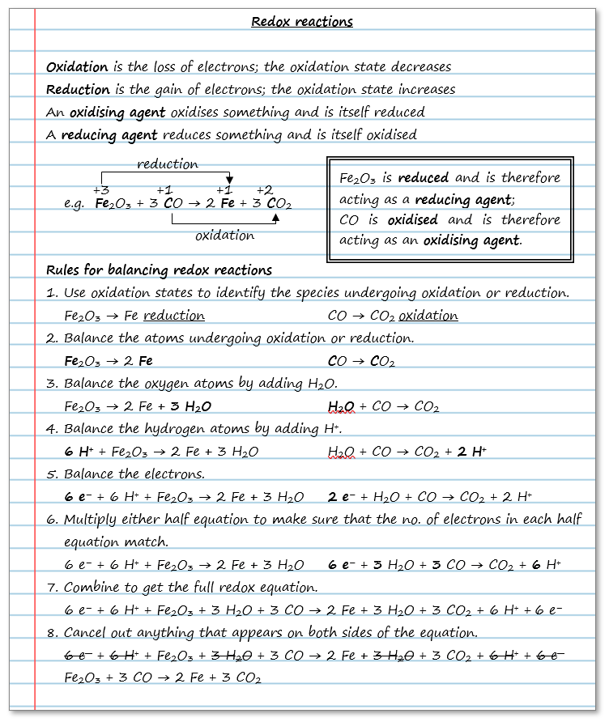

Standard electrode potentials

We can measure how readily something gives away electrons by measuring its standard electrode potential, E⦵.

1. Standard electrode potentials are measured by connecting a half cell containing the equilibrium, the potential of which is to be measured to a standard hydrogen electrode at 298 K.
(a) Label the diagram below showing the standard hydrogen electrode.
(3 marks)

(b) Complete the diagram to show the complete cell you would use if you wished to measure E⦵ for a zinc electrode.
(4 marks)

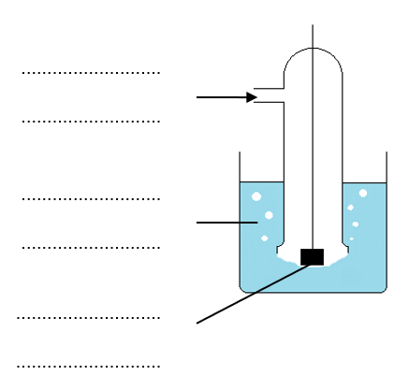
2. Cells can be represented in shorthand form using a series of standard conventions.
(a) Match up the symbol to its meaning when used to represent an electrochemical cell;
| Shows a salt bridge
|| Indicates a phase boundary
(1 mark)
(b) For each half cell, the species in the highest oxidation state in the redox equilibrium is written next to the salt bridge.

Use this convention to complete the shorthand representation of the cells produced when half cells containing each of the equilibria below are connected to a standard hydrogen electrode.

(i) Fe²⁺(aq) + 2 e– ⇌ Fe(s); Pt | H₂(g) | H⁺(aq) ||
(1 mark)
(ii) MnO₄⁻(aq) + 1 e– ⇌ MnO₄²⁻(aq); Pt | H₂(g) | H⁺(aq) ||
(1 mark)

Calculations involving electrochemical cells

1. For each of the electrochemical cells described below;
(i) Calculate the emf of the cell as written,
(ii) Identify the reaction occurring at the positive and negative electrodes,
(iii) Write an equation for the overall cell reaction which occurs when the electrodes are connected

Assume standard conditions. Use the table of standard electrode potentials provided at the start of this chapter for reference.

(a) Al(s) | Al³⁺(aq) || Zn²⁺(aq) | Zn(s)
E⦵ _{cell}
Positive electrode half equation
Negative electrode half equation
Overall cell reaction
(4 marks)

(b) Cl⁻(aq) | Cl₂(g) || Fe²⁺(aq) | Fe(s)
E⦵ _{cell}
Positive electrode half equation
Negative electrode half equation
Overall cell reaction
(4 marks)
2. The electrochemical cell shown below is set up;

Pt | Mn²⁺(aq), MnO₄⁻(aq) || S₂O²₈⁻(aq), SO₄²⁻(aq) | Pt, E⦵ _{cell} = +0.50 V

(a) Calculate the standard electrode potential for the following half-reaction;

S₂O₈²⁻(aq) + 2 e– ⇌ 2 SO₄²⁻(aq)
(1 mark)
(b) For the standard electrode potentials, all ion concentrations must be 1 mol dm⁻³.

Deduce what effect an increase in the concentration of S₂O₈²⁻(aq) ions to higher than 1 mol dm⁻³ would have on E⦵ _{cell}.
(1 mark)

Using Em_{sat} values to predict reactions

We can use standard electrode potentials to predict if reactions will happen. Remember the more negative the electrode potential the better the species on the right of the reduction half equation is as a reducing agent.

1. (a) Predict if the following reactions are feasible or not;
(i) Cu²⁺(aq) + 2 Br⁻(aq) → Cu(s) + Br₂(g)
(1 mark)
(ii) Fe(s) + Cu²⁺(aq) → Fe²⁺(aq) + Cu(s)
(1 mark)

(b) Choose a halogen that could be used to oxidise Fe²⁺(aq) ions to Fe³⁺(aq) ions. Explain your choice.

(2 marks)
(c) When carrying out oxidation reactions, a solution of MnO₄⁻(aq) cannot be acidified by HCl whereas a solution of Cr₂O₇²⁻ in theory can.

Explain why, using your understanding of standard electrode potentials.

(2 marks)
2. For each of the following combination of reagents, choose from the options below the final colour of the solution. Write an equation to represent the overall reaction occurring.

Green blue yellow orange lilac

- Addition of tin powder to a solution of VO₂⁺ ions in acidic conditions.
[V²⁺(aq) is lilac; V³⁺(aq) is green; VO²⁺(aq) is blue and VO₂⁺(aq) is yellow]

(2 marks)
(b) Addition of silver powder to a solution of dichromate (Cr₂O₇²⁻) ions in acidic conditions.
[Cr₂O₇²⁻ (aq) is orange; Cr³⁺(aq) is green; Cr²⁺(aq) is blue]

(2 marks)

Applications of electrochemical cells

Technically a battery is two or more simple cells connected together. However in everyday speech we rarely make the distinction.

There are a wide variety of batteries available today. The table below shows some details of the chemistry involved in just a few.

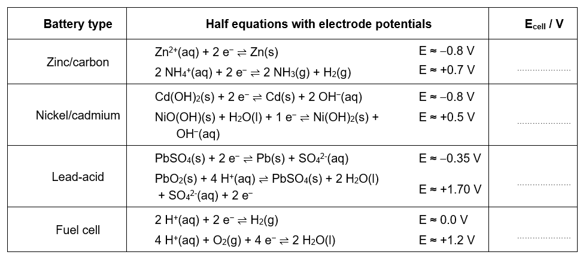
1. Complete the table above by calculating the e.m.f. for each of the different cell types.
(4 marks)
2. Consider the nickel/cadmium cell in more detail.
- Identify the element which undergoes a change in oxidation state at the positive electrode and state the oxidation state change.

- marks)
- Write the conventional representation of the cell.

(2 marks)
- The nickel-cadmium cell is rechargeable. Write an equation for the overall reaction that occurs when the battery is being recharged.

(1 mark)
- Nickel/cadmium cells must be carefully disposed of. Suggest one reason why.

(1 mark)

Redox equilibria - Answers

Redox reactions
Corrections shown in red and circled.
(10 marks; 1 mark for each correct correction made)
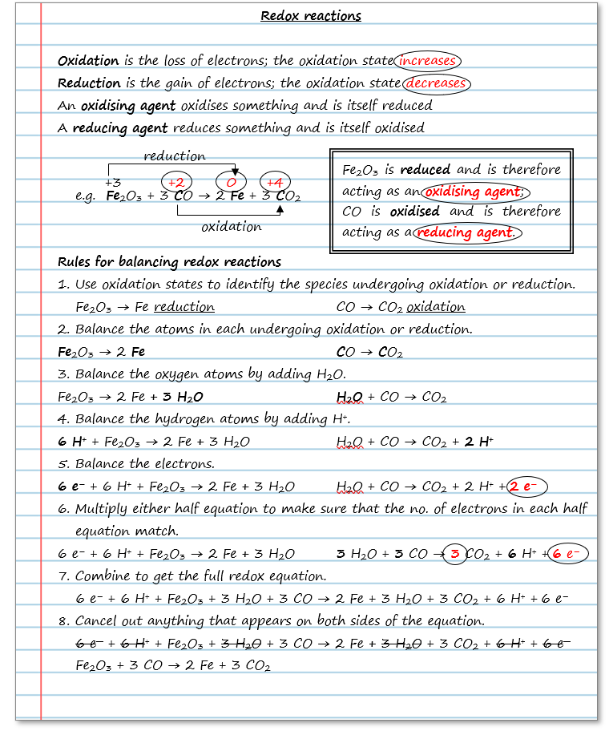

Standard electrode potentials
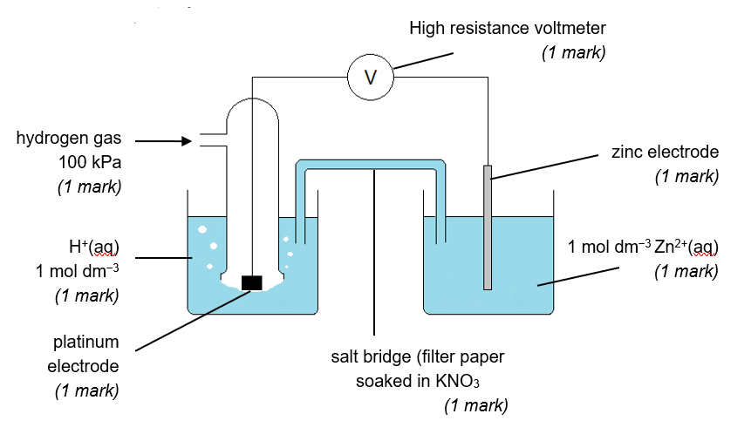
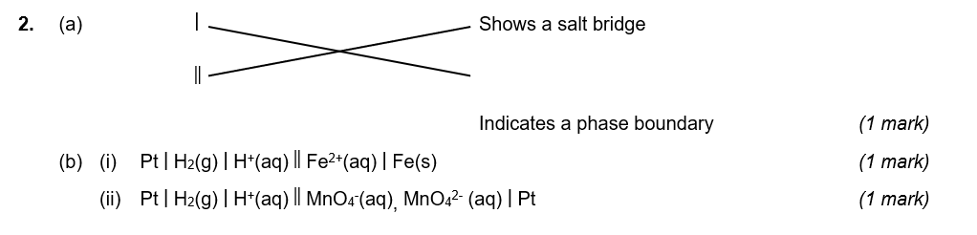

Calculations involving electrochemical cells

1. (a) E⦵ _{cell} = −0.76 − (−1.66) = +0.90 V
(1 mark)
Positive electrode: Zn²⁺(aq) + 2 e⁻ → Zn(s) × 3
(1 mark)
Negative electrode: Al(s) → Al³⁺(aq) + 3 e⁻ × 2
(1 mark)
Overall cell reaction: 3 Zn²⁺(aq) + 2 Al(s) → 3 Zn(s) + 2 Al³⁺(aq)
(1 mark)
(b) E⦵ _{cell} = −0.44 − (+1.36) = −1.80 V
(1 mark)
Positive electrode: Cl₂(g) + 2 e⁻ → 2 Cl⁻(aq)
(1 mark)
Negative electrode: Fe(s) → Fe²⁺(aq) + 2 e⁻
(1 mark)
Overall cell reaction: Cl₂(g) + Fe(s) → 2 Cl⁻(aq) + Fe²⁺(aq)
(1 mark)

2. (a) +0.50 V = E⦵ _{RHS} − (+1.51 V), ∴ E⦵ _{RHS} = +2.01 V
(1 mark)

- According to Le Chatelier’s principle, an increase in the concentration of S₂O₈²⁻(aq) ions causes the equilibrium to shift to the right (using up electrons) and therefore E⦵ _{RHS} will become more positive. Since E⦵ _{cell} = E⦵ _{RHS −} E⦵ _{LHS}, the more positive E⦵ _{RHS} the more positive E⦵ _{cell.} Therefore E⦵ _{cell} will increase / become more positive.

(1 mark)

Using Em_{sat} values to predict reactions

- (a) (i) Cu²⁺(aq) + 2 e– ⇌ Cu(s) E⦵ = +0.34 V, so Cu(s) → Cu²⁺(aq) + 2 e–
Br₂(g) + 2 e– ⇌ 2 Br–(aq) E⦵ = +1.07 V, so Br₂(g) + 2 e– → 2 Br–(aq)
Hence the reaction, Cu²⁺(aq) + 2 Br⁻(aq) → Cu(s) + Br₂(g) is not feasible
(1 mark)
(ii) Fe²⁺(aq) + 2 e– ⇌ Fe(s) E⦵ = −0.44 V, so Fe(s) → Fe²⁺(aq) + 2 e–
Cu²⁺(aq) + 2 e– ⇌ Cu(s) E⦵ = +0.34 V, so Cu²⁺(aq) + 2 e– ⇌ Cu(s)
Hence the reaction, Fe(s) + Cu²⁺(aq) → Fe²⁺(aq) + Cu(s) is feasible
(1 mark)

(b) Fe³⁺(aq) + 1 e– ⇌ Fe²⁺(aq) E⦵ = +0.77 V
F₂(g) + 2 e– ⇌ 2 F–(aq) E⦵ = +2.87 V
Cl₂(g) + 2 e– ⇌ 2 Cl–(aq) E⦵ = +1.36 V
Br₂(g) + 2 e– ⇌ 2 Br–(aq) E⦵ = +1.07 V
I₂(g) + 2 e– ⇌ 2 I–(aq) E⦵ = +0.54 V

For the halogen to oxidise the Fe³⁺ ions, +0.77 V must be the more negative reduction potential. Therefore any of fluorine, chlorine or bromine would be a suitable oxidising agent.
(2 marks)

(c) Cr₂O₇²⁻ (aq) + 14 H⁺(aq) + 6 e– ⇌ 2 Cr³⁺(aq) + 7 H₂O(l) E⦵ = +1.33 V
MnO₄⁻(aq) + 8 H⁺(aq) + 5 e– ⇌ Mn²⁺(aq) + 4 H₂O(l) E⦵ = +1.51 V
Cl₂(g) + 2 e– ⇌ 2 Cl–(aq) E⦵ = +1.36 V

Comparing initially at the reduction potentials for MnO₄⁻/Mn²⁺ and Cl₂/Cl–, the latter has the more negative value and hence the chloride ions in the hydrochloric acid will be oxidised by the MnO₄⁻ to produce chlorine gas which is toxic. Hence a solution of MnO₄⁻ cannot be acidified by HCl.
(1 mark)

Comparing now at the reduction potentials for Cr₂O₇²⁻ /Cr³⁺ and Cl₂/Cl–, the formed now has the more positive value and hence the chloride ions cannot be oxidised by Cr₂O₇²⁻ (this of course assumes standard conditions).
(1 mark)

2. (a) Sn²⁺(aq) + 2 e– ⇌ Sn(s) E⦵ = −0.14 V
V³⁺(aq) + 1 e– ⇌ V²⁺(aq) E⦵ = −0.26 V
VO²⁺(aq) + 2 H⁺(aq) + 1 e– ⇌ V³⁺(aq) + H₂O(l) E⦵ = +0.34 V
VO₂⁺(aq) + 2 H⁺(aq) + 1 e– ⇌ VO²⁺(aq) + H₂O(l) E⦵ = +1.00 V

Between VO₂⁺/ VO²⁺ and Sn²⁺ / Sn the latter has the more negative electrode potential and so Sn will act as a reducing agent, reducing VO₂⁺ to VO²⁺;

Sn(s) → Sn²⁺(aq) + 2 e– and VO₂⁺(aq) + 2 H⁺(aq) + 1 e– → VO²⁺(aq) + H₂O(l)

Between VO²⁺ / V³⁺ and Sn²⁺ / Sn again the latter has the more negative electrode potential and so Sn will act as a reducing agent, reducing VO²⁺ to V³⁺;

Sn(s) → Sn²⁺(aq) + 2 e– and VO²⁺(aq) + 2 H⁺(aq) + 1 e– → V³⁺(aq) + H₂O(l)

Finally between V³⁺/ V²⁺ and Sn²⁺ / Sn the former has the more negative electrode potential and so no further reaction will occur.

The colour of the final solution will therefore be green owing to the presence of V³⁺(aq) ions.

The overall equation for the reaction is;
2 Sn(s) + VO₂⁺ (aq) + 4 H⁺ → 2 Sn²⁺(aq) + V³⁺(aq) + 2 H₂O(l)

(1 mark for the identification of the correct final colour, 1 mark for the overall equation)

(b) Ag⁺(aq) + 1 e– ⇌ Ag(s) E⦵ = +0.80 V
Cr₂O₇²⁻ (aq) + 14 H⁺(aq) + 6 e– ⇌ 2 Cr³⁺(aq) + 7 H₂O(l) E⦵ = +1.33 V
Cr³⁺(aq) + 1 e– ⇌ Cr²⁺(aq) E⦵ = −0.41 V

Between Ag⁺/Ag and Cr₂O₇²⁻/Cr³⁺, the former has the more negative electrode potential and so Ag will act as a reducing agent, reducing Cr₂O₇²⁻ to Cr³⁺;

Ag(s) → Ag⁺(aq) + 1 e– and Cr₂O₇²⁻(aq) + 14 H⁺(aq) + 6 e– ⇌ 2 Cr³⁺(aq) + 7 H₂O(l)

Between Ag⁺/Ag and Cr³⁺/Cr²⁺, the latter has the more negative electrode potential and so no further reaction can occur i.e. the Ag cannot reduce any Cr³⁺ ions formed to Cr²⁺ ions.

Therefore the final colour of the solution will be green owing to the presence of Cr³⁺(aq) ions.

The overall equation for the reaction is;

6 Ag(s) + Cr₂O₇²⁻(aq) + 14 H⁺(aq) ⇌ 6 Ag⁺(aq) + 2 Cr³⁺(aq) + 7 H₂O(l)

(1 mark for the identification of the correct final colour, 1 mark for the overall equation)

Applications of electrochemical cells
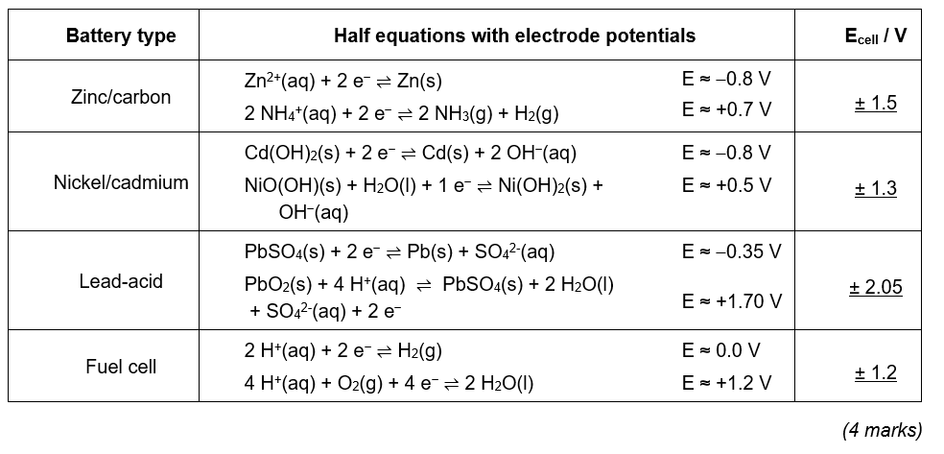
- (a) Nickel, from +3 in NiO(OH) to +2 in Ni(OH)₂
(2 marks)

(b) [2 OH⁻(aq) + Cd(s)], Cd(OH)₂(s) || [NiO(OH)(s) + H₂O(l)], [Ni(OH)₂(s) + OH⁻(aq)]
(2 marks, 1 for each side correct)

(c) Cd(OH)₂(s) + 2 Ni(OH)₂(s) → 2 NiO(OH)(s) + 2 H₂O(l) + Cd(s)
(1 mark)
(d) Nickel / cadmium are both toxic metals.
(1 mark)

