Eruption!
Education in Chemistry
January 2019
rsc.li/2Bf0hIf
Read through the article provided. The activities below will help you understand the material and learn more about the chemical processes that take place during eruptions.

1. Key word storyboard
In this activity, you will need to write sentences connecting key words from the article. It is extremely important that you use scientific language in your sentences and you should try to use words from the scientific word bank. Your teacher will work through some examples with you to get you started.

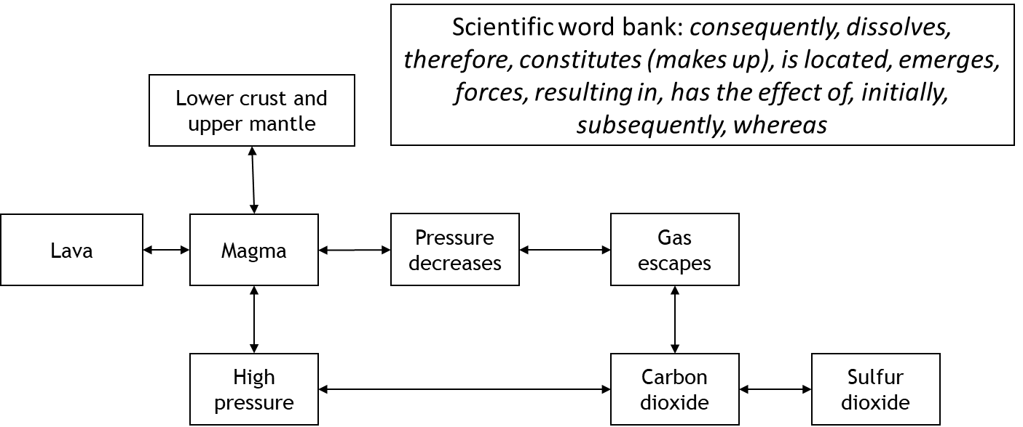

2. Viscosity experiment
Two students wanted to investigate the viscosity (thickness) of mixtures of honey and water. They used 10 cm³ in total but made each solution with different volumes of honey and water. They took a droplet of each mixture and let it roll down a ramp. They timed how long each droplet took to roll down the ramp and recorded their results in the table below. They repeated each experiment twice.
Mixture | Volume of water (cm³) | Volume of honey (cm³) | Time taken to roll down (s)
 |  |  | 1 | 2 | 3 | Mean
1 | 0 | 10 | 42 | 44 | 40
2 | 2 | 8 | 37 | 35 | 35
3 | 4 | 6 | 31 | 31 | 31
4 | 6 | 4 | 22 | 45 | 20
5 | 8 | 2 | 15 | 16 | 18
6 | 10 | 0 | 10 | 9 | 11

Answer the questions below.
- What is more viscous, honey or water?
- Calculate a mean for each mixture.
- There is one anomaly in the table. Circle it.
- Explain how you know it is an anomaly.
- Calculate the mean again, but this time ignore the anomaly.
- Why is it important that the students repeated their experiment?
- Why is it important that the students used the same slope each time?
- What other things should they keep the same each time?
- Draw a graph with volume of honey on the x axis and mean time on the y axis.

3. Volcanologists
A volcanologist is someone who studies volcanoes. A politician writes a letter to a volcanologist asking them to predict when a volcano is going to erupt. Write a letter in response explaining why it is difficult to predict when a volcano is going to erupt, but what things you could look at to help you make that prediction.

