Using seawater to reduce our carbon footprint

Original article by Rebecca Trager. Adapted by Nina Notman.

New system that uses the Earth’s seawater sink has advantages over existing systems that capture carbon dioxide gas from air

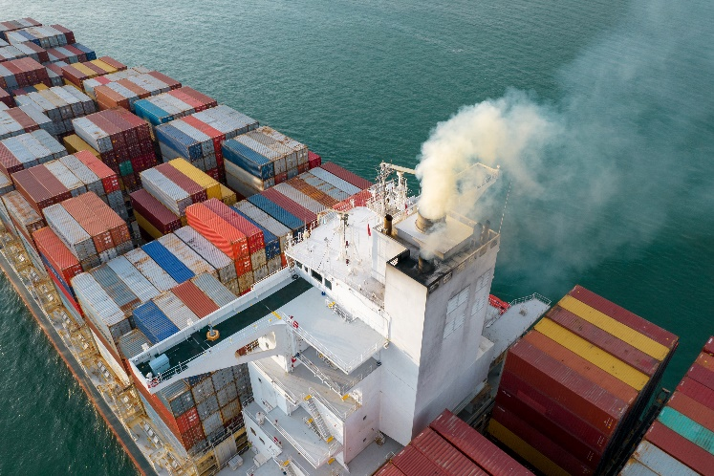
Capturing carbon dioxide (CO₂) from seawater to address climate change could be more efficient and cheaper than existing systems that capture it from ambient air, say engineers in the US. Oceans and other surface waters act as large carbon sinks and have absorbed 30% to 40% of CO₂ emissions from human activities since the industrial revolution began.

Source: © Suphanat Khumsap/EyeEm/Getty Images

Locking away CO₂ in a new method to reduce our carbon footprint

Ocean capture

Carbon dioxide reacts with seawater to form carbonic acid, which can then dissociate to form bicarbonate (and other) ions. The engineers at the Massachusetts Institute of Technology (MIT) have developed an electrochemical system that converts the bicarbonate ions back into CO₂ gas that can then be collected.

The MIT team’s ocean capture system uses a bismuth electrode that reacts with the chloride ions naturally present in salt water, producing a bismuth compound and protons. These protons increase the acidity of the water, which causes the bicarbonates to break down and reform CO₂. The water is then returned to its original pH before it is released back into the ocean.

Making space

Releasing CO₂ from ocean water in this way enables it to capture more CO₂ from the air. ‘Anthropogenic CO₂ distributes between the ambient air and the ocean water, so removing it from the oceans means there is a drive for more to be absorbed [by the water] and thereby be removed from the air,’ says Alan Hatton, one of the study’s co-authors. ‘The net result of what we do is to remove CO₂ from the environment as a whole,’ he adds.

The team’s ocean capture system could be more efficient than air capture systems because the concentration of dissolved CO₂ in seawater is more than 100 times greater than it is in air, Alan notes. A preliminary cost analysis suggests that this technology would be economically feasible, with costs ranging from $50–$100 (£42–£83) per tonne of CO₂. For comparison, one air capture system was calculated to cost $600 per tonne of CO₂ in 2020.

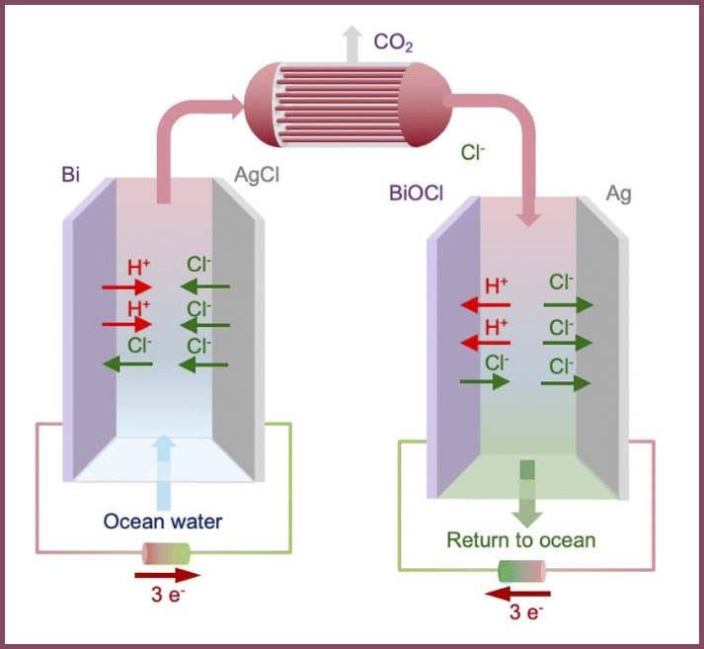
Finding a purpose

The Once the CO₂ is extracted from the seawater, the question becomes what to do with it. Alan believes there are two possibilities: CO₂ can be turned into fuels, chemicals and materials, or it can be permanently sequestered (stored) in rock formations underground. Both these solutions are already in use for CO₂ captured from air.

The MIT engineers are currently patenting their ocean capture system. At first, the idea is to couple the technology with existing infrastructure that already processes seawater, such as desalination plants that remove salt to create drinking water. The team’s end goal is for its system to be deployed as free-standing ocean capture plants around the world.

Source: © Alan Hatton

MIT scientists have harnessed electrolysis to separate CO₂ from acidic seawater to be used as fuels, chemicals and materials

This is adapted from the article Electrochemistry offers new way to tackle rising carbon dioxide – extract it from seawater in Chemistry World. Read the full article: rsc.li/3lkq2Sw

