Particle model: knowledge check
- Add the following labels to the diagram below.

boiling condensing freezing gas

liquid melting solid
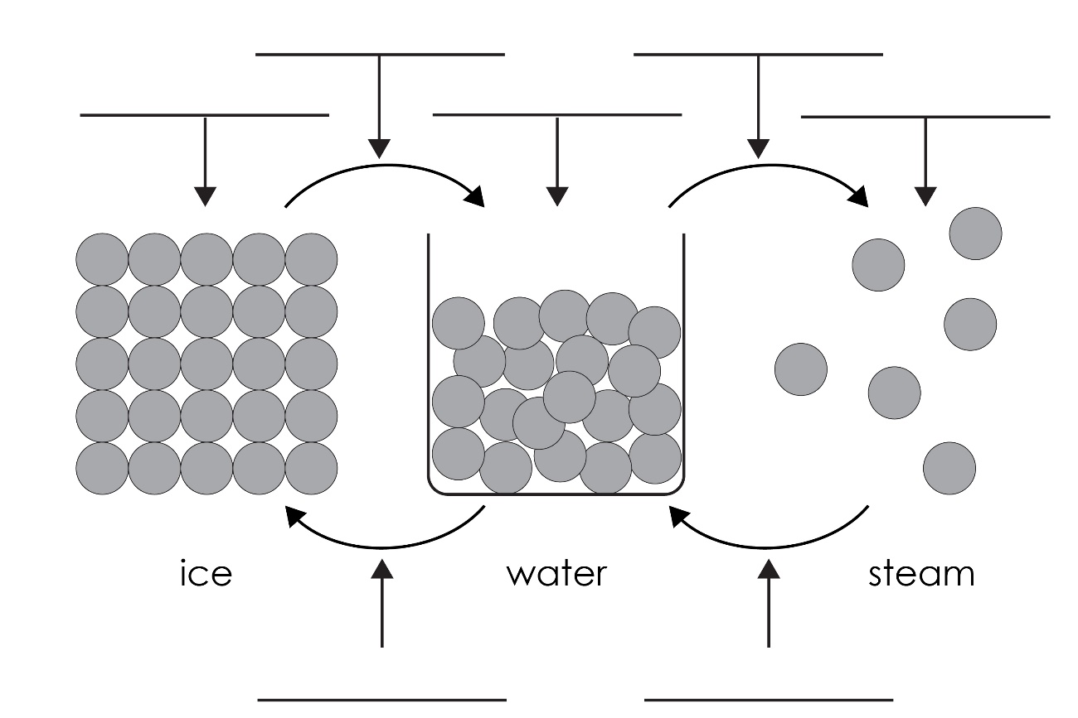
- (a) How are particles arranged in a solid?

  - How do the particles in a solid move?

  - Why is it very difficult to compress a solid?

- (a) How are the particles arranged in a liquid?

  - How do the particles in a liquid move?

  - Do the particles in a liquid have more or less energy than the particles in:
    - a solid? _____________________________________________________________
    - a gas? _____________________________________________________________
- (a) How are the particles arranged in a gas?

  - How do the particles in a gas move?

  - Why is it easy to compress a gas?

Particle model: test myself
- Write the words that describe the following changes of state.
  - Solid $→$ liquid (eg ice to water) is known as ___________________________.
  - Liquid $→$ solid (eg water to ice) is known as ___________________________.
  - Liquid $→$ gas (eg water to steam) is known as ___________________________.
  - Gas $→$ liquid (eg steam to water) is known as ___________________________.

- In which state do particles have most kinetic energy?

- What happens to the kinetic energy of the particles when a solid changes to a liquid?

- Describe the arrangement of particles in a solid.

- How do the particles in a gas move?

What happens to the movement of gas particles when the temperature is increased?

- What is meant by ‘melting point’?

- What is meant by ‘boiling point’?

If a substance has a melting point of 50°C and a boiling point of 170°C, in what state will it be at 100°C?

If a substance has a melting point of –220°C and a boiling point of –112°C, in what state will it be at room temperature (25°C)?

Particle model: feeling confident?
- Use the melting and boiling point data for the following substances to decide which state they are at –100°C, 0°C and 100°C. Write solid, liquid or gas to indicate the state.
Substance | Melting point (°C) | Boiling point (°C) | State at  –100°C | State at  0°C | State at  100°C
A | 44 | 208
B | 30 | 2403
C | –39 | 357
D | –101 | –35
E | –209 | –183
F | –71 | –62
G | –7 | 59
H | 302 | 669
I | 27 | 677

Particle model: what do I understand?

Think about your answers and confidence level for each mini-topic. Decide whether you understand it well, are unsure or need more help. Tick the appropriate column.
Mini-topic | I understand  this well | I think I understand this | I need more  help
I know the states of matter.
I can describe the arrangement of particles in:
- solids
- liquids
- gases.
I know the names of state changes.
I understand the relative energy of particles in:
- solids
- liquids
- gases.
I understand the changes in kinetic energy when substances change state.
I understand that different substances have different melting and boiling points and know what these represent.
I can use melting and boiling point data to deduce the state of a substance at a given temperature.
Feeling confident? topics | I understand  this well | I think I understand this | I need more  help
I can use melting and boiling point data to identify the state of a substance at different temperatures.

