Marvellous monosaccharides
Education in Chemistry
September 2019
rsc.li/2YTOmOl

Answers
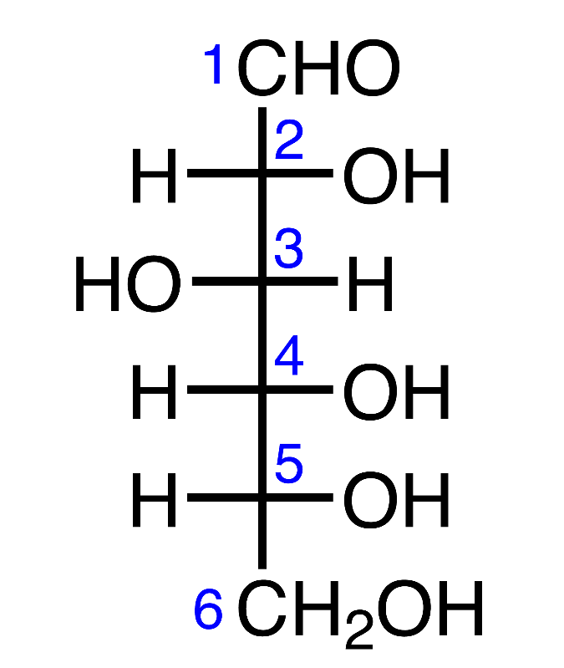
- What is the IUPAC systematic name for glucose as shown in the diagram above?
2,3,4,5,6-pentahydroxyhexanal

- What is the difference between α- glucose and β-glucose?
The hydroxyl (OH) at C1 have different arrangements in space.

- Draw four repeating units of the cellulose and starch polymers.
Cotton (cellulose) from β-glucose | 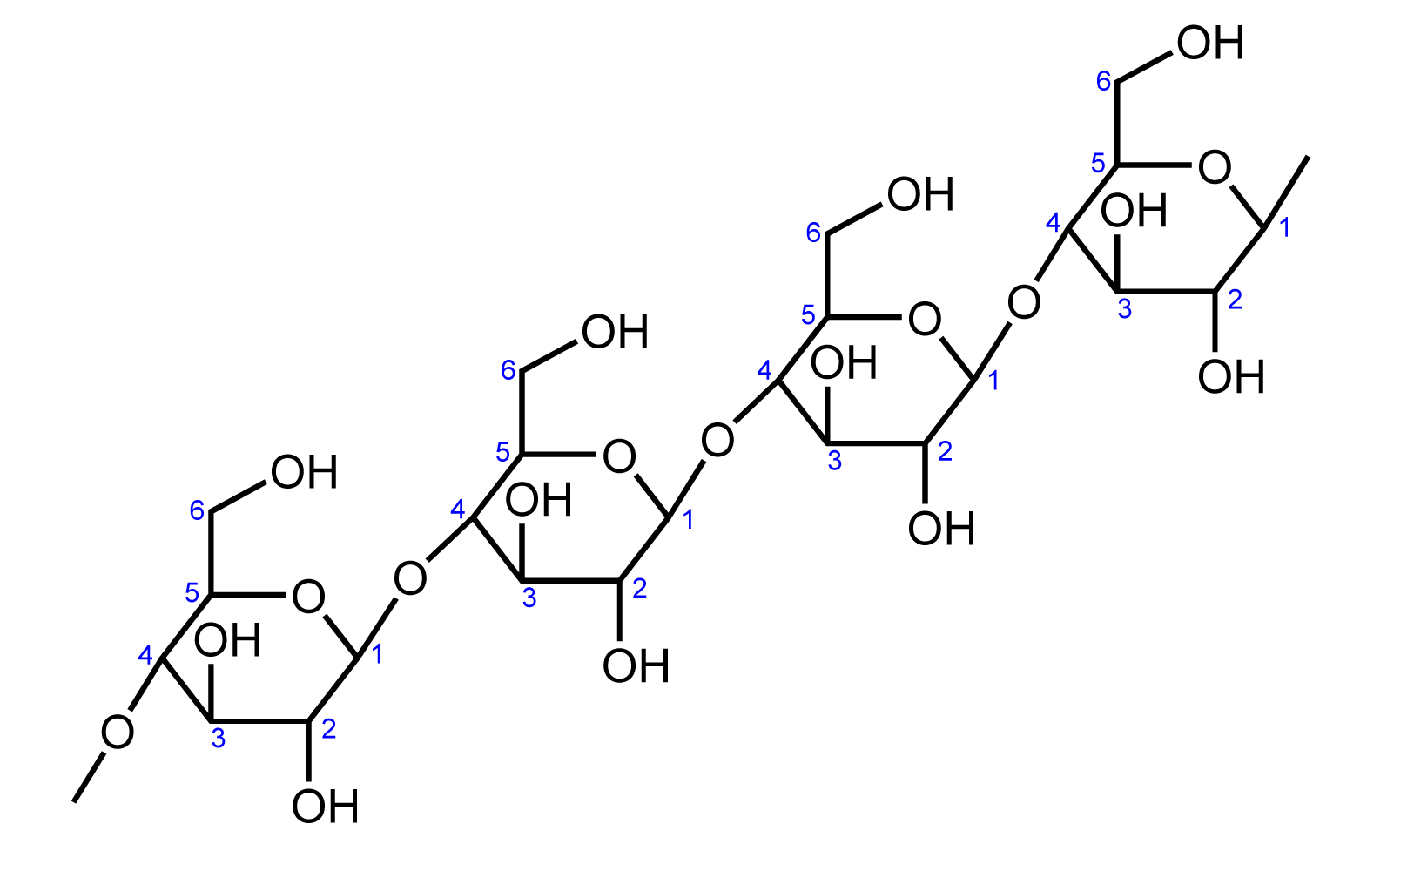
Starch from α- glucose | 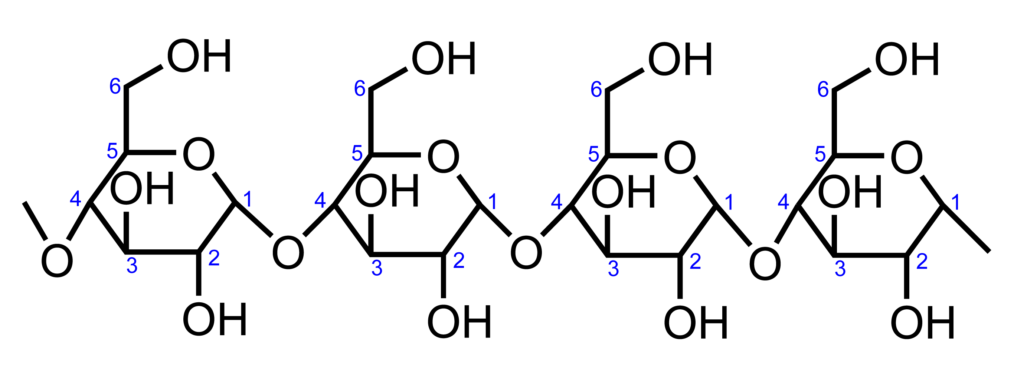

- Suggest how the differences you noted in question 2 are influencing the polymer structure.
The cellulose chain formed from β- glucose is a linear chain. The starch polymer chain formed from α- glucose is kinked (using proper structural forms it winds itself like a spring).
- Complete the table to show the skeletal structure of tetrahydropyran.
Pyran | Tetrahydropyran
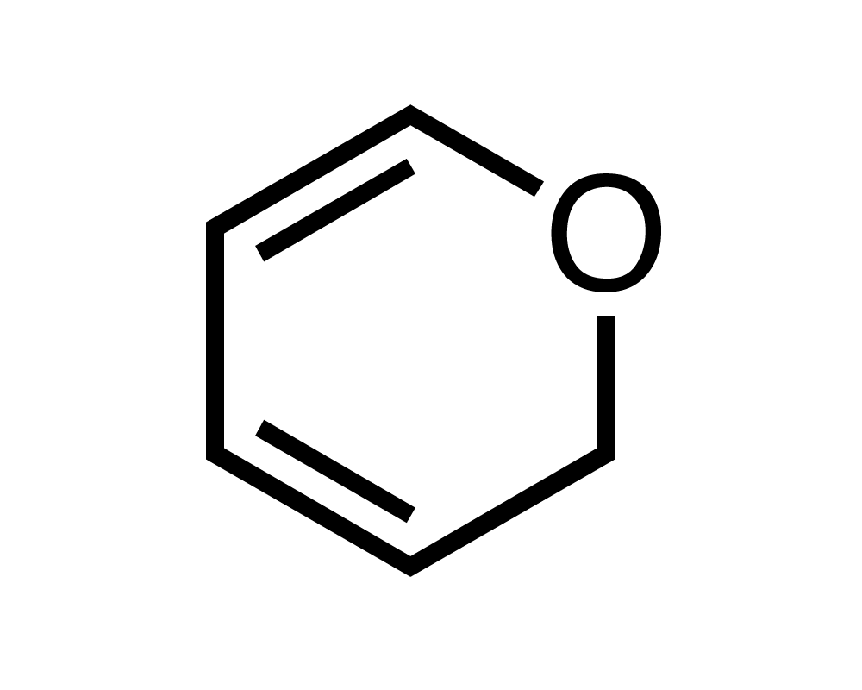 | 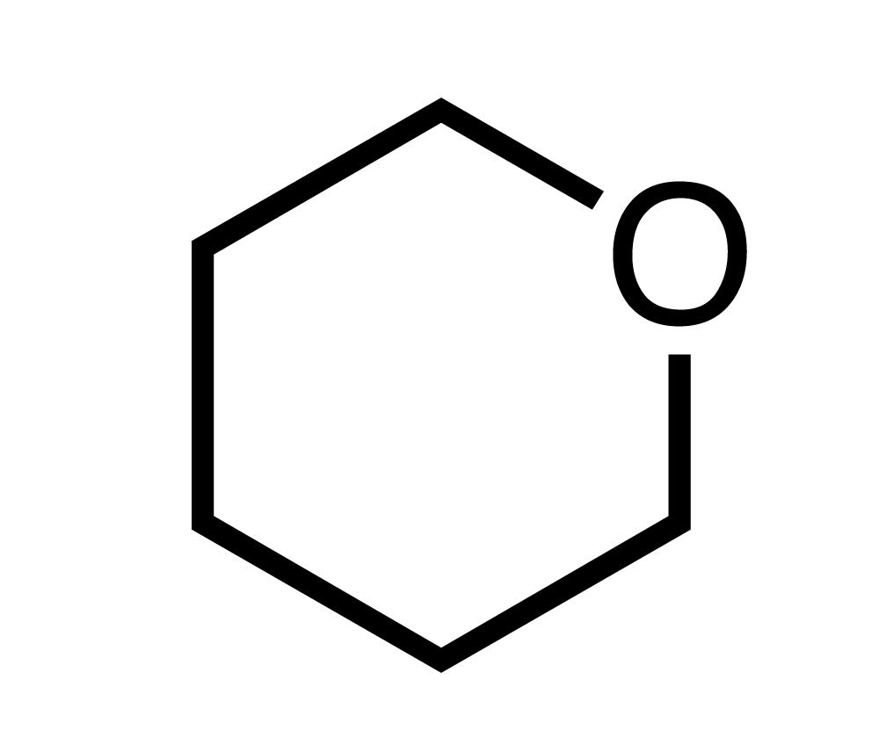

- Complete the table to show the skeletal structure of tetrahydropyran.
Furan | Tetrahydrofuran
 | 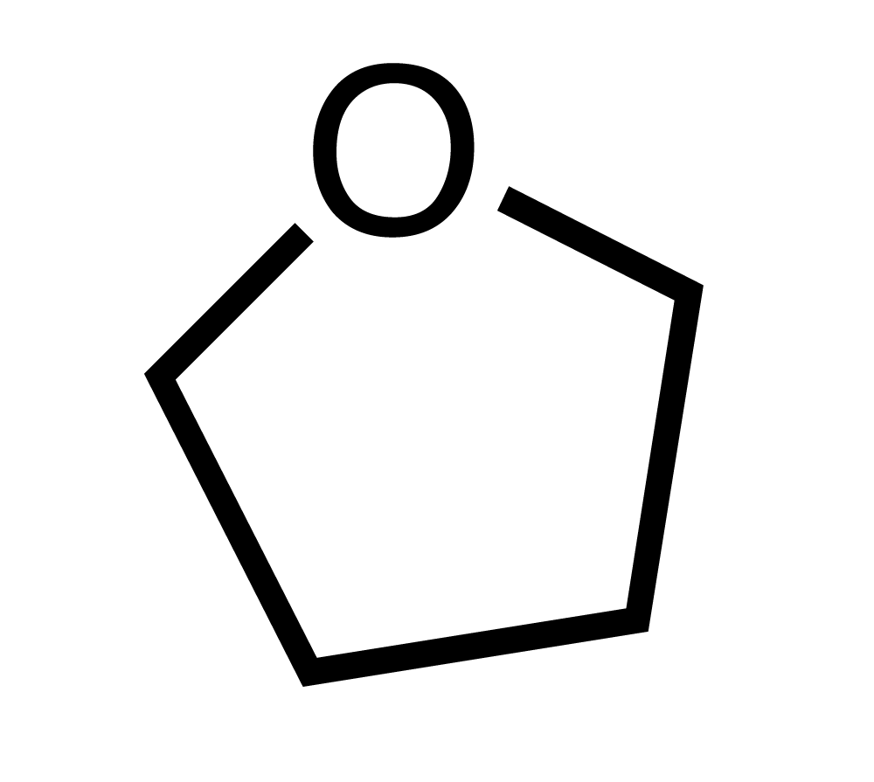

- Draw the two possible furanose structures of glucose (hint: look at the two pyranose forms and apply the difference to the form you are trying to create)
Stereochemistry not crucial at this level
α-furanose form | β-furanose form
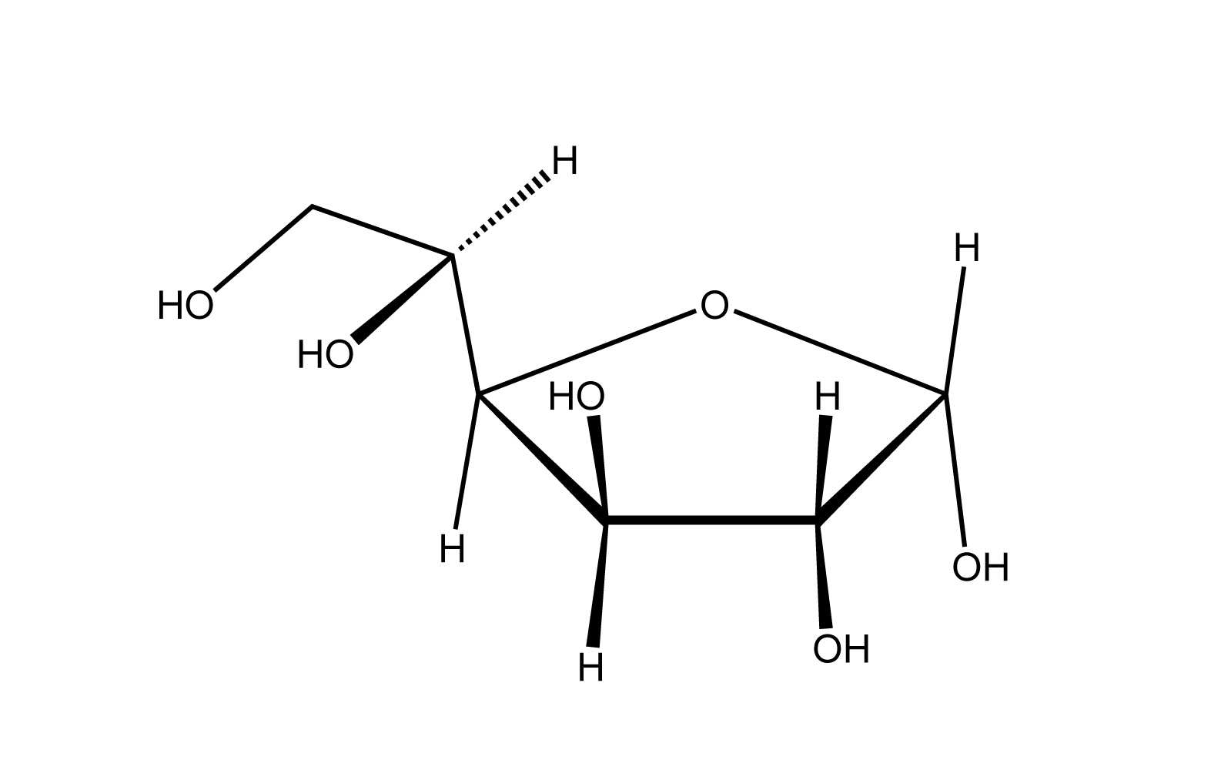 | 