Particle diagrams

This resource is part of the Structure strip series of resources, designed to support literacy in science teaching. More resources in this series can be found at: rsc.li/3JL80Bf

Learning objectives
- Recall, draw and describe the particle model for solids, liquids and gases where particles are represented by circles/spheres.
- Use particle diagrams to represent chemical reactions and physical changes.
- Evaluate the use of particle diagrams.

Introduction

Particle diagrams are often used to show the arrangement of atoms and molecules in substances. It is important that we understand all the information given in these diagrams and their limitations.

How to use structure strips

Structure strips are a type of scaffolding you can use to support learners to retrieve information independently. Use them to take an overview at the start of the topic, to activate prior knowledge, or to summarise learning at the end of a teaching topic.

Structure strips have sections containing prompts, sized to suggest the amount that learners must write. Learners glue the strips into the margin of an exercise book and write their answers next to the sections, in full sentences. When learners have finished using the structure strip, they should have an A4 page set of notes and examples.

Scaffolding

To further support learners to answer the questions you can include a list of keywords or add prompts to the structure strip. As learners grow in confidence, they may be able to attempt the follow-up question first and then use the structure strip to improve or self-assess their answer.

Metacognition

This activity supports learners to develop their metacognitive skills in three key areas.
- Planning: the strips provide scaffolding to plan the written response. Learners will decide where to gather information from (textbooks, own notes, revision websites). Ask learners: is the source of information you are using reliable?
- Monitoring: learners are prompted by the questions in the structure strip and can check their answer against the prompts. Ask learners: have you covered all of the questions in the space provided? Do you need to change anything to complete the task?
- Evaluation: learners can self-assess or ask a peer to check their work against the answers. Ask learners: did you achieve what you meant to achieve? What might you do differently another time?

Follow-up question

Learners should answer the question after they have attempted the structure strip. The structure strip activates the required knowledge which learners can then apply to the question.

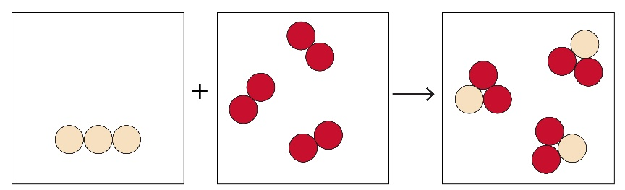
Substance X
Substance Z
Substance Y

The diagram shows a chemical reaction. Explain how the diagram shows this is a chemical reaction and what the diagram shows about the types and states of the substances involved. Suggest a symbol equation with state symbols that would fit the diagram.

Answers

Find suggested answers for the structure strip activity on page three.

Answer to follow-up question

The diagram shows a chemical reaction because the circles in the boxes show individual atoms. As the equation goes from reactants to products, the atoms in the reactants get rearranged and joined differently to make the products.

The diagram shows the atoms of substance X as a solid element. This is shown by the atoms touching each other in a regular arrangement and they are all the same colour, indicating they are the same type of atom.

The diagram shows substance Y is also an element which exists as (diatomic) molecules. The molecules are shown far away from each other, so substance Y is a gas.

Substance Z is a compound. This is shown by the different colour circles which are joined, indicating they are bonded. This substance is also a gas.

Possible equations: C(s) + $O_{2}$(g) $→$ ${CO}_{2}$(g)

S(s) + $O_{2}$(g) $→$ ${SO}_{2}$(g)

Learners may suggest other similar equations.
Particle diagrams  Structure strip | Suggested answer
Draw diagrams of the arrangement of particles for each of the following states:  - solid  - liquid  - gas  Describe and explain the key features of your diagrams. | 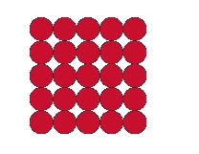  Particles are in a regular arrangement (lattice). All of the particles are touching. The particles do not fill the whole container.  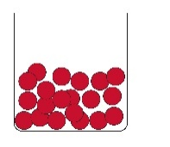  Particles have an irregular arrangement; they can roll over each other. Particles are still touching. Particles take the shape of the container.  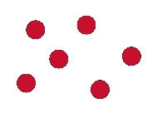  Particles have an irregular arrangement. They have large gaps between them and will fill the whole container.
Explain why representing atoms and molecules as circles/spheres is useful for representing state changes. | When representing state changes, the individual atoms in substances are not particularly important. It is more important to show the arrangement of particles, whether they are regular or random, close together or far part.
Using circles for the individual atoms, show what happens when sulfur, S, reacts with oxygen $O_{2}$ to make sulfur dioxide, ${SO}_{2}$. Explain your diagram. | This diagram shows a chemical reaction has taken place. The atoms in the reactants are rearranged into new arrangements in the products. The sulfur is a solid, the oxygen is a gas and the product, sulfur dioxide, is a gas.  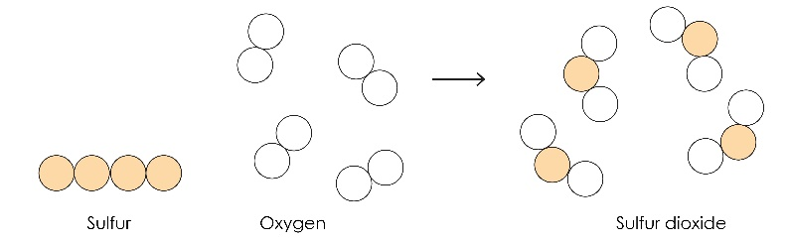
Using circles for the individual atoms, show what happens when iron, Fe, mixes with sulfur, S, but does not react. Explain your diagram. | 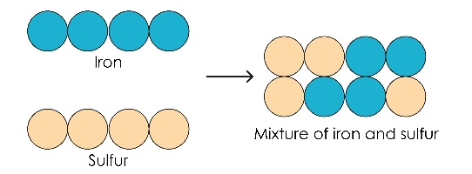  The diagram shows both reactants and products are solids. The product is not a compound, it is a mixture. This is shown by the atoms not being in a regular alternating arrangement.
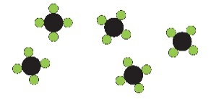Evaluate the pros and cons of this diagram which shows molecules of methane, ${CH}_{4}$, as a gas. | Pros – shows all the atoms in the molecules of methane, can give an indication of the size of the atoms.  Cons – the additional detail makes it difficult to see the gaps between the molecules which indicate it is a gas.

