- This question is about how trends in properties of the fractions from crude oil change with the chain length of the molecule.

  - Complete the table by writing the words: ‘decreases’, ‘increases’ or ‘stays the same’ into the right-hand column.

Property | Trend in property as carbon chain length increases
Boiling point
Viscosity
Flammability
  - Place these fractions from crude oil in order of their boiling point.
diesel kerosene petroleum gas petrol bitumen

Write your answers below.
Name of fraction | Increasing boiling point

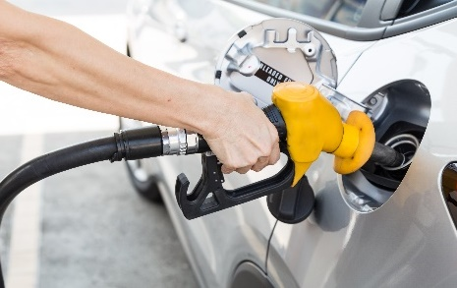
- A sample of petrol (gasoline) was analysed by a chemist.
She recorded a mass of petrol of 5.20 g.

The analysis found a substance called decane in the petrol.

The percentage of decane in the petrol sample was 4.8%, by mass.
Source: Envato Elements

Decane is an alkane containing ten carbon atoms in its molecule.
  - Which two elements are present in alkanes?

  - What is the general formula for an alkane?

  - Use your answer to part b) to work out the molecular formula for decane.

  - Draw the structure of a decane molecule.

  - Explain why a decane molecule is described as ‘saturated’.

  - Calculate the mass of decane in the petrol sample.
Give your answer to 3 significant figures.
Show your working.

  - What mass of petrol would contain exactly 10.0 g of decane?
Give your answer to 1 decimal place.
Show your working.

- Crude oil is a complex mixture of hydrocarbons, many of which are alkanes.
The boiling points of the first six members of the alkane homologous series are shown in the table below.
Number of carbon atoms in alkane | Boiling point in °C
1 | –162
2 | –89
3 | –42
4 | –0.5
5 | 36
6 | 69

  - Plot the number of carbon atoms on the horizontal axis and the boiling point on the vertical axis on the graph below.

  - Draw a best fit line through these points.

  - Describe how the boiling point changes from two carbon atoms to six carbon atoms.

  - Use your graph to determine the boiling point of the alkane with seven carbon atoms.

  - Which of the hydrocarbons are gases at room temperature, 20°C?

  - Dane and Debbie have a discussion about the best graph to draw to show the data in the table.
Dane suggests that a line is a good idea, but Debbie suggests a bar chart would be better.
State who you think is correct. Give a reason.

