Ions logic puzzle

This resource accompanies the article Highly charged in Education in Chemistry which can be viewed at: https://rsc.li/3o0jnLa

Learning objectives
- Recognise descriptions of ions based on charge and group number.
- Draw electron configuration diagrams for ions.

Instructions for teachers

The logic puzzle is a fun and challenging way to check understanding of the learning objectives. However, some learners may not have come across this style of puzzle before. Working in small groups or completing the puzzle as a whole class will allow learners to access the follow-up worksheet where they can practise drawing ions.

A version of the logic puzzle with only two categories is also provided to support learners who find this format difficult to access. It tests the same scientific knowledge.

Setting a time limit after which the completed grid will be shared with all learners will help to keep the lesson moving and avoid frustration at not being able to complete the puzzle.

Hints and tips for learners

Encourage your learners to attempt the puzzle, even if they haven’t tried anything like this before, by giving the following hints and tips:
- You do not have to go through all the clues in order.
- Look for a clue you can solve easily if you are stuck.
- Skip a clue if you don’t know what to do, you can come back to it later.
- Once you have completed all the clues go through them from the beginning again. You might have new information available the second time around.
- If you have filled in a tick in one of the sections, do you know anything else about the items in that row or column that you can transfer to another section of the grid?

Full instructions for completing grid-based logic puzzles can be found at https://logic.puzzlebaron.com/how-to-solve-a-logic-puzzle.php. This is an external website and therefore the RSC is not responsible for any content on the site.

Answers (challenge)

Clue 1 Clue 2 Clue 3

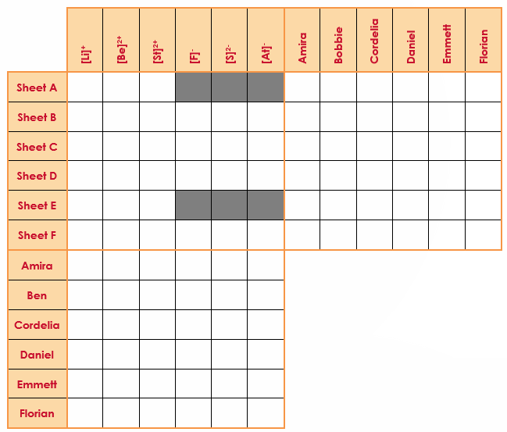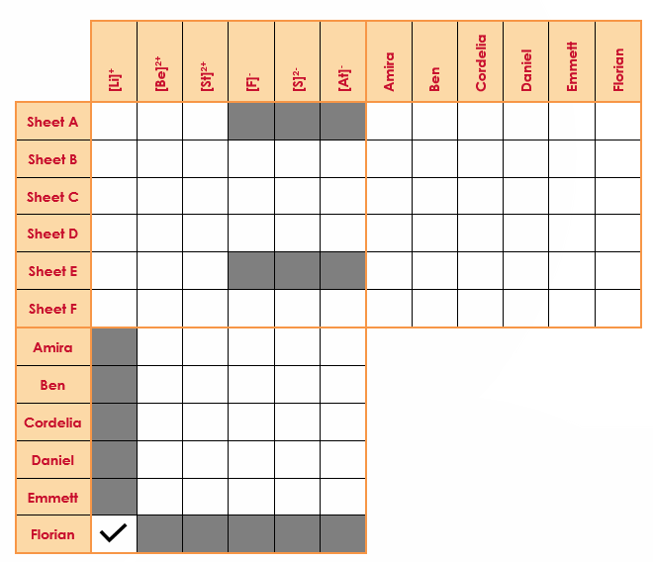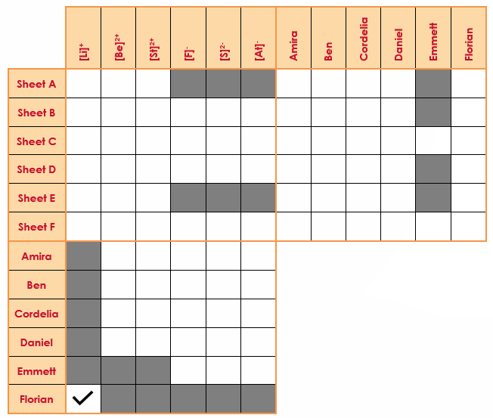

Clue 4 Clue 5 Clue 6

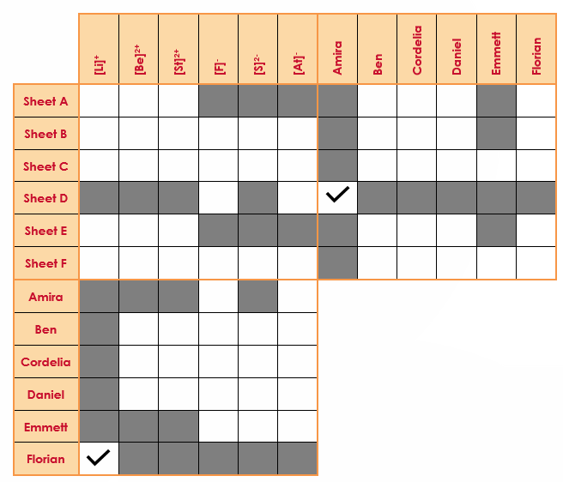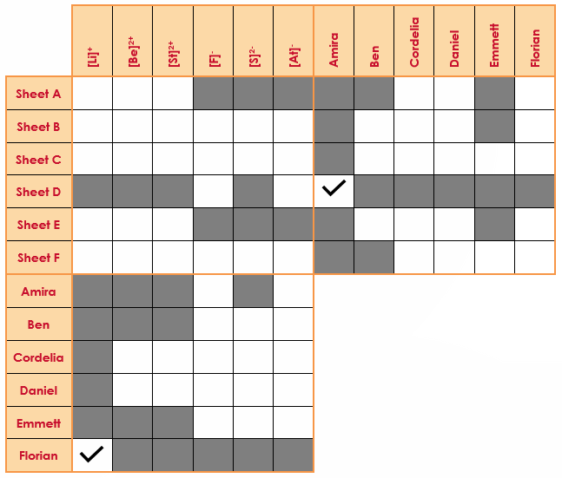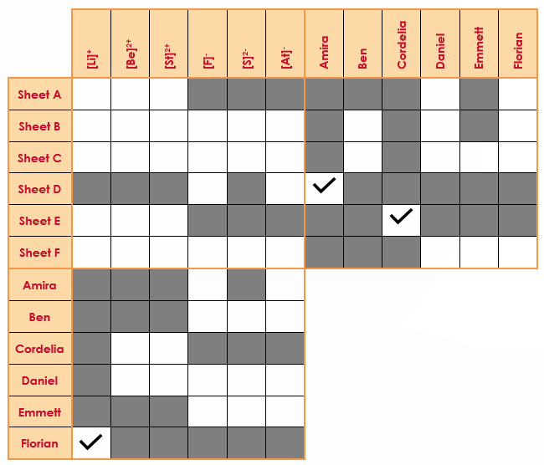

Clue 7 Clue 8 Clue 8 cont.

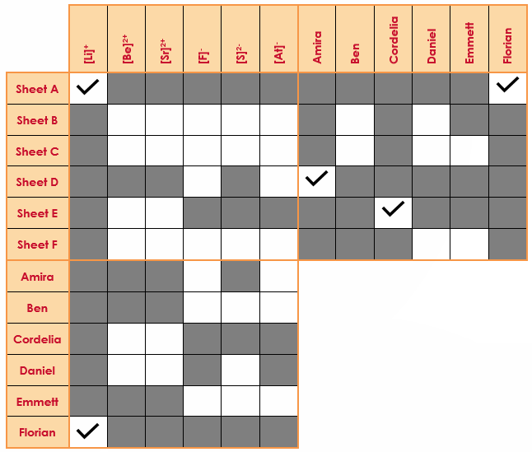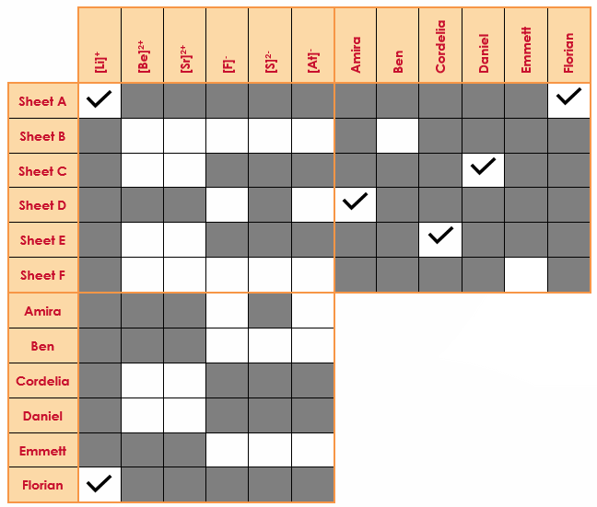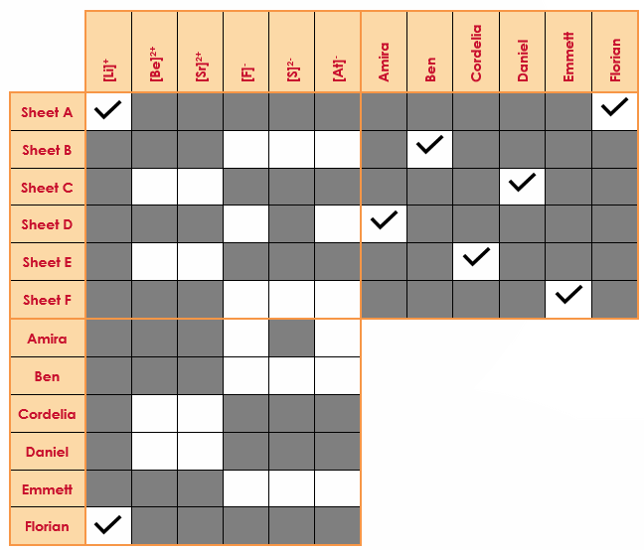

Clue 9 Clue 10 Clue 11

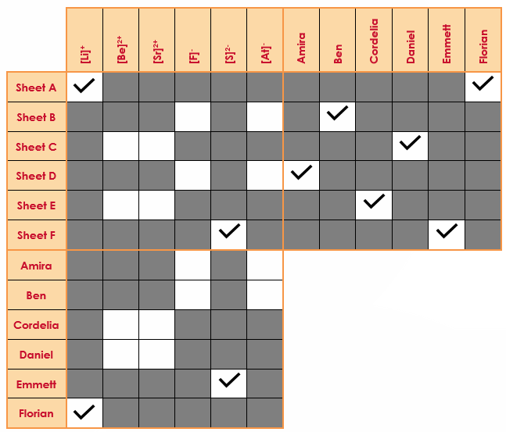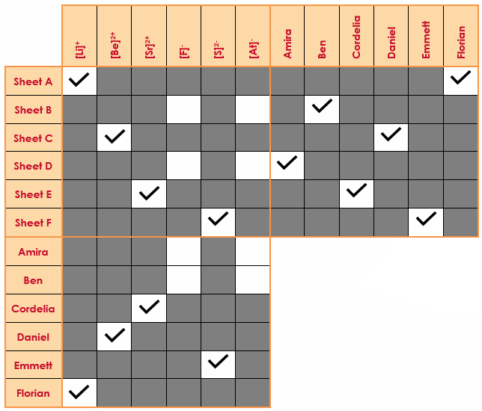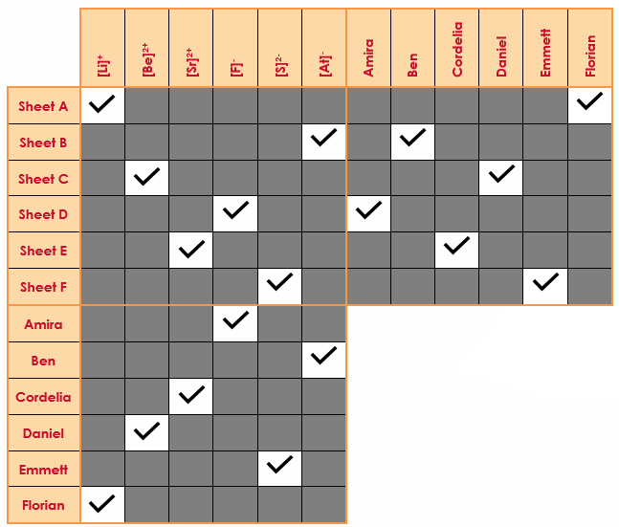

Answers (support)

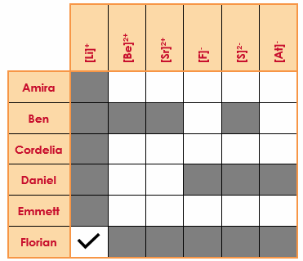
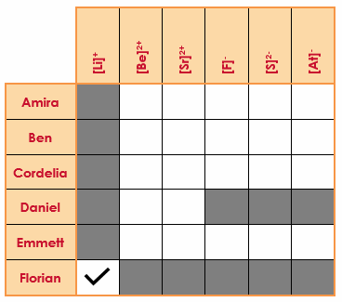
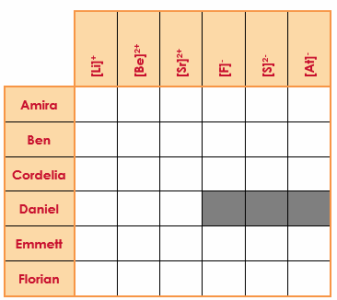
Clue 1 Clue 2 Clue 3

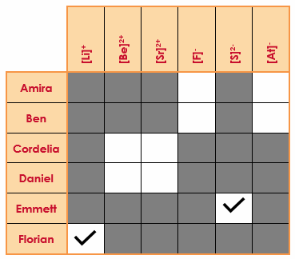
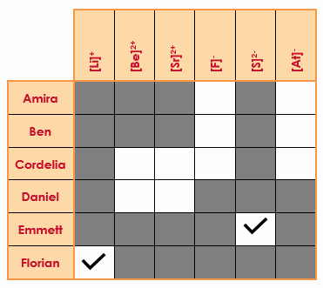
Clue 4 Clue 5 Clue 6
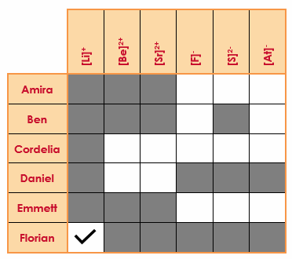

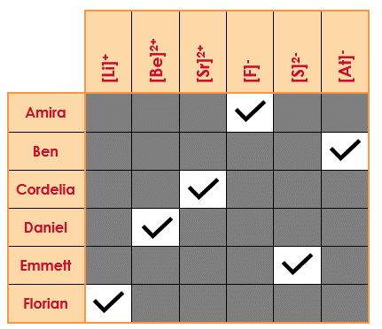
Clue 7 Clue 8
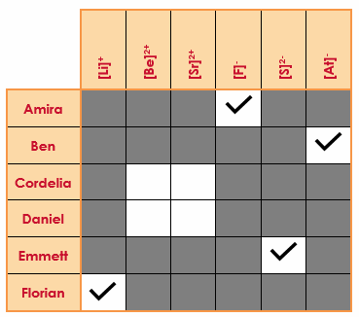

Solution
 | Amira | Ben | Cordelia | Daniel | Emmett | Florian
Ion | [F]- | [At]- | [Sr]²⁺ | [Be]²⁺ | [S]²- | [Li]⁺
Charge | - | - | 2+ | 2+ | 2- | +
Group | 7 | 7 | 2 | 2 | 6 | 1

Answers (Follow up sheet)

A Student name: Florian
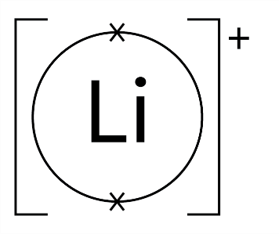
Name of ion: lithium ion
Symbol of ion: [Li]⁺
Periodic table group: one

C Student name: Daniel
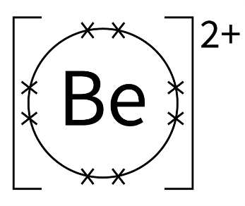
Name of ion: beryllium ion
Symbol of ion: [Be]²⁺
Periodic table group: two

E Student name: Cordelia
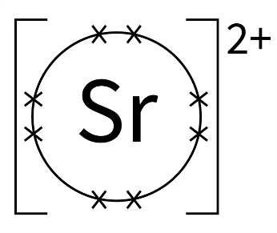
Name of ion: strontium ion
Symbol of ion: [Sr]²⁺
Periodic table group: two

B Student name: Ben
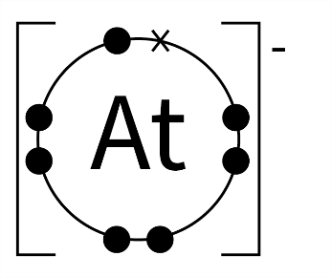
Name of ion: astatine ion
Symbol of ion: [At]⁻
Periodic table group: seven

D Student name: Amira
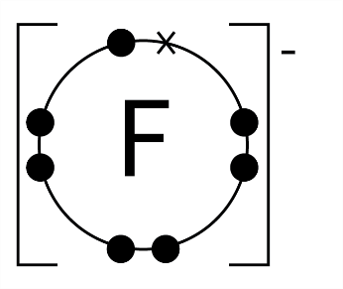
Name of ion: fluorine ion
Symbol of ion: [F]⁻
Periodic table group: seven

F Student name: Emmett
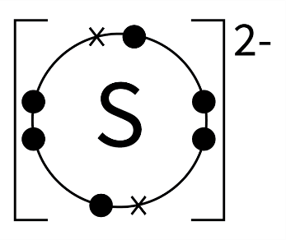
Name of ion: sulphur ion
Symbol of ion: [S]²⁻
Periodic table group: six

